

**Module Title : Designing and Developing Object-Oriented Computer Programs**

**Assignment Titl Assignment Name : Fitness Tracker**

**Examination Cycle : Autumn 2024**

**Candidate Name : SAW SAI MANG GYAW**

**Candidate No : 207284**

**Centre Name : KMD COMPUTER CENTRE (YANGON)**

**Submission Date : 9th July 2024**

**Important Notes :**

* Please refer to the Assignment Presentation Requirements for advice on how to set out your assignment. These can be found on the NCC Education *Campus*. Scroll down the left-hand side of the screen until you reach Personal Support. Click on this, and then on Policies and Advice. You will find the Assignment Presentation Requirements under the Advice section.
* You must familiarise yourself with the NCC Education Academic Dishonesty and Plagiarism Policy and ensure that you acknowledge all the sources which you use in your work. The policy is available on Campus. Follow the instructions above, but click on Policies rather than Advice.
* You must complete the **‘Statement and Confirmation of Own Work’**. The form is available on the Policies section of *Campus*. Scroll down the left-hand side until you reach Personal Support. Click on this and then click on Policies and Advice.
* Please make a note of the recommended word count. You could lose marks if you write 10%more or less than this.
* You must submit a paper copy and digital copy (on disk or similarly acceptable medium). Media containing viruses, or media which cannot be run directly, will result in a fail grade being awarded for this module.
* All electronic media will be checked for plagiarism.

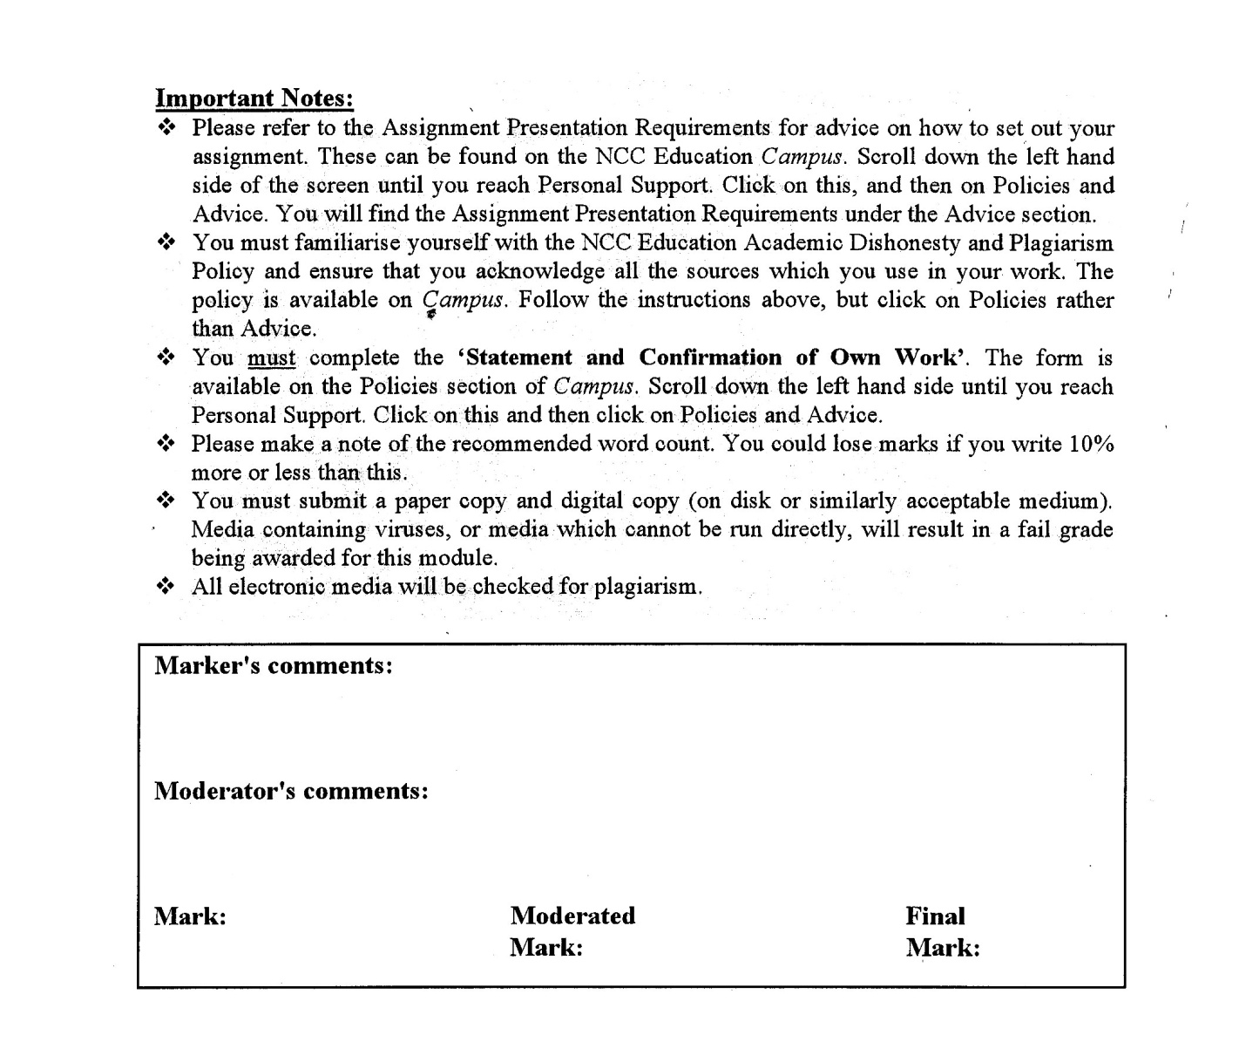



Statement and Confirmation of Own Work

A signed copy of this form must be submitted with every assignment.

If the statement is missing your work may not be marked.

For Level 7 assignments, please use the separate Level 7 Candidate Statement of Own Work form instead of this one.

Student Declaration

I confirm the following details:

|  |  |
| --- | --- |
| **Candidate Name:** | **SAW SAI MANG GYAW** |
| **Candidate ID Number:** | **207284** |
| **Qualification:** | **Level 4 Diploma in Computing** |
| **Unit:** | **DDOOCP** |
| **Centre:** | **KMD COMPUTER CENTRE (YANGON)** |
| **Word Count:** | **1612** |
| I have read and understood both NCC Education’s *Academic Misconduct Policy* and the *Referencing and Bibliographies* document. To the best of my knowledge my work has been accurately referenced and all sources cited correctly.  I confirm that I have not exceeded the stipulated word limit by more than 10%.  I confirm that this is my own work and that I have not colluded or plagiarised any part of it. | |
| **Candidate Signature:** | **Sai Mang** |
| **Date:** | **9th July 2024** |

Table of Contents

**Introduction** 4

**Task1_Design and Implement a Program** 6

**a)** **Implement a Program** 6

**b)** **Quality of a Program** 35

**Task2 _Testing** 42

**Test Plan** 42

**Test Script** 43

**Task3_Detailed Class Diagram** 76

**Class Diagram** 76

**Explanation** 76

**Description** 77

References 79

# **Introduction**

As the popularity of fitness continues to grow, there is an increasing need for software designed to monitor activities and progress. This assignment involves creating fitness-tracking software with personalized goal setting and activity monitoring features.

**Task 1**

Develop a fitness-tracking program in C# that meets all specified functional and non-functional requirements, focusing on account creation, goal setting, activity recording, progress monitoring, and calorie calculation. Additionally, ensure the program is well-structured, adheres to OOP principles like encapsulation, uses appropriate control structures, and maintains readability with proper comments.

**Task 2**

Prepare a 500-word report detailing the test plan, including the objectives of each test, test scripts, and the corresponding results. Include a separate 500-word section discussing the selection and execution of test data. The test plan should specifically address potential invalid inputs for three functions, with careful attention to exception handling.

**Task 3**

Produce a comprehensive class diagram manually, without relying on automated tools. Alongside the diagram, please provide a 500-word explanation justifying the design choices.

**Task1**

# **Task1_Design and Implement a Program**

## **Implement a Program**

**Program Design**

Admin Login Form Design:

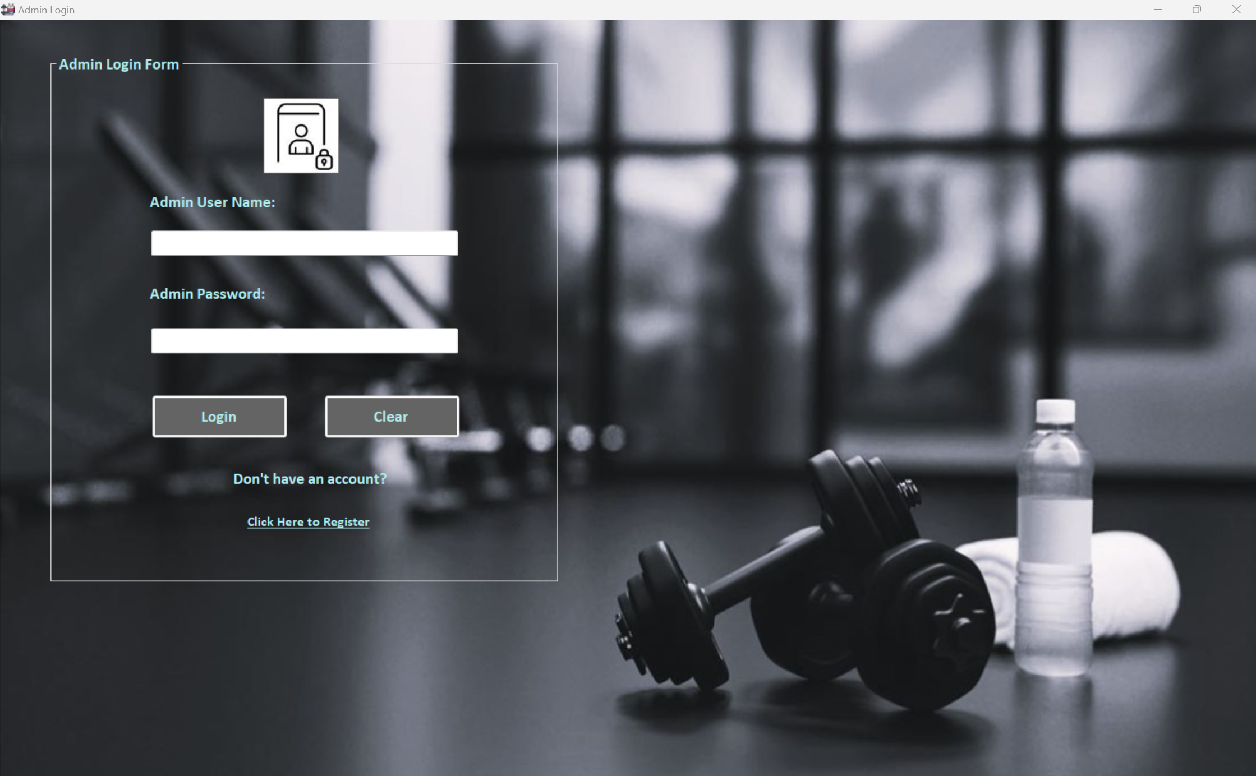

*Figure 1 – Admin Login Form*

Admin Homepage Design:

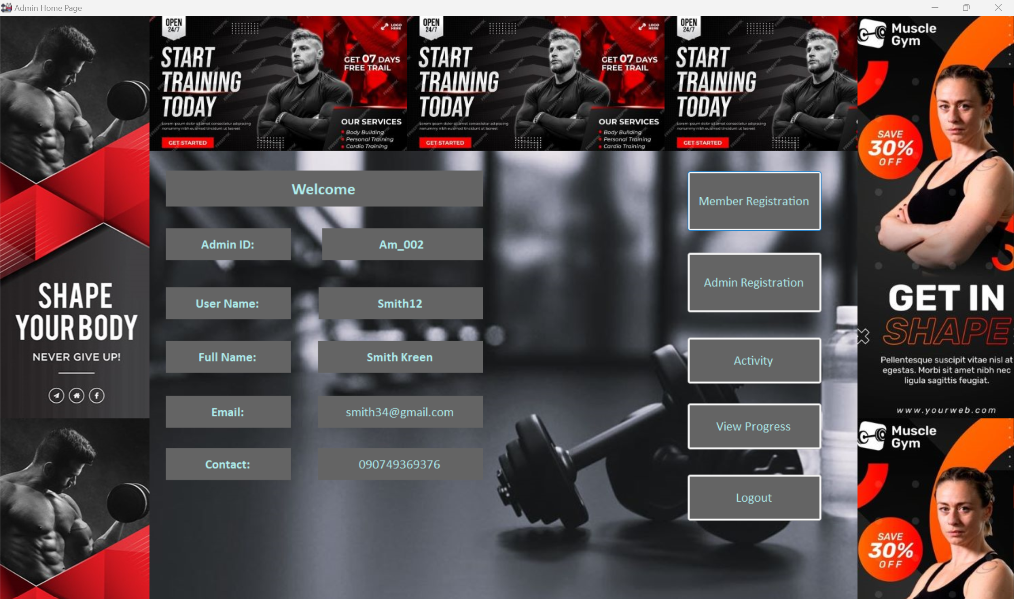

*Figure 2 – Admin Homepage*

Admin Registration Form Design:

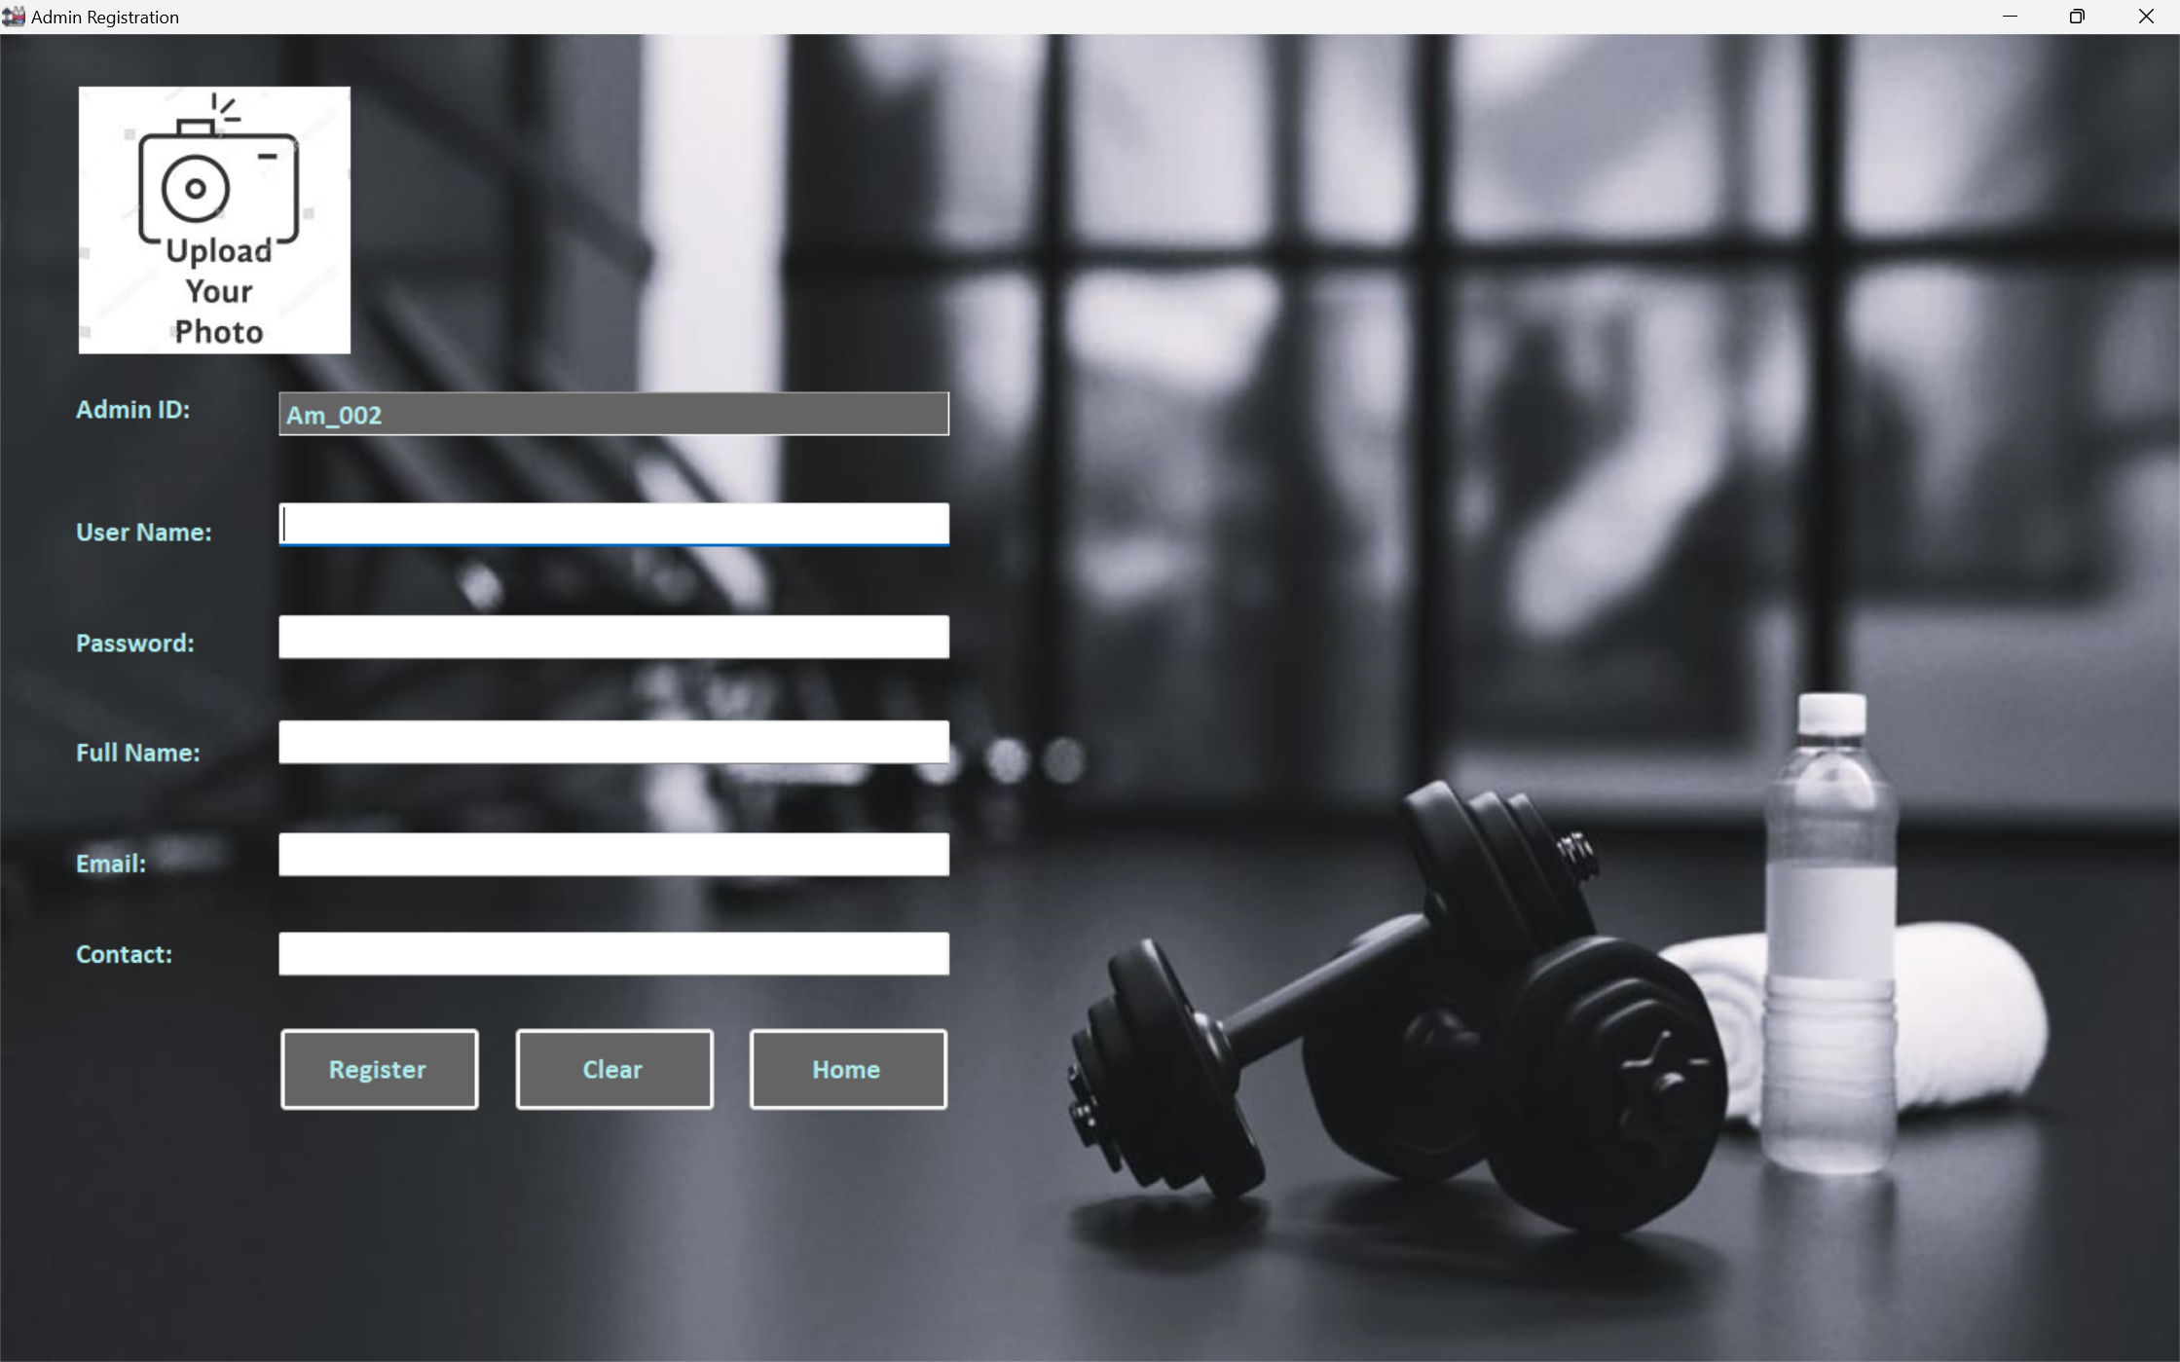

*Figure 3 – Admin Registration Form*

Member Login Form Design:

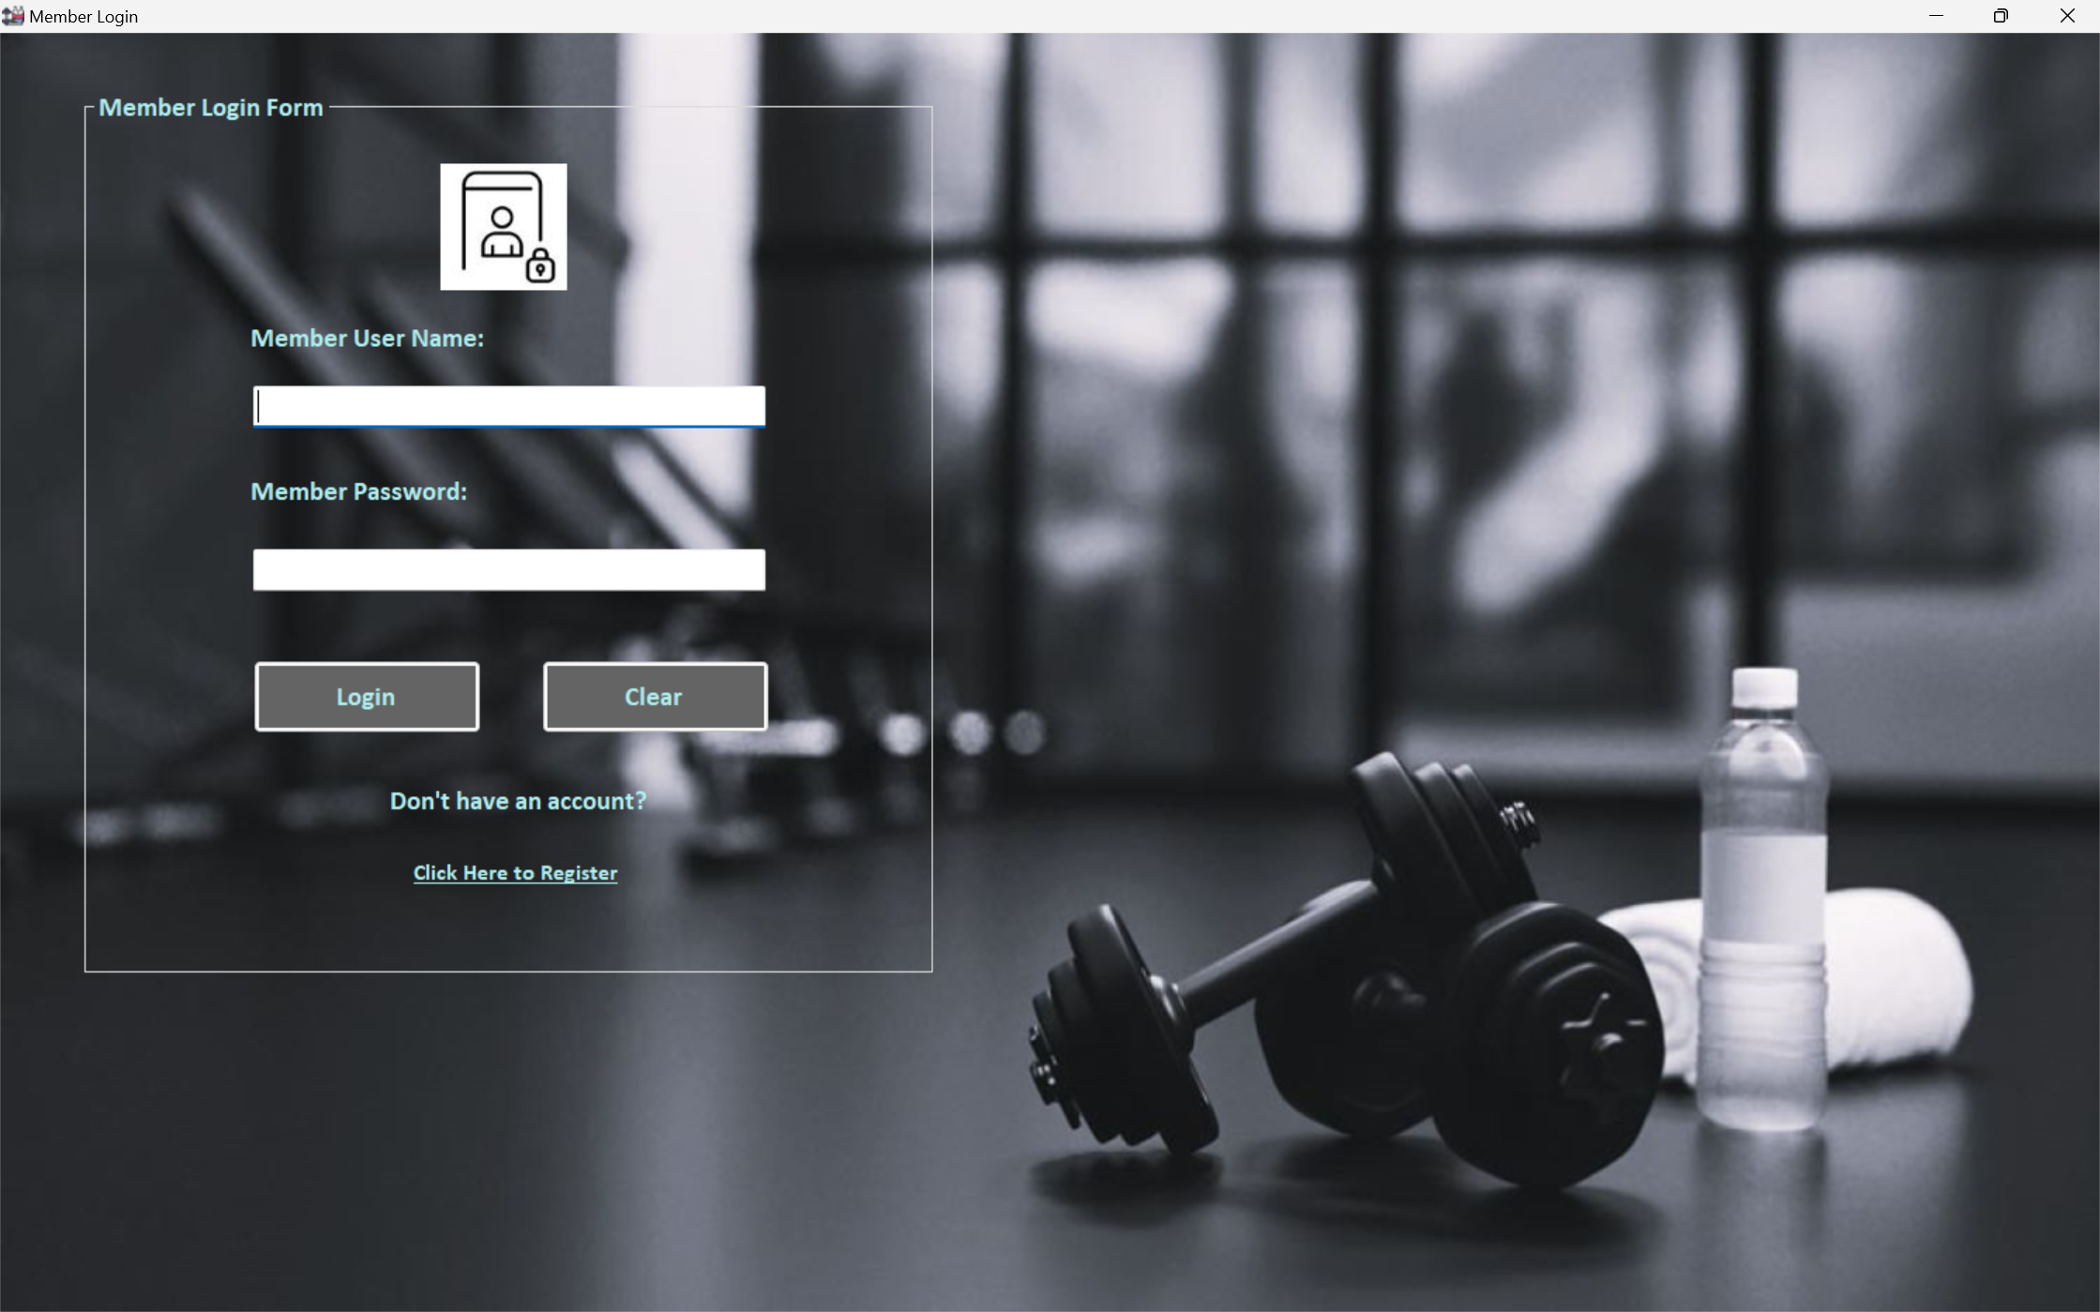

*Figure 4 – Member Login Form*

Member Homepage Design:

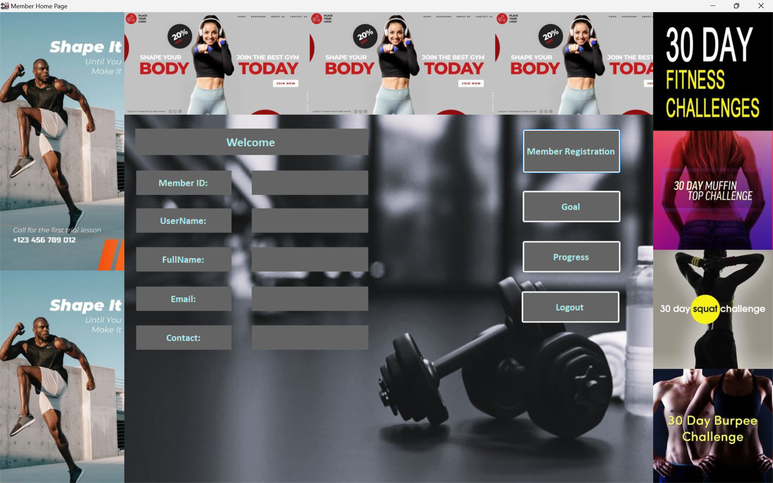

*Figure 5 – Member Homepage*

Member Registration Form Design:

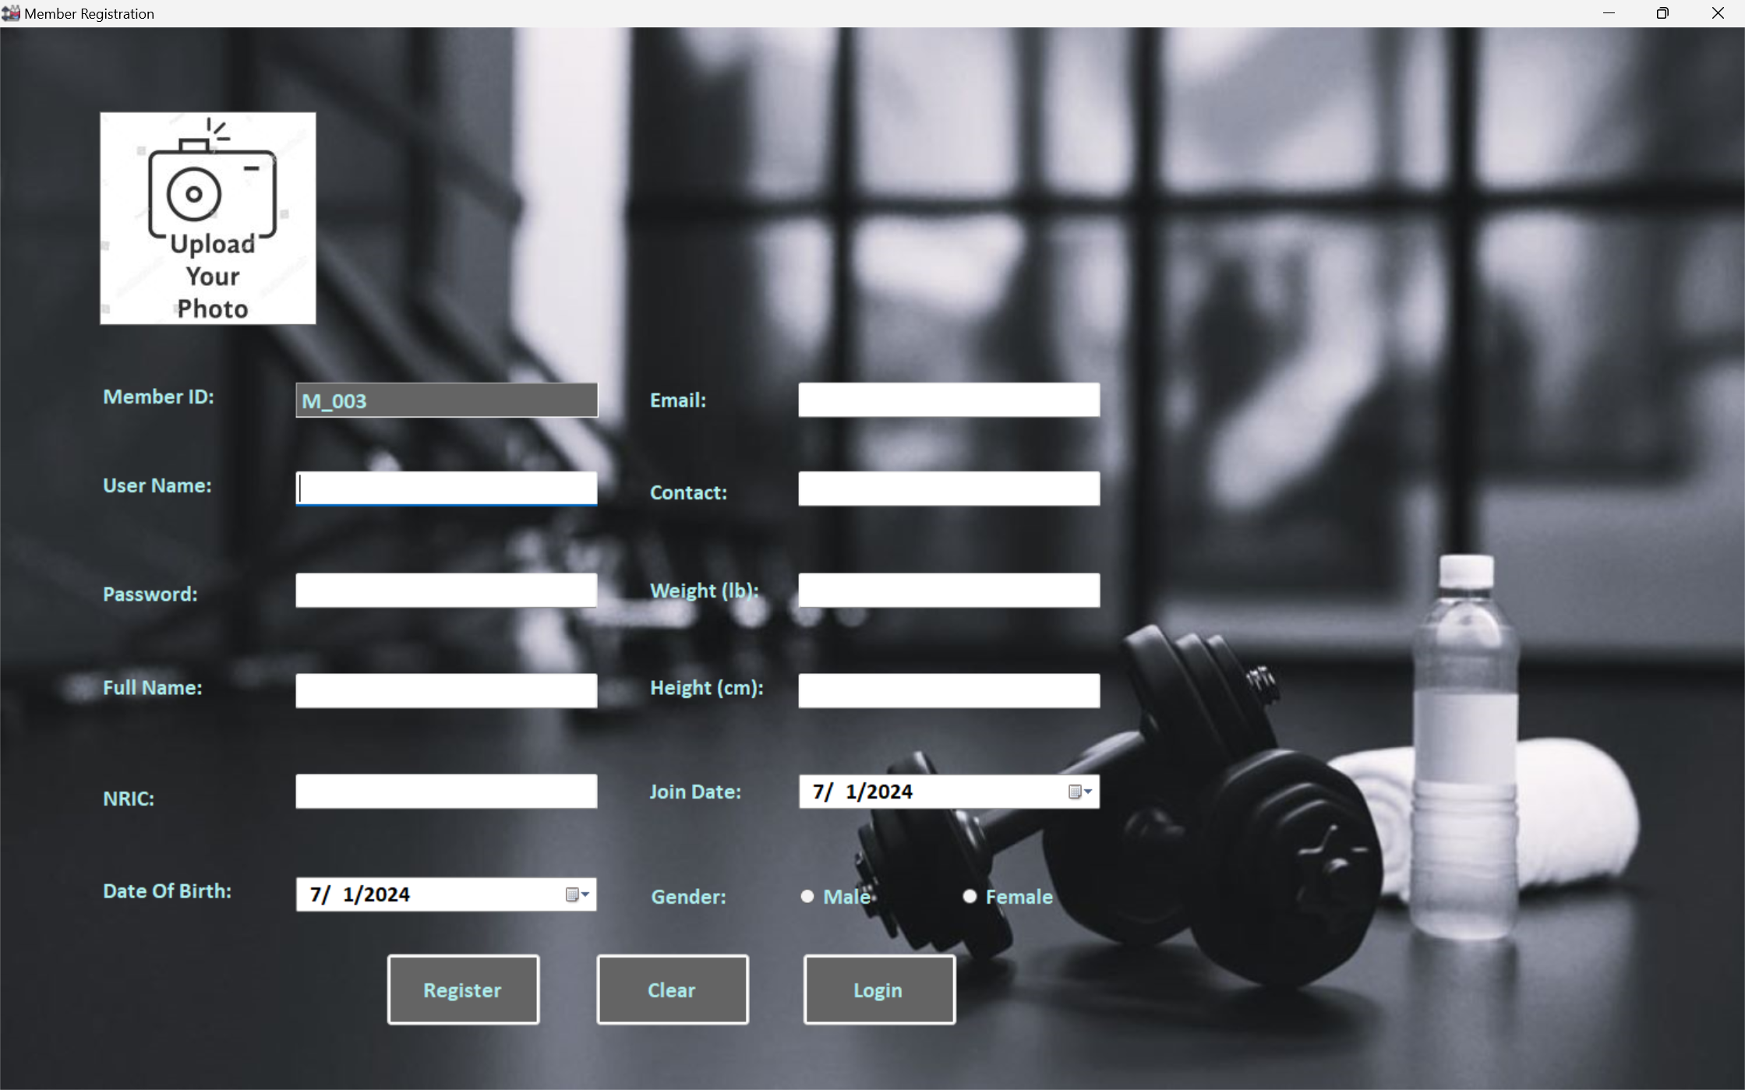

*Figure 6 – Member Registration Form*

Goal Form Design:

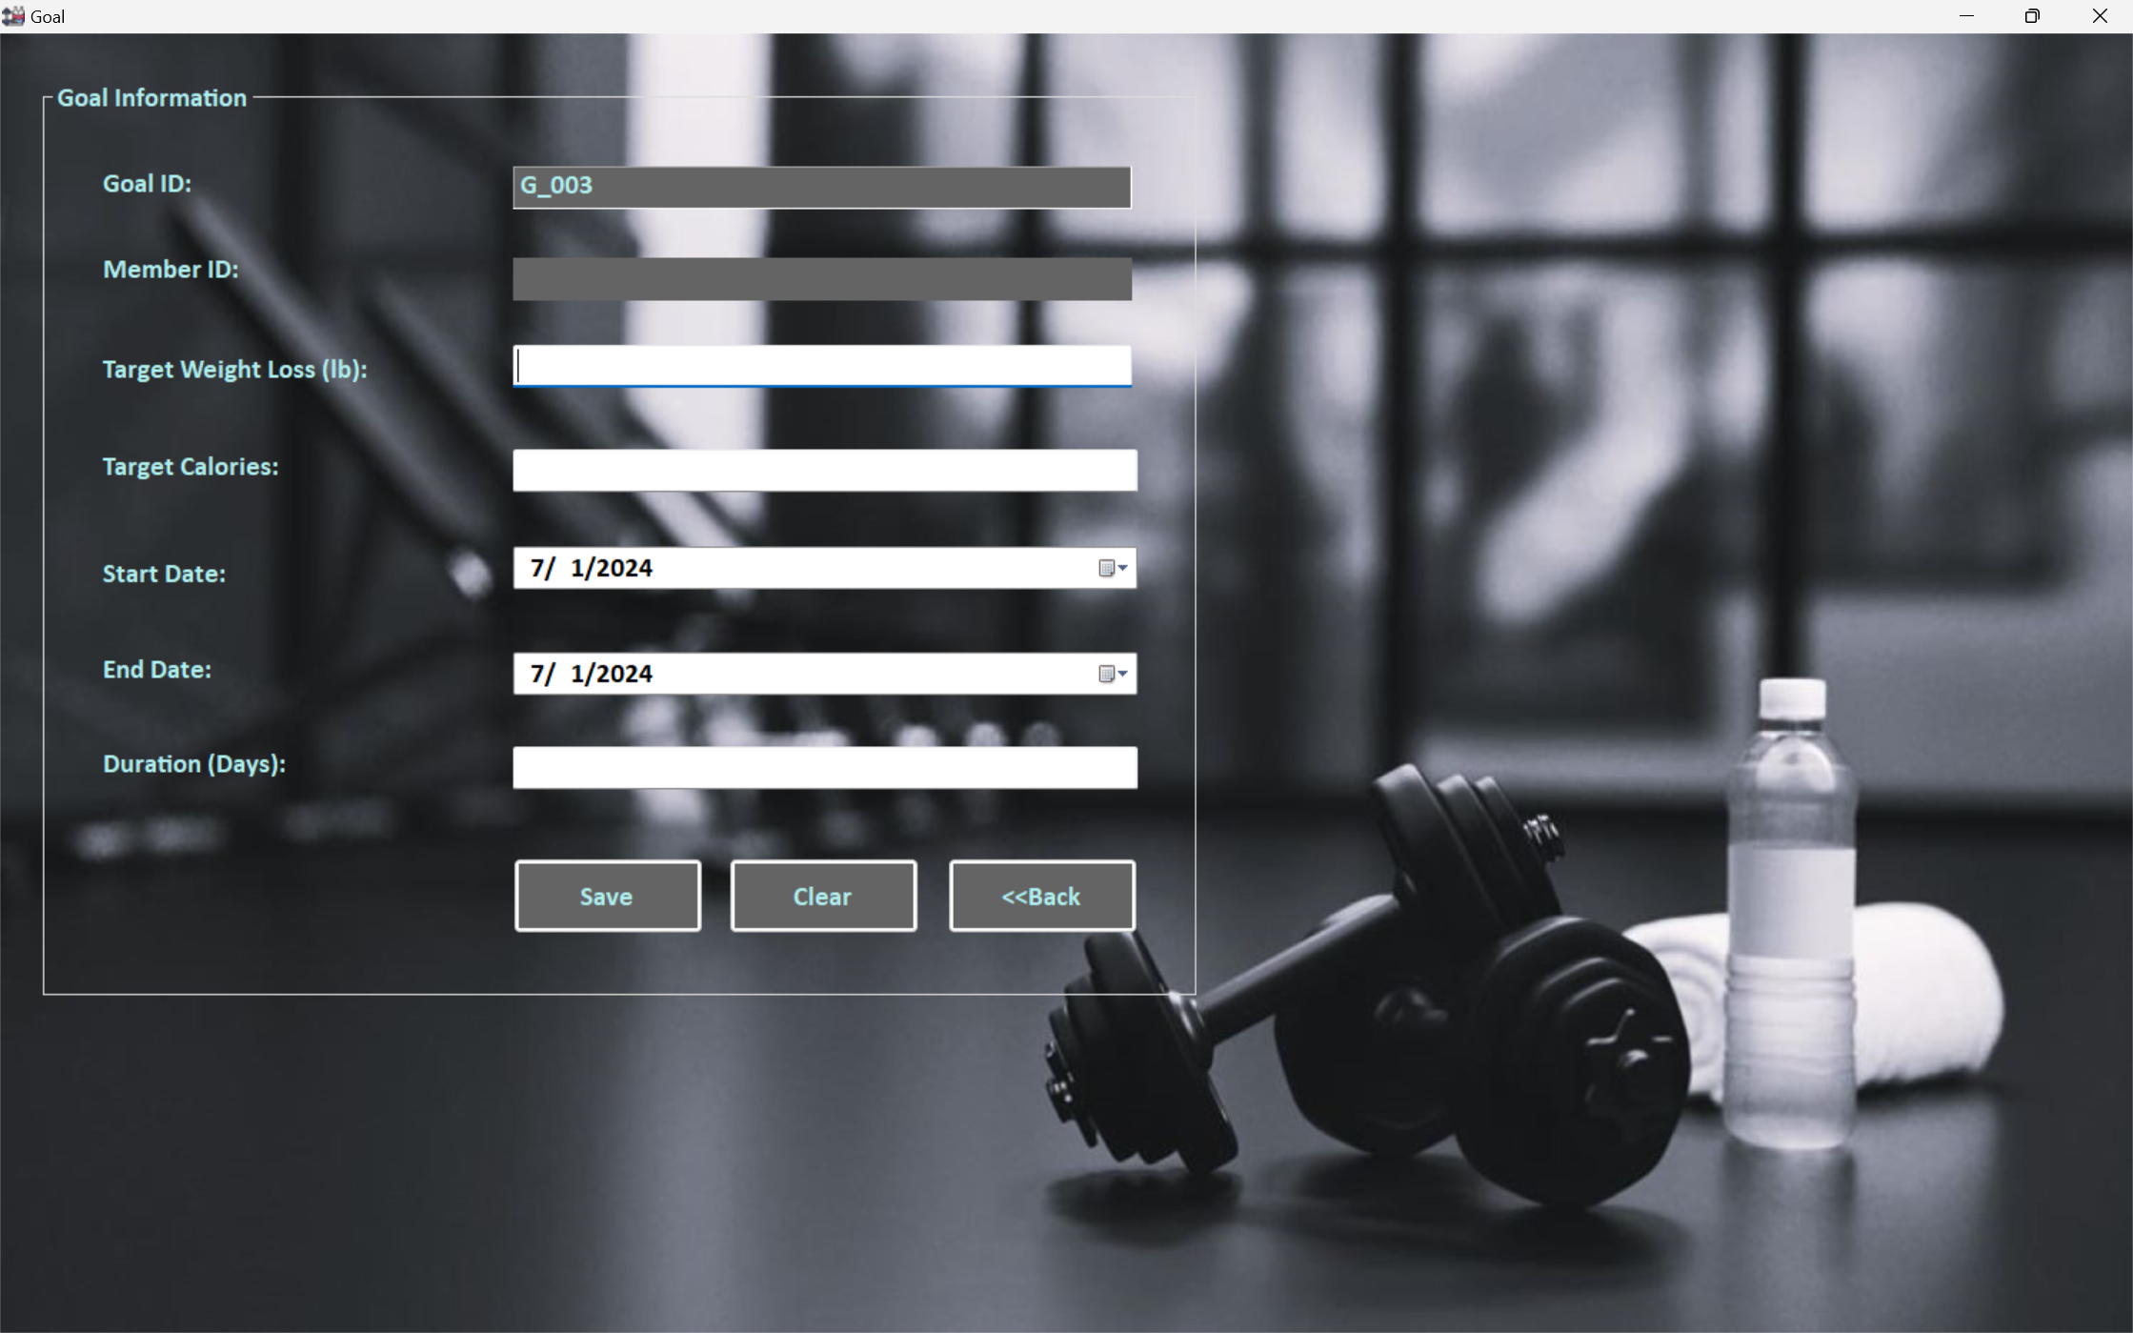

*Figure 7 – Goal Form*

Activity Form Design:

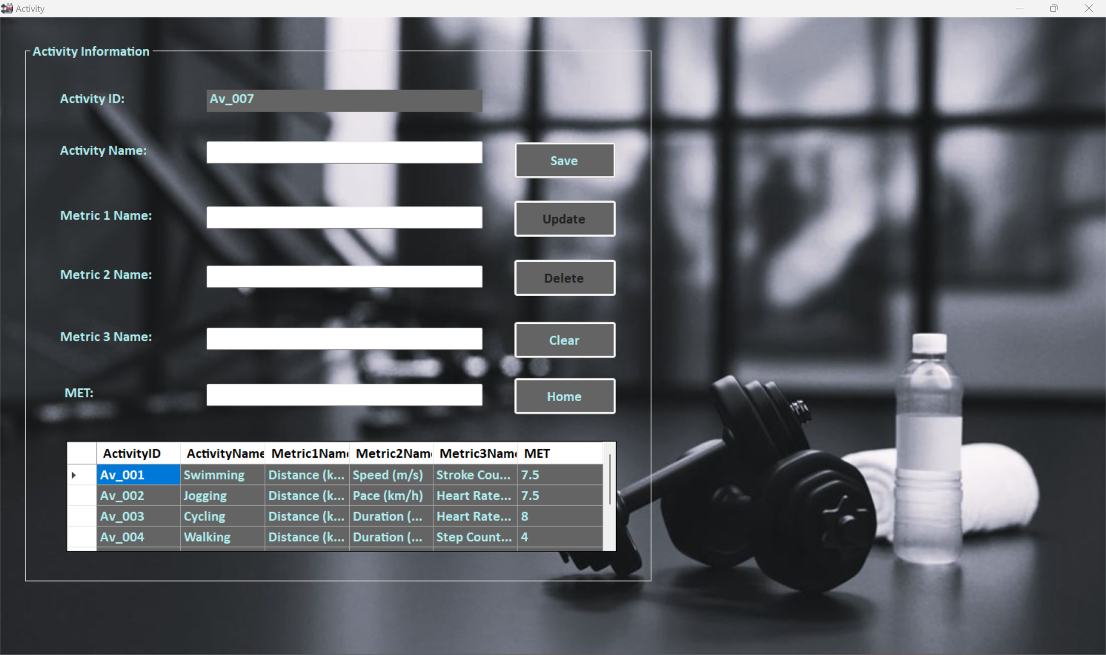

*Figure 8 – Activity Form*

Progress Form Design:

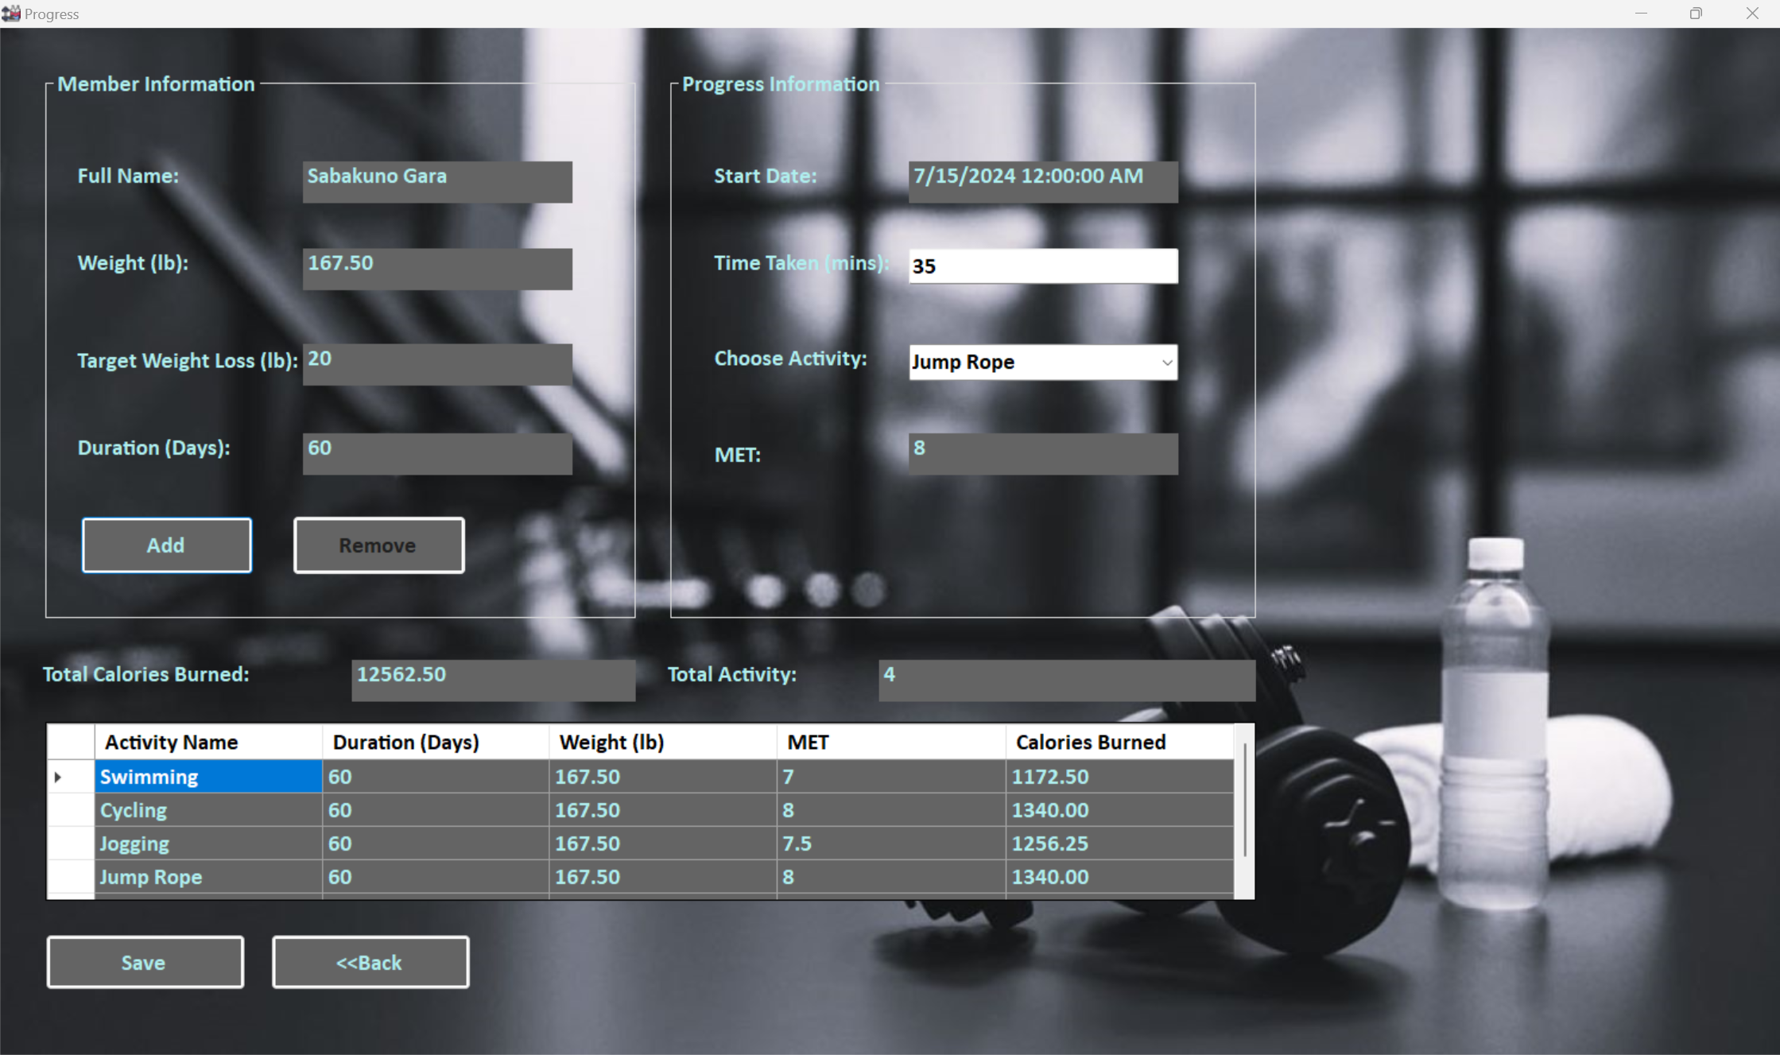

*Figure 9 – Progress Form*

Progress Form Design:

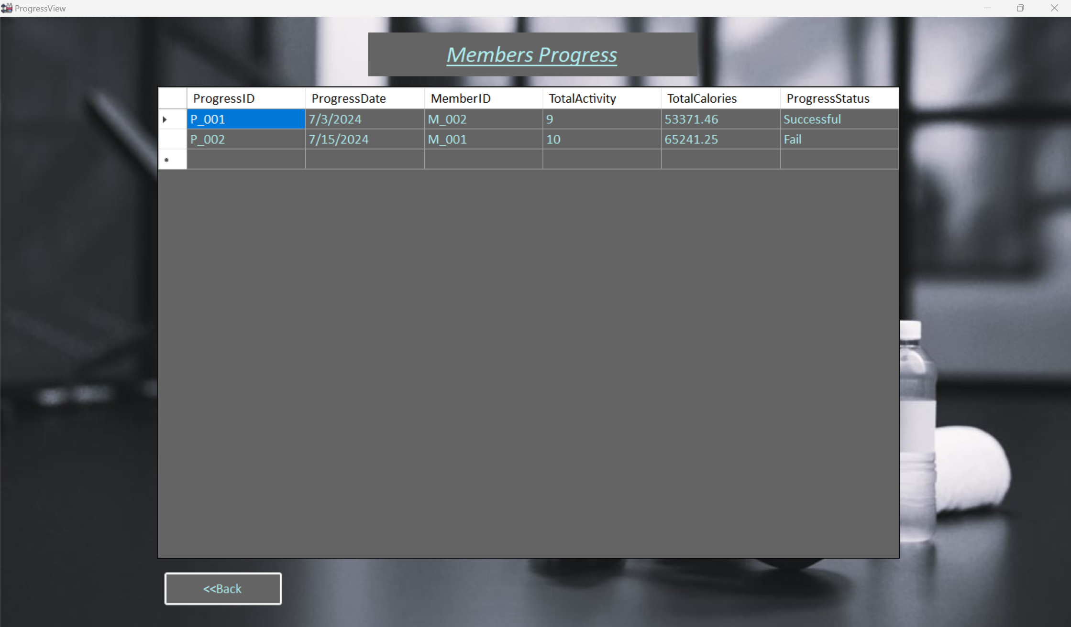

*Figure 10 – Progress View Form*

**Coding**

Admin Login Form Coding:

public partial class frmAdminLogin : Form

{

Fitness_Tracker_DDOOCP_DataSetTableAdapters.AdminTableAdapter objtAdmin = new Fitness_Tracker_DDOOCP_DataSetTableAdapters.AdminTableAdapter();

private int LoginAttempt = 0;

//public static string MemberID, UserName;

public static string AdminID, UserName;

public frmAdminLogin()

{

InitializeComponent();

}

private void linkAdminRegistration_LinkClicked(object sender, LinkLabelLinkClickedEventArgs e)

{

frmAdminRegister AR = new frmAdminRegister();

AR.Show();

this.Hide();

}

private void btnLogin_Click(object sender, EventArgs e)

{

if (LoginAttempt >= 3)

{

MessageBox.Show("You have reached limited login attempt 3 times! Please try again later!",

"Stop", MessageBoxButtons.OK, MessageBoxIcon.Stop);

}

else if (txtAdminUserName.Text == "")

{

MessageBox.Show("Please Enter UserName!", "Warning" , MessageBoxButtons.OK, MessageBoxIcon.Warning);

txtAdminUserName.Focus();

}

else if (txtAdminPassword.Text == "")

{

MessageBox.Show("Please Enter Password!" , "Warning" , MessageBoxButtons.OK , MessageBoxIcon.Warning);

txtAdminPassword.Focus();

}

else

{

DataTable dt = new DataTable();

dt = objtAdmin.AdminLogin(txtAdminUserName.Text, txtAdminPassword.Text);

if (dt.Rows.Count == 1)

{

MessageBox.Show("Login Successful!", "Info", MessageBoxButtons.OK, MessageBoxIcon.Information);

dgvAdmin.DataSource = dt;

AdminID = dgvAdmin[0, 0].Value.ToString();

UserName = dgvAdmin[1, 0].Value.ToString();

FullName = dgvAdmin[3, 0].Value.ToString();

Email = dgvAdmin[4, 0].Value.ToString();

Contact = dgvAdmin[5, 0].Value.ToString();

frmAdminHomePage AMH = new frmAdminHomePage();

AMH.Show();

this.Hide();

}

else

{

LoginAttempt += 1;

if (LoginAttempt >= 3)

{

MessageBox.Show("You have reached the limited login attempt 3 times! Please try again later.", "Stop", MessageBoxButtons.OK, MessageBoxIcon.Stop);

}

else

{

MessageBox.Show("Invalid Login Attempt: " + LoginAttempt, "Warning", MessageBoxButtons.OK, MessageBoxIcon.Warning);

}

}

}

}

private void btnClear_Click(object sender, EventArgs e)

{

txtAdminUserName.Clear();

txtAdminPassword.Clear();

}

private void dgvAdmin_CellContentClick(object sender, DataGridViewCellEventArgs e)

{

}

}

Admin Homepage Coding:

public partial class frmAdminHomePage : Form

{

public frmAdminHomePage()

{

InitializeComponent();

}

private void btnMemberReg_Click(object sender, EventArgs e)

{

frmMemberRegister MR = new frmMemberRegister();

MR.Show();

this.Hide();

}

private void btnAdminReg_Click(object sender, EventArgs e)

{

frmAdminRegister AR = new frmAdminRegister();

AR.Show();

this.Hide();

}

private void btnActivity_Click(object sender, EventArgs e)

{

frmActivity AV = new frmActivity();

AV.Show();

this.Hide();

}

private void lblUserName_Click(object sender, EventArgs e)

{

}

private void btnLogout_Click(object sender, EventArgs e)

{

frmAdminLogin AL = new frmAdminLogin();

AL.Show();

this.Hide();

}

private void frmAdminHomePage_Load(object sender, EventArgs e)

{

lblAdminID.Text = frmAdminLogin.AdminID;

lblUserName.Text = frmAdminLogin.UserName;

lblFullName.Text = frmAdminLogin.FullName;

lblEmail.Text = frmAdminLogin.Email;

lblContact.Text = frmAdminLogin.Contact;

}

private void btnProgress_Click (object sender, EventArgs e)

{

frmProgressView PV = new frmProgressView();

PV.Show();

this.Hide();

}

}

}

Admin Registration Form Coding:

public partial class frmAdminRegister : Form

{

public frmAdminRegister()

{

InitializeComponent();

IDIncrement();

}

Fitness_Tracker_DDOOCP_DataSetTableAdapters.AdminTableAdapter objtAdmin = new Fitness_Tracker_DDOOCP_DataSetTableAdapters.AdminTableAdapter();

DataTable dtAdmin = new DataTable();

public void IDIncrement()

{

DataTable dt = new DataTable();

dt = objtAdmin.GetData();

if (dt.Rows.Count == 0)

{

lblAdminID.Text = "Am_001";

}

else

{

int size = dt.Rows.Count - 1; //to get the last ID from Admin table

string oldID = dt.Rows[size][0].ToString();

int newID = Convert.ToInt32(oldID.Substring(3,3));

if (newID >= 1 && newID < 9)

{

lblAdminID.Text = "Am_00" + (newID + 1);

}

else if (newID >= 9 && newID < 99)

{

lblAdminID.Text = "Am_0" + (newID + 1);

}

else if (newID >= 99 && newID < 999)

{

lblAdminID.Text = "Am_" + (newID + 1);

}

}

}

public void ClearTextBox()

{

lblAdminID.Text = "";

txtAdminUserName.Clear();

txtAdminPassword.Clear();

txtAdminFullName.Clear();

txtAdminFullName.Clear();

txtAdminEmail.Clear();

txtAdminContact.Clear();

AdminPhoto.Image = null;

}

private void btnClear_Click(object sender, EventArgs e)

{

lblAdminID.Text = "";

txtAdminUserName.Clear();

txtAdminPassword.Clear();

txtAdminFullName.Clear();

txtAdminFullName.Clear();

txtAdminEmail.Clear();

txtAdminContact.Clear();

IDIncrement();

}

private void btnRegister_Click(object sender, EventArgs e)

{

string password = txtAdminPassword.Text;

if (txtAdminUserName.Text == "")

{

MessageBox.Show("Please Provide User Name!", "Warning", MessageBoxButtons.OK, MessageBoxIcon.Warning);

txtAdminUserName.Focus();

}

else if(!txtAdminUserName.Text.Any(char.IsNumber))

{

MessageBox.Show("Use Name should contain numbers!", "Warning", MessageBoxButtons.OK, MessageBoxIcon.Warning);

txtAdminUserName.Focus();

}

else if (!txtAdminUserName.Text.Any(char.IsLetter))

{

MessageBox.Show("Use Name should contain letters!", "Warning", MessageBoxButtons.OK, MessageBoxIcon.Warning);

txtAdminUserName.Focus();

}

else if (txtAdminFullName.Text == "")

{

MessageBox.Show("Please Provide Admin Full Name!", "Warning", MessageBoxButtons.OK, MessageBoxIcon.Warning);

txtAdminFullName.Focus();

}

else if (txtAdminPassword.Text == "")

{

MessageBox.Show("Please Provide Password!", "Warning", MessageBoxButtons.OK, MessageBoxIcon.Warning);

txtAdminPassword.Focus();

}

else if (txtAdminEmail.Text == "")

{

MessageBox.Show("Please Provide Admin Email!", "Warning", MessageBoxButtons.OK, MessageBoxIcon.Warning);

txtAdminEmail.Focus();

}

else if (txtAdminContact.Text == "")

{

MessageBox.Show("Please Provide Admin Contact!", "Warning", MessageBoxButtons.OK, MessageBoxIcon.Warning);

txtAdminContact.Focus();

}

else if (password.Length < 6 )

{

MessageBox.Show("Password cannot be less than 6 characters!", "Warning", MessageBoxButtons.OK, MessageBoxIcon.Warning);

txtAdminPassword.Focus();

}

else if (password.Length > 12)

{

MessageBox.Show("Password cannot be more than 12 characters!", "Warning", MessageBoxButtons.OK, MessageBoxIcon.Warning);

txtAdminPassword.Focus();

}

else if (!password.Any(char.IsUpper))

{

MessageBox.Show("Password should contain at least One(1) Uppercase Letter!", "Warning", MessageBoxButtons.OK, MessageBoxIcon.Warning);

txtAdminPassword.Focus();

}

else if (!password.Any(char.IsLower))

{

MessageBox.Show("Password should contain at least One(1) Lowercase Letter!", "Warning", MessageBoxButtons.OK, MessageBoxIcon.Warning);

txtAdminPassword.Focus();

}

else if (!password.Any(char.IsNumber))

{

MessageBox.Show("Password should contain numbers!", "Warning", MessageBoxButtons.OK, MessageBoxIcon.Warning);

txtAdminPassword.Focus();

}

else

{

if (AdminPhoto.Image == null)

{

// Show a message box if the image is missing

MessageBox.Show("Please input an image.", "Image Missing", MessageBoxButtons.OK, MessageBoxIcon.Warning);

return; // Exit the method if no image is provided

}

// Define the location and path to save the image

string loc = "C:\\207284_SawSai_DDOOCP_GA\\Program\\Fitness_Tracker_DDOOCP\\Fitness_Tracker_DDOOCP\\bin\\Debug\\images\\Admin_Photos";

string path = Path.Combine(loc, txtAdminUserName.Text + ".jpg");

// Save the image

Image a = AdminPhoto.Image;

a.Save(path);

//string loc = "C:\\207284_SawSai_DDOOCP_GA\\Program\\Fitness_Tracker_DDOOCP\\Fitness_Tracker_DDOOCP\\bin\\Debug\\images\\Admin_Photos";

//string path = Path.Combine(loc, txtAdminUserName.Text + ".jpg");

//Image a = AdminPhoto.Image;

//a.Save(path);

Admin_Model_Class AM = new Admin_Model_Class();

AM.AdminID = lblAdminID.Text;

AM.UserName = txtAdminUserName.Text;

AM.Password = txtAdminPassword.Text;

AM.FullName = txtAdminFullName.Text;

AM.Email = txtAdminEmail.Text;

AM.Contact = txtAdminContact.Text;

//objtAdmin.Insert(AM.AdminID, AM.UserName, AM.Password, AM.FullName, AM.Email);

objtAdmin.InsertAdminRegister(AM.AdminID, AM.UserName, AM.Password, AM.FullName, AM.Email, AM.Contact, path );

//objtAdmin.Insert(lblAdminID.Text, txtAdminUserName.Text, txtAdminPassword.Text, txtAdminFullName.Text, txtAdminEmail.Text);

MessageBox.Show("Successfully Registered!", "Info", MessageBoxButtons.OK, MessageBoxIcon.Information);

IDIncrement();

ClearTextBox();

txtAdminUserName.Focus();

}

}

private void lblAdminFullName_Click(object sender, EventArgs e)

{

}

private void AdminPhoto_Click(object sender, EventArgs e)

{

OpenFileDialog open = new OpenFileDialog();

PictureBox pb = sender as PictureBox;

if (pb != null)

{

open.Filter = "(*.jpg;*.jpeg;*.png) | *.jpg;*.jpeg;*.png";

if (open.ShowDialog() == DialogResult.OK)

{

pb.Image = Image.FromFile(open.FileName);

}

}

}

private void btnHome_Click(object sender, EventArgs e)

{

frmAdminHomePage AMH = new frmAdminHomePage();

AMH.Show();

this.Hide();

}

}

Member Login Form Coding:

public partial class frmMemberLogin : Form

{

Fitness_Tracker_DDOOCP_DataSetTableAdapters.MemberTableAdapter objtMember = new Fitness_Tracker_DDOOCP_DataSetTableAdapters.MemberTableAdapter();

//private int LoginAttempt = 0;

private int LoginAttempt = 0;

public static string MemberID, UserName;

public frmMemberLogin()

{

InitializeComponent();

}

private void linkMemberRegistration_LinkClicked(object sender, LinkLabelLinkClickedEventArgs e)

{

frmMemberRegister MR = new frmMemberRegister();

MR.Show();

this.Hide();

}

private void btnLogin_Click(object sender, EventArgs e)

{

if (LoginAttempt >= 3)

{

MessageBox.Show("You have reached limited login attempt 3 times! Please try again later!",

"Stop", MessageBoxButtons.OK, MessageBoxIcon.Stop);

}

else if (txtMemberUserName.Text == "")

{

MessageBox.Show("Please Enter UserName!", "Warning", MessageBoxButtons.OK, MessageBoxIcon.Warning);

txtMemberUserName.Focus();

}

else if (txtMemberPassword.Text == "")

{

MessageBox.Show("Please Enter Password!", "Warning", MessageBoxButtons.OK, MessageBoxIcon.Warning);

txtMemberPassword.Focus();

}

else

{

DataTable dt = new DataTable();

dt = objtMember.MemberLogin(txtMemberUserName.Text, txtMemberPassword.Text);

if (dt.Rows.Count == 1)

{

MessageBox.Show("Login Successful!", "Info", MessageBoxButtons.OK, MessageBoxIcon.Information);

dgvMember.DataSource = dt;

MemberID = dgvMember[0, 0].Value.ToString();

UserName = dgvMember[1, 0].Value.ToString();

FullName = dgvMember[3, 0].Value.ToString();

Email = dgvMember[6, 0].Value.ToString();

Contact = dgvMember[7, 0].Value.ToString();

//frmAdminHomePage AMH = new frmAdminHomePage();

//AMH.Show();

frmMemberHomePage MH = new frmMemberHomePage();

MH.Show();

this.Hide();

}

else

{

LoginAttempt += 1;

if (LoginAttempt >= 3)

{

MessageBox.Show("You have reached limited login attempt 3 times! Please try again later!",

"Stop", MessageBoxButtons.OK, MessageBoxIcon.Stop);

}

else

{

MessageBox.Show("Invalid Login Attempt: " + LoginAttempt, "Warning", MessageBoxButtons.OK, MessageBoxIcon.Warning);

}

}

}

}

private void btnClear_Click(object sender, EventArgs e)

{

txtMemberUserName.Clear();

txtMemberPassword.Clear();

}

}

Member Homepage Coding:

public partial class frmMemberHomePage : Form

{

public frmMemberHomePage()

{

InitializeComponent();

}

private void btnMemberReg_Click(object sender, EventArgs e)

{

frmMemberRegister MR = new frmMemberRegister();

MR.Show();

this.Hide();

}

private void btnGoal_Click(object sender, EventArgs e)

{

frmGoal G = new frmGoal();

G.Show();

this.Hide();

}

private void btnLogout_Click(object sender, EventArgs e)

{

frmMemberLogin ML = new frmMemberLogin();

ML.Show();

this.Hide();

}

private void frmMemberHomePage_Load(object sender, EventArgs e)

{

lblMemberID.Text = frmMemberLogin.MemberID;

lblUserName.Text = frmMemberLogin.UserName;

lblFullName.Text = frmMemberLogin.FullName;

lblEmail.Text = frmMemberLogin.Email;

lblContact.Text = frmMemberLogin.Contact;

}

}

Member Registration Form Coding:

public partial class frmMemberRegister : Form

{

public frmMemberRegister()

{

InitializeComponent();

IDIncrement();

}

Fitness_Tracker_DDOOCP_DataSetTableAdapters.MemberTableAdapter objtMember = new Fitness_Tracker_DDOOCP_DataSetTableAdapters.MemberTableAdapter();

DataTable dtMember = new DataTable();

public void IDIncrement()

{

DataTable dt = new DataTable();

dt = objtMember.GetData();

if (dt.Rows.Count == 0)

{

lblMemberID.Text = "M_001";

}

else

{

int size = dt.Rows.Count - 1; //to get the last ID from Member table;

string oldID = dt.Rows[size][0].ToString();

int newID = Convert.ToInt32(oldID.Substring(2,3));

if (newID >= 1 && newID < 9)

{

lblMemberID.Text = "M_00" + (newID + 1);

}

else if(newID >= 9 && newID < 99)

{

lblMemberID.Text = "M_0" + (newID + 1);

}

else if (newID >= 99 && newID < 999)

{

lblMemberID.Text = "M_" + (newID + 1);

}

}

}

private void label1_Click(object sender, EventArgs e)

{

}

private void MemberPhoto_Click(object sender, EventArgs e)

{

}

private void pictureBox1_Click(object sender, EventArgs e)

{

}

private void button1_Click(object sender, EventArgs e)

{

}

public void ClearTextBox()

{

lblMemberID.Text = "";

txtMemberUserName.Clear();

txtMemberPassword.Clear();

txtMemberFullName.Clear();

txtNRIC.Clear();

dateTimePickerDOB.Value = DateTime.Today;

txtMemberEmail.Clear();

txtContact.Clear();

txtWeight.Clear();

txtHeight.Clear();

dateTimePickerJoinDate.Value = DateTime.Today;

radioMale.Checked = false;

radioFemale.Checked = false;

MemberPhoto.Image = null;

}

private void btnClear_Click(object sender, EventArgs e)

{

lblMemberID.Text = "";

txtMemberUserName.Clear();

txtMemberPassword.Clear();

txtMemberFullName.Clear();

txtNRIC.Clear();

dateTimePickerDOB.Value = DateTime.Today;

txtMemberEmail.Clear();

txtContact.Clear();

txtWeight.Clear();

txtHeight.Clear();

dateTimePickerJoinDate.Value = DateTime.Today;

radioMale.Checked = false;

radioFemale.Checked = false;

IDIncrement();

}

private void btnRegister_Click(object sender, EventArgs e)

{

dateTimePickerDOB.MinDate = new DateTime(1970, 1, 1);

dateTimePickerDOB.MaxDate = DateTime.Today;

int age = DateTime.Today.Year - dateTimePickerDOB.Value.Year;

string password = txtMemberPassword.Text;

dateTimePickerJoinDate.MinDate = new DateTime(1970, 1, 1);

if (txtMemberUserName.Text == "")

{

MessageBox.Show("Please Enter User Name!", "Warning", MessageBoxButtons.OK, MessageBoxIcon.Warning);

txtMemberUserName.Focus();

}

else if (!txtMemberUserName.Text.Any(char.IsNumber))

{

MessageBox.Show("Use Name should contain numbers!", "Warning", MessageBoxButtons.OK, MessageBoxIcon.Warning);

txtMemberUserName.Focus();

}

else if (!txtMemberUserName.Text.Any(char.IsLetter))

{

MessageBox.Show("Use Name should contain letters!", "Warning", MessageBoxButtons.OK, MessageBoxIcon.Warning);

txtMemberUserName.Focus();

}

else if (txtMemberFullName.Text == "")

{

MessageBox.Show("Please Enter Your Full Name!", "Warning", MessageBoxButtons.OK, MessageBoxIcon.Warning);

txtMemberFullName.Focus();

}

else if (txtNRIC.Text == "")

{

MessageBox.Show("Please Enter Your NRIC Number!", "Warning", MessageBoxButtons.OK, MessageBoxIcon.Warning);

txtNRIC.Focus();

}

else if (age < 18 || age > 40)

{

MessageBox.Show("We apologize, registration is only open to individuals between age 18 and 40!",

"Warning", MessageBoxButtons.OK, MessageBoxIcon.Warning);

return;

}

else if (txtMemberEmail.Text == "")

{

MessageBox.Show("Please Provide Email Address!", "Warning", MessageBoxButtons.OK, MessageBoxIcon.Warning);

txtMemberEmail.Focus();

}

else if (txtContact.Text == "")

{

MessageBox.Show("Please Enter Contact Number!", "Warning", MessageBoxButtons.OK, MessageBoxIcon.Warning);

txtContact.Focus();

}

else if (txtMemberPassword.Text == "")

{

MessageBox.Show("Please Create Password!", "Warning", MessageBoxButtons.OK, MessageBoxIcon.Warning);

txtMemberPassword.Focus();

}

else if (password.Length < 6)

{

MessageBox.Show("Password cannot be less than 6 characters!", "Warning", MessageBoxButtons.OK, MessageBoxIcon.Warning);

txtMemberPassword.Focus();

}

else if (password.Length > 12)

{

MessageBox.Show("Password cannot be more than 12 characters!", "Warning", MessageBoxButtons.OK, MessageBoxIcon.Warning);

txtMemberPassword.Focus();

}

else if (!password.Any(char.IsUpper))

{

MessageBox.Show("Password should contain at least One(1) Uppercase Letter!", "Warning", MessageBoxButtons.OK, MessageBoxIcon.Warning);

txtMemberPassword.Focus();

}

else if (!password.Any(char.IsLower))

{

MessageBox.Show("Password should contain at least One(1) Lowercase Letter!", "Warning", MessageBoxButtons.OK, MessageBoxIcon.Warning);

txtMemberPassword.Focus();

}

else if (!password.Any(char.IsNumber))

{

MessageBox.Show("Password should contain numbers!", "Warning", MessageBoxButtons.OK, MessageBoxIcon.Warning);

txtMemberPassword.Focus();

}

else if (txtWeight.Text == ""))

{

MessageBox.Show("Please Enter Weight(lb)!", "Warning", MessageBoxButtons.OK, MessageBoxIcon.Warning);

txtWeight.Focus();

}

else if (txtWeight.Text.Any(char.IsLetter))

{

MessageBox.Show("Weight cannot have letters. Please enter a valid numeric weight!", "Warning", MessageBoxButtons.OK, MessageBoxIcon.Warning);

txtWeight.Focus();

}

else if (Convert.ToDecimal(txtWeight.Text) < 45 || Convert.ToDecimal(txtWeight.Text) > 600)

{

MessageBox.Show("Sorry, weight must be between 45lb and 600lb", "Warning", MessageBoxButtons.OK, MessageBoxIcon.Warning);

txtWeight.Focus();

return;

}

else if (txtHeight.Text == ""))

{

MessageBox.Show("Please Enter Weight(lb)!", "Warning", MessageBoxButtons.OK, MessageBoxIcon.Warning);

txtHeight.Focus();

}

else if (txtHeight.Text.Any(char.IsLetter))

{

MessageBox.Show("Height cannot have letters. Please enter a valid numeric height!", "Warning", MessageBoxButtons.OK, MessageBoxIcon.Warning);

txtHeight.Focus();

}

else if (Convert.ToDecimal(txtHeight.Text) < 120 || Convert.ToDecimal(txtHeight.Text) > 220)

{

MessageBox.Show("Sorry, height must be between 120cm and 220cm", "Warning", MessageBoxButtons.OK, MessageBoxIcon.Warning);

txtHeight.Focus();

return;

}

else if (!radioMale.Checked && !radioFemale.Checked)

{

MessageBox.Show("Please Select Gender!", "Warning", MessageBoxButtons.OK, MessageBoxIcon.Warning);

}

else

{

if (MemberPhoto.Image == null)

{

// Show a message box if the image is missing

MessageBox.Show("Please Input an image!", "Warning", MessageBoxButtons.OK, MessageBoxIcon.Warning);

return; // Exit the method if no image is provided

}

string loc = "C:\\207284_SawSai_DDOOCP_GA\\Program\\Fitness_Tracker_DDOOCP\\Fitness_Tracker_DDOOCP\\bin\\Debug\\images\\Member_Photos";

string path = Path.Combine(loc, txtMemberUserName.Text + ".jpg");

// Save the image

Image a = MemberPhoto.Image;

a.Save(path);

Member_Model_Class MM = new Member_Model_Class();

MM.MemberID = lblMemberID.Text;

MM.UserName = txtMemberUserName.Text;

MM.Password = txtMemberPassword.Text;

MM.FullName = txtMemberFullName.Text;

MM.NRIC = txtNRIC.Text;

MM.DateOfBirth = dateTimePickerDOB.Value;

MM.Email = txtMemberEmail.Text;

MM.Contact = txtContact.Text;

MM.Weight = Convert.ToDecimal(txtWeight.Text);

MM.Height = Convert.ToDecimal(txtHeight.Text);

MM.JoinDate = dateTimePickerJoinDate.Value;

MM.SetGender(radioMale, radioFemale);

objtMember.InsertMemberRegister(

MM.MemberID,

MM.UserName,

MM.Password,

MM.FullName,

MM.NRIC,

MM.DateOfBirth.ToString(),

MM.Email,

MM.Contact,

MM.Weight,

MM.Height,

MM.JoinDate.ToString(),

MM.Gender,

path

);

/*

objtMember.Insert(

MM.MemberID,

MM.UserName,

MM.Password,

MM.FullName,

MM.NRIC,

MM.DateOfBirth,

MM.Email,

MM.Contact,

MM.Weight,

MM.Height,

MM.JoinDate,

gender

);

*/

/*

// Convert weight and height from text to decimal

decimal weight = Convert.ToDecimal(txtWeight.Text);

decimal height = Convert.ToDecimal(txtHeight.Text);

objtMember.Insert(

lblMemberID.Text,

txtMemberUserName.Text,

txtMemberPassword.Text,

txtMemberFullName.Text,

txtNRIC.Text,

dateTimePickerDOB.Value,

txtMemberEmail.Text,

txtContact.Text,

weight,

height,

dateTimePickerJoinDate.Value,

lblGender.Text

);*/

MessageBox.Show("Successfully Registered!", "Info", MessageBoxButtons.OK, MessageBoxIcon.Information);

IDIncrement();

ClearTextBox();

txtMemberUserName.Focus();

}

}

private void MemberPhoto_Click_1(object sender, EventArgs e)

{

OpenFileDialog open = new OpenFileDialog();

PictureBox pb = sender as PictureBox;

if (pb != null)

{

open.Filter = "(*.jpg;*.jpeg;*.png) | *.jpg;*.jpeg;*.png";

if (open.ShowDialog() == DialogResult.OK)

{

pb.Image = Image.FromFile(open.FileName);

}

}

}

private void gbMemberInfo_Enter(object sender, EventArgs e)

{

}

private void btnLogin_Click(object sender, EventArgs e)

{

frmMemberLogin ML = new frmMemberLogin();

ML.Show();

this.Hide();

}

}

Goal Form Coding:

public partial class frmGoal : Form

{

public frmGoal()

{

InitializeComponent();

IDIncrement();

}

public static string M_ID, G_ID;

Fitness_Tracker_DDOOCP_DataSetTableAdapters.GoalTableAdapter objtGoal = new Fitness_Tracker_DDOOCP_DataSetTableAdapters.GoalTableAdapter();

DataTable dtGoal = new DataTable();

public void IDIncrement()

{

DataTable dt = new DataTable();

dt = objtGoal.GetData();

if (dt.Rows.Count == 0)

{

lblGoalID.Text = "G_001";

}

else

{

int size = dt.Rows.Count - 1; //to get the last ID from Goal table

string oldID = dt.Rows[size][0].ToString();

int newID = Convert.ToInt32(oldID.Substring(2, 3));

if (newID >= 1 && newID < 9)

{

lblGoalID.Text = "G_00" + (newID + 1);

}

else if (newID >= 9 && newID < 99)

{

lblGoalID.Text = "G_0" + (newID + 1);

}

else if (newID >= 99 && newID < 999)

{

lblGoalID.Text = "G_" + (newID + 1);

}

}

}

private void lblDuration_Click(object sender, EventArgs e)

{

}

private void lblUserName_Click(object sender, EventArgs e)

{

}

public void ClearTextBox()

{

txtTargetWeightLoss.Clear();

txtTargetCalories.Clear();

txtDuration.Clear();

dtpGoalStartDate.Value = DateTime.Today;

dtpGoalEndDate.Value = DateTime.Today;

}

private void btnClear_Click(object sender, EventArgs e)

{

ClearTextBox();

}

private void btnBack_Click(object sender, EventArgs e)

{

frmMemberHomePage MH = new frmMemberHomePage();

MH.Show();

this.Hide();

}

private void frmGoal_Load(object sender, EventArgs e)

{

lblMemberID.Text = frmMemberLogin.MemberID;

IDIncrement();

}

private void dtpGoalEndDate_ValueChanged(object sender, EventArgs e)

{

DateTime StartDate, EndDate;

TimeSpan Duration;

StartDate = dtpGoalStartDate.Value;

EndDate = dtpGoalEndDate.Value;

Duration = EndDate - StartDate;

txtDuration.Text = Math.Floor(Duration.TotalDays).ToString();

}

private void txtTargetWeightLoss_TextChanged(object sender, EventArgs e)

{

string input = txtTargetWeightLoss.Text;

if (input.Any(char.IsLetter))

{

MessageBox.Show("Please enter vailid numeric number!", "Warning", MessageBoxButtons.OK, MessageBoxIcon.Warning);

txtTargetWeightLoss.Clear();

txtTargetCalories.Clear();

}

else if (!string.IsNullOrEmpty(txtTargetWeightLoss.Text) && txtTargetWeightLoss.Text.All(char.IsDigit))

{

int TWL = Convert.ToInt32(txtTargetWeightLoss.Text);

int targetCalories = TWL * 3500;

txtTargetCalories.Text = targetCalories.ToString();

}

else

{

txtTargetCalories.Clear();

}

}

private void btnSave_Click(object sender, EventArgs e)

{

if (txtTargetWeightLoss.Text == "")

{

MessageBox.Show("Please Enter Target Weight Loss!", "Warning", MessageBoxButtons.OK, MessageBoxIcon.Warning);

txtTargetWeightLoss.Focus();

return;

}

int TWL = Convert.ToInt32(txtTargetWeightLoss.Text);

if (TWL < 10)

{

MessageBox.Show("Target Weight Loss should be at least 10lb!", "Warning", MessageBoxButtons.OK, MessageBoxIcon.Warning);

txtTargetWeightLoss.Clear();

}

else

{

int TC = Convert.ToInt32(txtTargetCalories.Text);

string G_ID = lblGoalID.Text;

string M_ID = lblMemberID.Text;

int Duration = Convert.ToInt32(txtDuration.Text);

objtGoal.Insert(G_ID, M_ID, TWL, TC, dtpGoalStartDate.Value, dtpGoalEndDate.Value, Duration );

MessageBox.Show("Successfully Saved!", "Info", MessageBoxButtons.OK, MessageBoxIcon.Information);

ClearTextBox();

txtTargetWeightLoss.Focus();

}

}

}

Activity Form Coding:

public partial class frmActivity : Form

{

public frmActivity()

{

InitializeComponent();

IDIncrement();

}

Fitness_Tracker_DDOOCP_DataSetTableAdapters.ActivityTableAdapter objtActivity = new Fitness_Tracker_DDOOCP_DataSetTableAdapters.ActivityTableAdapter();

DataTable dt = new DataTable();

public void IDIncrement()

{

DataTable dt = new DataTable();

dt = objtActivity.GetData();

if (dt.Rows.Count == 0)

{

lblActivityID.Text = "Av_001";

}

else

{

int size = dt.Rows.Count - 1; //to get the last ID from Activity table

string oldID = dt.Rows[size][0].ToString();

int newID = Convert.ToInt32(oldID.Substring(3, 3));

if (newID >= 1 && newID < 9)

{

lblActivityID.Text = "Av_00" + (newID + 1);

}

else if (newID >= 9 && newID < 99)

{

lblActivityID.Text = "Av_0" + (newID + 1);

}

else if (newID >= 99 && newID < 999)

{

lblActivityID.Text = "Av_" + (newID + 1);

}

}

}

private void btnHome_Click(object sender, EventArgs e)

{

frmAdminHomePage AMH = new frmAdminHomePage();

AMH.Show();

this.Hide();

}

private void btnClear_Click(object sender, EventArgs e)

{

txtActivityName.Clear();

txtMetric1Name.Clear();

txtMetric2Name.Clear();

txtMetric3Name.Clear();

txtMET.Clear();

}

private void btnSave_Click(object sender, EventArgs e)

{

objtActivity.Insert(

lblActivityID.Text,

txtActivityName.Text,

txtMetric1Name.Text,

txtMetric2Name.Text,

txtMetric3Name.Text,

txtMET.Text

);

MessageBox.Show("Successfully Saved Activity!", "Info", MessageBoxButtons.OK, MessageBoxIcon.Information);

DataTable dt = objtActivity.GetData();

dgvActivity.DataSource = dt;

dgvActivity.Refresh();

IDIncrement();

}

private void frmActivity_Load(object sender, EventArgs e)

{

dgvActivity.DataSource = objtActivity.GetData();

btnDelete.Enabled = false;

btnUpdate.Enabled = false;

}

private void dgvActivity_CellMouseClick(object sender, DataGridViewCellMouseEventArgs e)

{

DataGridViewRow row = this.dgvActivity.Rows[e.RowIndex];

lblActivityID.Text = row.Cells[0].Value.ToString();

txtActivityName.Text = row.Cells[1].Value.ToString();

txtMetric1Name.Text = row.Cells[2].Value.ToString();

txtMetric2Name.Text = row.Cells[3].Value.ToString();

txtMetric3Name.Text = row.Cells[4].Value.ToString();

txtMET.Text = row.Cells[5].Value.ToString();

btnUpdate.Enabled = true;

btnDelete.Enabled = true;

}

private void btnUpdate_Click(object sender, EventArgs e)

{

objtActivity.UpdateActivity(

lblActivityID.Text,

txtActivityName.Text,

txtMetric1Name.Text,

txtMetric2Name.Text,

txtMetric3Name.Text,

txtMET.Text.ToString()

);

MessageBox.Show("Successfully Updated Activity!", "Info", MessageBoxButtons.OK, MessageBoxIcon.Information);

dt = objtActivity.GetData();

dgvActivity.DataSource = dt;

dgvActivity.Refresh();

}

private void btnDelete_Click(object sender, EventArgs e)

{

objtActivity.DeleteActivity(lblActivityID.Text);

MessageBox.Show("Successfully Deleted Activity!", "Info", MessageBoxButtons.OK, MessageBoxIcon.Information);

dt = objtActivity.GetData();

dgvActivity.DataSource = dt;

dgvActivity.Refresh();

}

}

Progress Form Coding:

public partial class frmProgress : Form

{

public frmProgress()

{

InitializeComponent();

}

Fitness_Tracker_DDOOCP_DataSetTableAdapters.Member_InfoTableAdapter objtMemberInfo = new Fitness_Tracker_DDOOCP_DataSetTableAdapters.Member_InfoTableAdapter();

Fitness_Tracker_DDOOCP_DataSetTableAdapters.ActivityTableAdapter objtActivity = new Fitness_Tracker_DDOOCP_DataSetTableAdapters.ActivityTableAdapter();

Fitness_Tracker_DDOOCP_DataSetTableAdapters.ProgressTableAdapter objtProgress = new Fitness_Tracker_DDOOCP_DataSetTableAdapters.ProgressTableAdapter();

Fitness_Tracker_DDOOCP_DataSetTableAdapters.ProgressDetailsTableAdapter objtProgressDetails = new Fitness_Tracker_DDOOCP_DataSetTableAdapters.ProgressDetailsTableAdapter();

Fitness_Tracker_DDOOCP_DataSetTableAdapters.AdminTableAdapter objtAdmin = new Fitness_Tracker_DDOOCP_DataSetTableAdapters.AdminTableAdapter();

DataTable DT_dgv = new DataTable();

DataRow dr;

int remove_variable;

decimal Total_Cal = 0;

public static string ProgressID;

//int p_details;

public void IDIncrement()

{

DataTable dt = new DataTable();

dt = objtProgress.GetData();

if (dt.Rows.Count == 0)

{

ProgressID = "P_001";

}

else

{

int size = dt.Rows.Count - 1; //to get the last ID from Progress table;

string oldID = dt.Rows[size][0].ToString();

int newID = Convert.ToInt32(oldID.Substring(2, 3));

if (newID >= 1 && newID < 9)

{

ProgressID = "P_00" + (newID + 1);

}

else if (newID >= 9 && newID < 99)

{

ProgressID = "P_0" + (newID + 1);

}

else if (newID >= 99 && newID < 999)

{

ProgressID = "P_" + (newID + 1);

}

}

}

private void ProgressDisplay()

{

dr = DT_dgv.NewRow();

DT_dgv.Columns.Add("Activity Name").ToString();

DT_dgv.Columns.Add("Duration (Days)").ToString();

DT_dgv.Columns.Add("Weight (lb)").ToString();

DT_dgv.Columns.Add("MET").ToString();

DT_dgv.Columns.Add("Calories Burned").ToString();

dgvProgress.DataSource = DT_dgv;

dgvProgress.Refresh();

}

private void frmProgress_Load(object sender, EventArgs e)

{

IDIncrement();

btnRemove.Enabled = false;

ProgressDisplay();

//Get Data from Member_Info Table

DataTable dt = new DataTable();

string m_id = frmMemberLogin.MemberID;

dt = objtMemberInfo.CheckData(m_id);

if (dt.Rows.Count > 0)

{

lblFullName.Text = dt.Rows[0][1].ToString();

lblWeight.Text = dt.Rows[0][2].ToString();

lblTargetWeightLoss.Text = dt.Rows[0][3].ToString();

lblStartDate.Text = dt.Rows[0][4].ToString();

lblDuration.Text = dt.Rows[0][5].ToString();

}

//Get Data from Activity Table

DataTable dtAv = new DataTable();

dtAv = objtActivity.GetData();

if (dtAv.Rows.Count > 0)

{

for (int i = 0; i < dtAv.Rows.Count; i++)

{

cbActivity.Items.Add(dtAv.Rows[i][1].ToString());

}

}

}

private void btnBack_Click(object sender, EventArgs e)

{

frmMemberHomePage MH = new frmMemberHomePage();

MH.Show();

this.Hide();

}

private void cbActivity_SelectedIndexChanged(object sender, EventArgs e)

{

DataTable dtAv = new DataTable();

string Activity_Name;

Activity_Name = cbActivity.SelectedItem.ToString();

dtAv = objtActivity.CheckAvName(Activity_Name);

if (dtAv.Rows.Count > 0)

{

lblMET.Text = dtAv.Rows[0][5].ToString();

}

}

private void btnAdd_Click(object sender, EventArgs e)

{

if (txtTimeTaken.Text == "")

{

MessageBox.Show("Please Enter Time Taken!", "Warning", MessageBoxButtons.OK, MessageBoxIcon.Warning);

txtTimeTaken.Focus();

}

else if (cbActivity.SelectedIndex == -1)

{

MessageBox.Show("Please Choose One Activity!", "Warning", MessageBoxButtons.OK, MessageBoxIcon.Warning);

cbActivity.Focus();

}

else

{

string Member_ID, Member_Name, Av_Name;

int Duration, TotalAv = 0;

decimal Weight, MET, Cal_Burned;

Member_ID = frmMemberLogin.MemberID;

Member_Name = lblFullName.Text;

Av_Name = cbActivity.SelectedItem.ToString();

Duration = Convert.ToInt32(lblDuration.Text);

Weight = Convert.ToDecimal(lblWeight.Text);

MET = Convert.ToDecimal(lblMET.Text);

Cal_Burned = Math.Round((MET * Weight * Duration) / 60, 2);

dr = DT_dgv.NewRow();

int flag = -1;

if (flag == -1)

{

dr[0] = Av_Name;

dr[1] = Duration;

dr[2] = Weight;

dr[3] = MET;

dr[4] = Cal_Burned;

DT_dgv.Rows.Add(dr);

dgvProgress.DataSource = DT_dgv;

dgvProgress.Refresh();

for (int i = 0; i < dgvProgress.Rows.Count - 1; i++)

{

Total_Cal += (Convert.ToDecimal(dgvProgress.Rows[i].Cells["Calories Burned"].Value));

TotalAv += 1;

}

lblTotalCaloriesBurned.Text = Total_Cal.ToString();

lblTotalActivity.Text = TotalAv.ToString();

}

}

}

private void dgvProgress_CellMouseClick(object sender, DataGridViewCellMouseEventArgs e)

{

btnRemove.Enabled = true;

remove_variable = dgvProgress.CurrentRow.Index;

}

private void btnRemove_Click(object sender, EventArgs e)

{

int i = dgvProgress.CurrentRow.Index;

decimal removed_cal = Convert.ToDecimal(dgvProgress["Calories Burned", i].Value);

decimal current_total_cal = Convert.ToDecimal(lblTotalCaloriesBurned.Text);

lblTotalCaloriesBurned.Text = Convert.ToString(current_total_cal - removed_cal);

lblTotalActivity.Text = Convert.ToString(Convert.ToDecimal(lblTotalActivity.Text) - 1);

this.dgvProgress.Rows.RemoveAt(i);

}

private void btnSave_Click(object sender, EventArgs e)

{

if (DT_dgv.Rows.Count < 0)

{

MessageBox.Show("No Activity to Save!", "Warning", MessageBoxButtons.OK, MessageBoxIcon.Warning);

}

else

{

string MemID, P_Status;

MemID = frmMemberLogin.MemberID;

DateTime P_Date;

int Total_Av;

decimal Total_Cal_Burned, TargetWeightLoss;

P_Date = Convert.ToDateTime(lblStartDate.Text);

Total_Av = Convert.ToInt32(lblTotalActivity.Text);

Total_Cal_Burned = Convert.ToDecimal(lblTotalCaloriesBurned.Text);

TargetWeightLoss = Convert.ToDecimal(lblTargetWeightLoss.Text);

// Convert total calories burned to weight(lb)

decimal weightLoss = Total_Cal_Burned / 3500;

if (weightLoss >= TargetWeightLoss)

{

P_Status = "Successful";

MessageBox.Show("Congratulations! The Progress is Successful!", "Info", MessageBoxButtons.OK, MessageBoxIcon.Information);

}

else

{

P_Status = "Fail";

MessageBox.Show("Sorry, The Progress is Fail!", "Info", MessageBoxButtons.OK, MessageBoxIcon.Error);

}

objtProgress.InsertProgress(ProgressID, P_Date.ToString(), MemID, Total_Av, Total_Cal_Burned.ToString(),P_Status) ;

MessageBox.Show("Successfully Saved The Progress!", "Info", MessageBoxButtons.OK, MessageBoxIcon.Information);

}

}

}

Progress View Form Coding:

public partial class frmProgressView : Form

{

public frmProgressView()

{

InitializeComponent();

}

Fitness_Tracker_DDOOCP_DataSetTableAdapters.ProgressTableAdapter objtProgress = new Fitness_Tracker_DDOOCP_DataSetTableAdapters.ProgressTableAdapter();

DataTable dtP = new DataTable();

private void frmProgressView_Load(object sender, EventArgs e)

{

dtP = objtProgress.GetData();

dgvMemberProgress.DataSource = dtP;

dgvMemberProgress.Refresh();

}

private void label1_Click(object sender, EventArgs e)

{

}

private void btnBack_Click(object sender, EventArgs e)

{

frmAdminHomePage AMH = new frmAdminHomePage();

AMH.Show();

this.Hide();

}

}

## **Quality of a Program**

1. **Encapsulation**

Encapsulation in C# is an OOP concept where data and method are bundled together into a single unit, typically a Class, to restrict direct access to certain components or allow modifications only through defined methods. Encapsulation is used for data hiding, object’s internal state protection from external modifications and easier classes management. It also simplifies the maintenance through the localization of changes within the class and enhances security by restricting data manipulation to class methods (Ganesh, Jan 28, 2023).

Encapsulation for Gym Member Registration Form:

Encapsulation ensures data integrity by controlling access to member information. It offers the ability to enforce validation rules, thus maintaining the consistency of data and providing a user-friendly interface for interacting with member data. This approach makes the system easier to update and extend, promoting to reuse the code of encapsulated member classes in different parts of the application.

class Member_Model_Class

{

private string

_MemberID,

_UserName,

_Password,

_FullName,

_NRIC,

_Email,

_Contact,

_Gender;

private DateTime

_DateOfBirth,

_JoinDate;

private decimal

_Weight,

_Height;

public string MemberID

{

set {_MemberID = value;}

get {return _MemberID; }

}

public string UserName

{

set { _UserName = value; }

get { return _UserName; }

}

public string Password

{

set { _Password = value; }

get { return _Password; }

}

public string FullName

{

set { _FullName = value; }

get { return _FullName; }

}

public string NRIC

{

set { _NRIC = value; }

get { return _NRIC; }

}

public string Email

{

set { _Email = value; }

get { return _Email; }

}

public string Contact

{

set { _Contact = value; }

get { return _Contact; }

}

public DateTime DateOfBirth

{

set { _DateOfBirth = value; }

get { return _DateOfBirth; }

}

public DateTime JoinDate

{

set { _JoinDate = value; }

get { return _JoinDate; }

}

public decimal Weight

{

set { _Weight = value; }

get { return _Weight; }

}

public decimal Height

{

set { _Height = value; }

get { return _Height; }

}

public string Gender

{

set { _Gender = value; }

get { return _Gender; }

}

public void SetGender(RadioButton radioMale, RadioButton radioFemale)

{

if (radioMale.Checked)

{

_Gender = "Male";

}

else if (radioFemale.Checked)

{

_Gender = "Female";

}

else

{

_Gender = null;

}

}

}

1. **Loops and Selections**

Loops and selections represent foundational control structures in C#, which allows for repetitive tasks and decision-making process in the code.

Loops are constructs that repeatedly execute a block of codes based on the condition and until the condition is met. Common types of loops include “for”, “while”, “do-while”, “for-each” and they are used for iterating over collections, executing the codes a certain set of loops as long as the given condition is true (StudySmarter, 2024).

Selections are control structures in programming that play a crucial role in facilitating decision-making by executing different code blocks based on specific conditions. These structures include if, else if, else, and switch which are essential for implementing branching logic, allowing developers to create different conditions within the code (Science, 2024).

These structures are important for enhancing the performance and user interaction of the Fitness Tracker software through task automation, decision-making using user data, and guaranteeing seamless operation. Here are the examples of code, utilized across various sections of the software:

public void IDIncrement()

{

DataTable dt = new DataTable();

dt = objtMember.GetData();

if (dt.Rows.Count == 0)

{

lblMemberID.Text = "M_001";

}

else

{

int size = dt.Rows.Count - 1; //to get the last ID from Member table;

string oldID = dt.Rows[size][0].ToString();

int newID = Convert.ToInt32(oldID.Substring(2,3));

if (newID >= 1 && newID < 9)

{

lblMemberID.Text = "M_00" + (newID + 1);

}

else if(newID >= 9 && newID < 99)

{

lblMemberID.Text = "M_0" + (newID + 1);

}

else if (newID >= 99 && newID < 999)

{

lblMemberID.Text = "M_" + (newID + 1);

}

}

}

int flag = -1;

if (flag == -1)

{

dr[0] = Av_Name;

dr[1] = Duration;

dr[2] = Weight;

dr[3] = MET;

dr[4] = Cal_Burned;

DT_dgv.Rows.Add(dr);

dgvProgress.DataSource = DT_dgv;

dgvProgress.Refresh();

for (int i = 0; i < dgvProgress.Rows.Count - 1; i++)

{

Total_Cal += (Convert.ToDecimal(dgvProgress.Rows[i].Cells["Calories Burned"].Value));

TotalAv += 1;

}

lblTotalCaloriesBurned.Text = Total_Cal.ToString();

lblTotalActivity.Text = TotalAv.ToString();

}

1. **Readability**

Improving code readability is crucial for maintaining and understanding software. It facilitates effective collaboration among developers, decreases the probability of errors during maintenance, and improves the capacity to understand the logic and structure of the codebase quickly (Sadangi, Oct. 11 2017). Below are few practices used to improve readability of the developed software coding:

1. **Comments:** Use comments to provide explanations for intricate sections, clarify the purpose, or offer context to enhance code comprehension.

if (AdminPhoto.Image == null)

{

// Show a message box if the image is missing

MessageBox.Show("Please input an image.", "Image Missing", MessageBoxButtons.OK, MessageBoxIcon.Warning);

return; // Exit the method if no image is provided

}

else

{

int size = dt.Rows.Count - 1; //to get the last ID from Member Table;

string oldID = dt.Rows[size][0].ToString();

// Convert total calories burned to weight(lb)

decimal weightLoss = Total_Cal_Burned / 3500;

1. **Meaningful Names:** Use clear and descriptive names for variables, functions, and classes to clearly describe their purpose and how they are used.

public partial class frmGoal : Form

{

public frmGoal()

{

InitializeComponent();

IDIncrement();

}

public void IDIncrement()

{

DataTable dt = new DataTable();

dt = objtProgress.GetData();

if (dt.Rows.Count == 0)

{

ProgressID = "P_001";

}

1. **Formatting:** Maintain consistent formatting by using proper indentation, spacing, and structure, which is crucial for enhancing visual clarity and readability of the code.

private void btnClear_Click(object sender, EventArgs e)

{

ClearTextBox();

}

private void btnBack_Click(object sender, EventArgs e)

{

frmMemberHomePage MH = new frmMemberHomePage();

MH.Show();

this.Hide();

}

private void frmGoal_Load(object sender, EventArgs e)

{

lblMemberID.Text = frmMemberLogin.MemberID;

IDIncrement();

}

1. **Avoid Complex Expressions:** Simplify complicated logical expressions and nested structures to enhance readability and lessen cognitive strain.

private void btnSave_Click(object sender, EventArgs e)

{

objtActivity.Insert(

lblActivityID.Text,

txtActivityName.Text,

txtMetric1Name.Text,

txtMetric2Name.Text,

txtMetric3Name.Text,

txtMET.Text

);

MessageBox.Show("Successfully Saved Activity!", "Info", MessageBoxButtons.OK, MessageBoxIcon.Information);

DataTable dt = objtActivity.GetData();

dgvActivity.DataSource = dt;

dgvActivity.Refresh();

IDIncrement();

}

1. **Error Handling:** Use try and catch blocks to ensure that clear and informative messages are provided to aid in debugging and troubleshooting issues.

private void btnAdd_Click(object sender, EventArgs e)

{

try

{

if (txtTimeTaken.Text == "")

{

MessageBox.Show("Please Enter Time Taken!", "Warning", MessageBoxButtons.OK, MessageBoxIcon.Warning);

txtTimeTaken.Focus();

}

catch (Exception)

{

MessageBox.Show("Invalid Code!", "Warning", MessageBoxButtons.OK, MessageBoxIcon.Warning);

}

**Task2**

# **Task2 _Testing**

## **Test Plan**

A Test Plan in programming is a report that outlines the strategy, objectives, resources, schedule and scope of testing activities to ensure a software’s quality and performance. Implementing a test plan is essential to ensure comprehensive testing coverage, categorize clear testing targets, minimize risks, and promote effective communication among stakeholders and end users. For this test plan, black box testing will be used to verify the functionality of 10 forms in this fitness tracker software, ensuring each form operates correctly based on specified requirements (LambdaTest., 2024).

**Black Box Testing**

Black Box Testing is a technique which involves the testing of software without the tester being aware of the internal code structure or workings of the software. Instead, tests are performed externally by focusing on inputs, outputs, and expected outcomes without insight into its internal implementation. This approach evaluates how well the software works, whether it's accurate and how easy it is for users to interact with (Hamilton, April 8, 2024).

**White Box Testing**

White Box Testing involves thoroughly examining the internal structure and code paths of a software application. Unlike Black Box Testing, it differs by examining specific lines of code, branches and conditions to verify their intended functionality, rather than focusing on software external behavior. This approach identifies logical errors, ensures thorough code coverage, and verifies that the software’s internal operations are correct (Dua, 20 Feb 2024).

|  |  |  |  |  |
| --- | --- | --- | --- | --- |
| **Unit Testing** | **Description** | **Date** | **Time** | **Tester** |
| 1 | Admin Login Form | 04 July, 2024 | 03:04 PM | Saw Sai Mang Gyaw |
| 2 | Admin Registration Form | 04 July, 2024 | 04:07 PM | Saw Sai Mang Gyaw |
| 3 | Member Login Form | 04 July, 2024 | 09:06 PM | Saw Sai Mang Gyaw |
| 4 | Member Registration Form | 05 July, 2024 | 10:35 AM | Saw Sai Mang Gyaw |
| 5 | Member Homepage Form | 05 July, 2024 | 11:25 AM | Saw Sai Mang Gyaw |
| 6 | Goal Form | 05 July, 2024 | 02:45 PM | Saw Sai Mang Gyaw |
| 7 | Admin Homepage Form | 06 July, 2024 | 09:55 AM | Saw Sai Mang Gyaw |
| 8 | Activity Form | 06 July, 2024 | 12:45 PM | Saw Sai Mang Gyaw |
| 9 | Progress Form | 07 July, 2024 | 02:05 PM | Saw Sai Mang Gyaw |
| 10 | Progress View Form | 07 July, 2024 | 04:25 PM | Saw Sai Mang Gyaw |

## **Test Script**

**Unit Testing 1**

**Admin Login Form**

|  |  |
| --- | --- |
| Test Case ID | 1.1 |
| Test Description | Testing empty username and password login |
| Test Objective | To verify the login form responds with error message box when admin login with empty username or password |
| Procedure | 1. Open the admin login form. 2. Fill in login details and leave username or password field empty. 3. Press login button to check whether the error message box appears. |
| Expected Result | If either the username or password field is left empty and the login button is pressed, an error message box should appear indicating that both fields are required. |
| Actual Results | The error message box appeared for the required login details. (Figure 1.1.1, Figure 1.1.2) |
| Result Status | Pass |

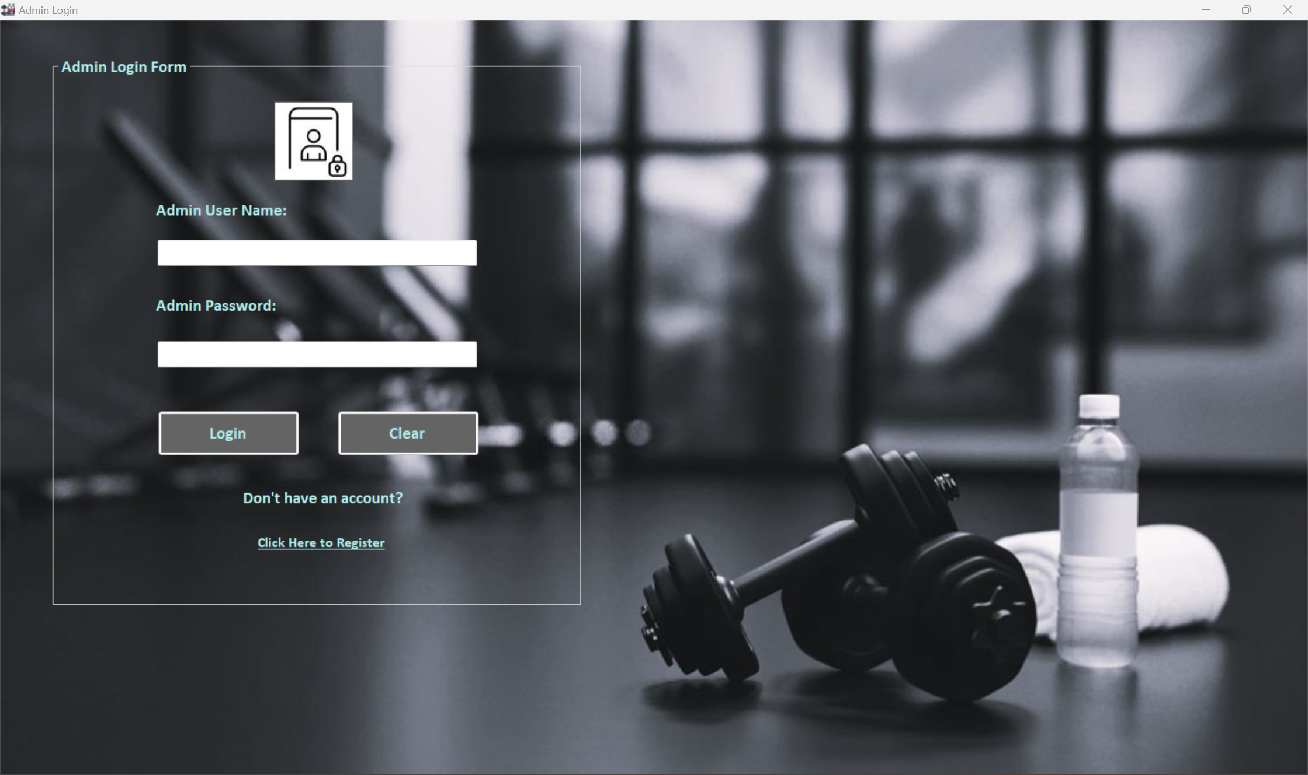

*Figure 1.1.1*

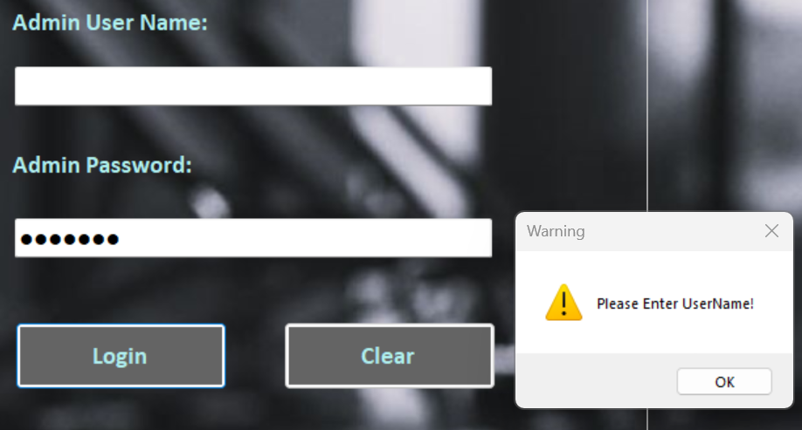 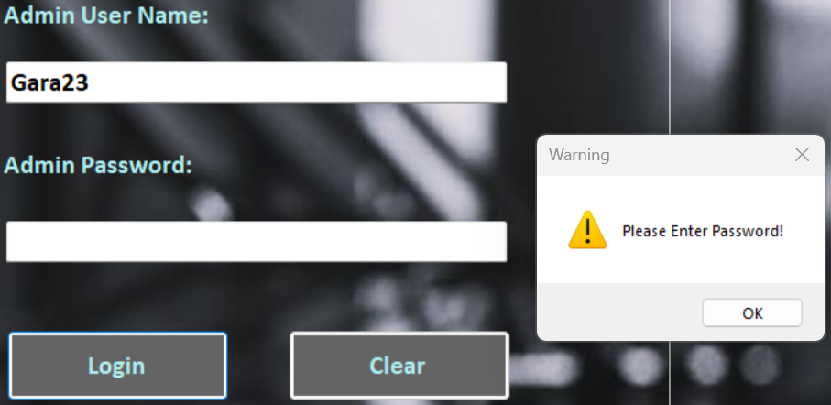

*Figure 1.1.2*

|  |  |
| --- | --- |
| Test Case ID | 1.2 |
| Test Description | Testing Invalid Log-in attempts |
| Test Objective | To verify the error message box is shown and limits the invalid login attempt to 3 times when admin login with incorrect username or password |
| Procedure | 1. Open the admin login form. 2. Fill in the incorrect username or password. 3. Press login button to check whether the error message box appears. |
| Expected Result | If an incorrect username or password is entered and the login button is pressed, an error message box should appear indicating that the login credentials are invalid. |
| Actual Results | The error message box displayed and restricted login attempts after three invalid login attempts. (Figure 1.2.1, Figure 1.2.2) |
| Result Status | Pass |

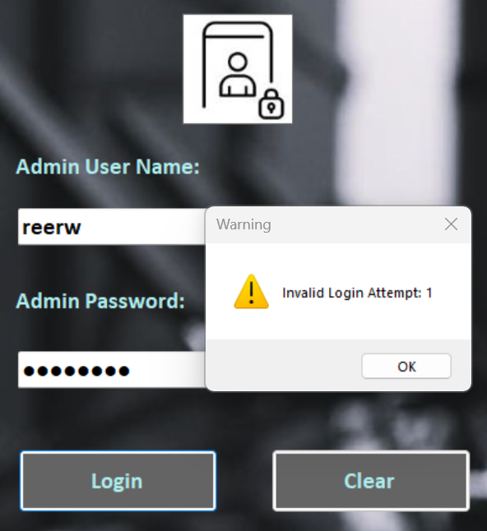 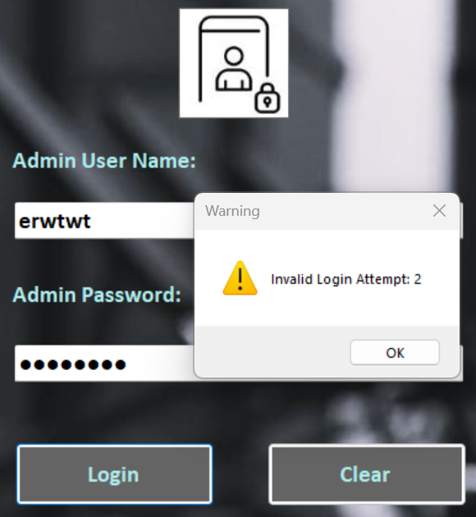

*Figure 1.2.1*

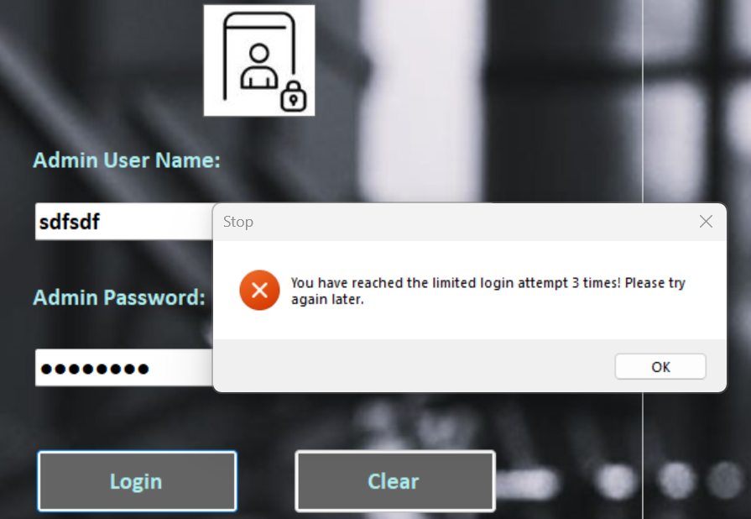

*Figure 1.2.2*

|  |  |
| --- | --- |
| Test Case ID | 1.3 |
| Test Description | Testing Clear Button |
| Test Objective | To check whether the clear button works |
| Procedure | 1. Open the admin login form. 2. Fill in the username or password. 3. Click “Clear” button and see whether the data were removed. |
| Expected Result | Entering a username or password and then clicking the "Clear" button should remove all entered data from the form fields. |
| Actual Results | The username and password were removed upon clicking “Clear” button. (Figure 1.3.1) |
| Result Status | Pass |

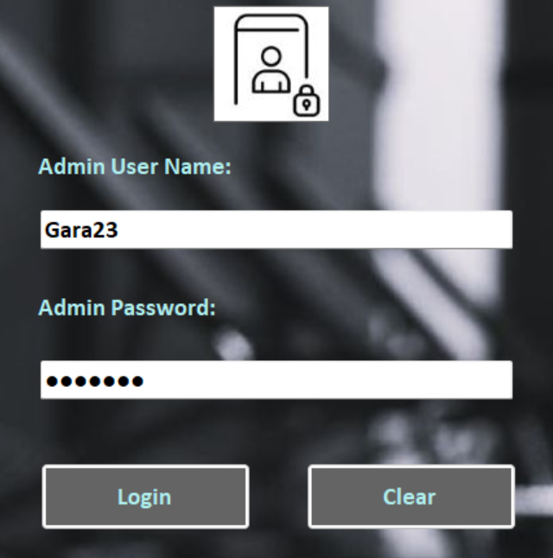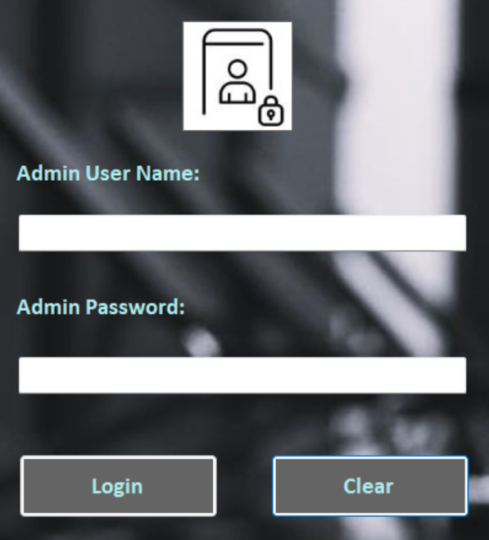

*Figure 1.3.1*

|  |  |
| --- | --- |
| Test Case ID | 1.4 |
| Test Description | Testing Linked Admin Registration Form |
| Test Objective | To check if admin registration for loads correctly upon clicking the link in login form |
| Procedure | 1. Open the admin login form. 2. Click the link “Click Here to Register” |
| Expected Result | Clicking the "Click Here to Register" link should redirect the user to the registration form. |
| Actual Results | The admin registration form loaded without error. (Figure 1.4.1, Figure 1.4.2) |
| Result Status | Pass |

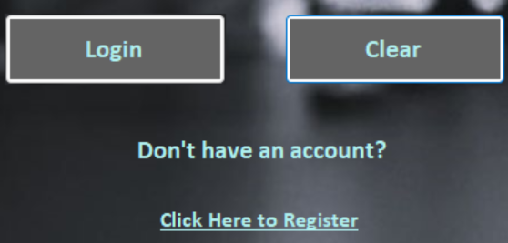

*Figure 1.4.1*

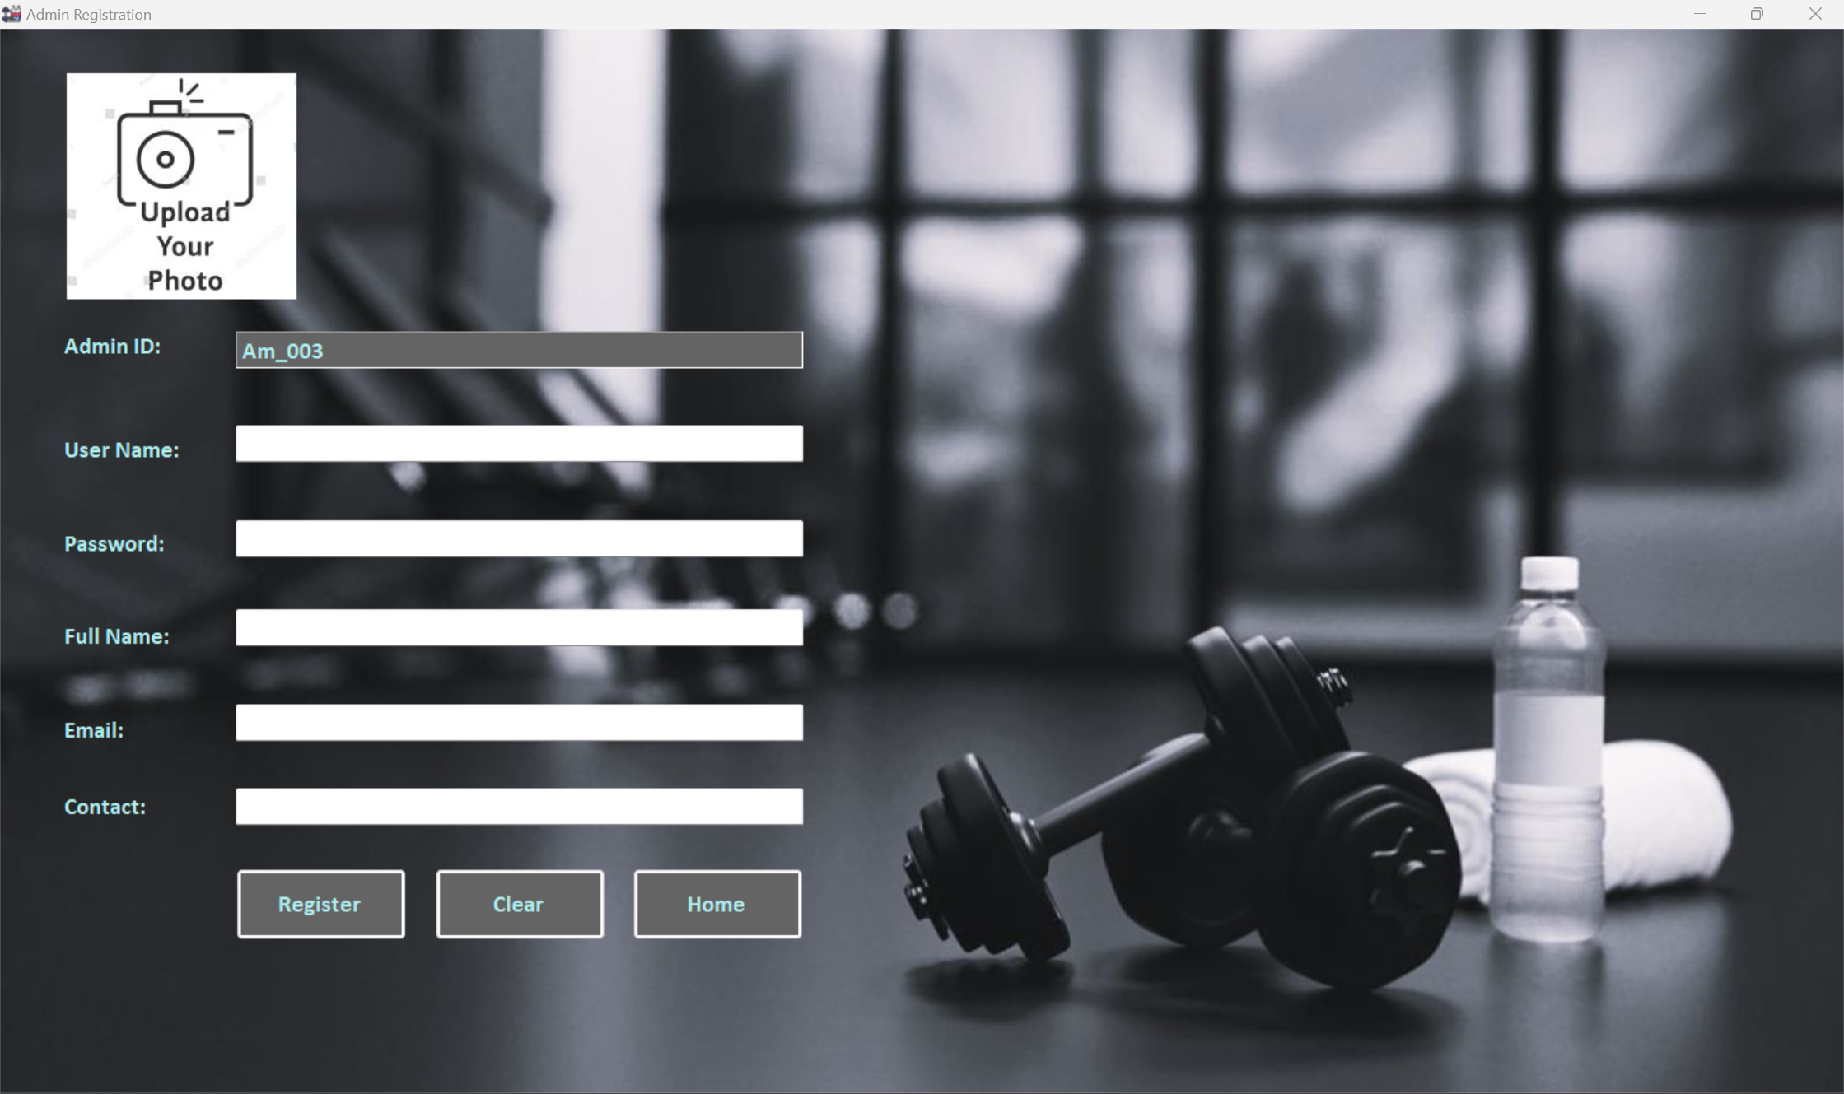

*Figure 1.4.2*

**Unit Testing 2**

**Admin Registration Form**

|  |  |
| --- | --- |
| Test Case ID | 2.1 |
| Test Description | Testing Username Field |
| Test Objective | To check if the error message box appears when the username field is empty, without letters or numbers |
| Procedure | 1. Open the admin registration form. 2. Leave the username field empty or fill in the username without letter or number. |
| Expected Result | Upon clicking the "Register" button, the form should display error message box accordingly. |
| Actual Results | The error message boxes appeared accordingly. (Figure 2.1.1, Figure 2.1.2) |
| Result Status | Pass |

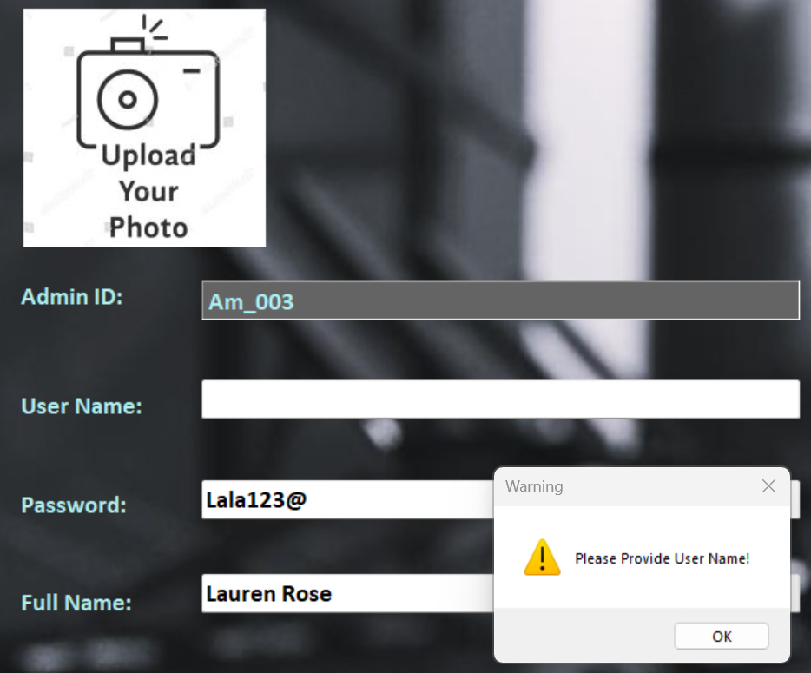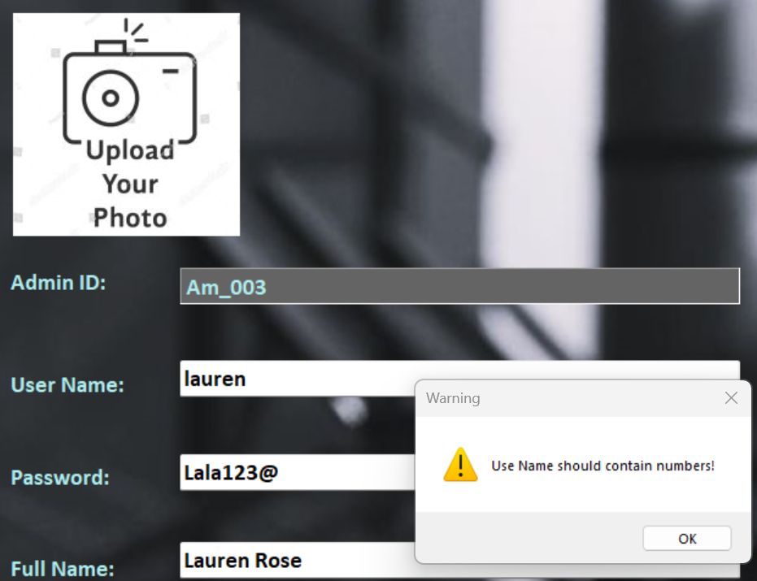

*Figure 2.1.1*

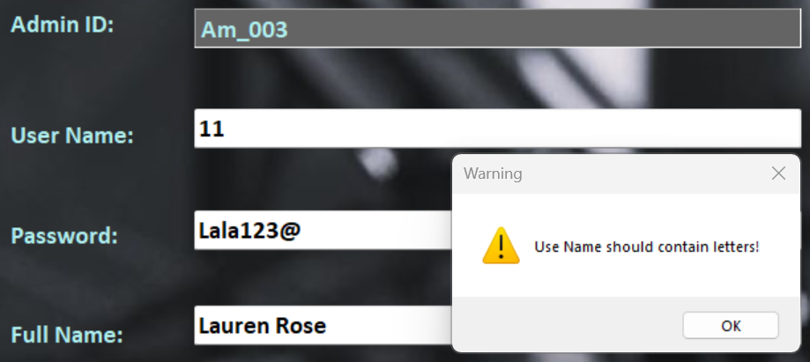

*Figure 2.1.2*

|  |  |
| --- | --- |
| Test Case ID | 2.2 |
| Test Description | Testing Password Field |
| Test Objective | To verify if an error message box appears when the password field is empty, contains no letters or numbers, or lacks uppercase or lowercase letters. |
| Procedure | 1. Open the admin registration form. 2. Leave the password field empty or fill in the password without letter or number, or don’t use uppercase or lowercase letters. |
| Expected Result | When the "Register" button is clicked, the form should display the appropriate error message box. |
| Actual Results | The error message boxes appeared as expected. (Figure 2.2.1, Figure 2.2.2) |
| Result Status | Pass |

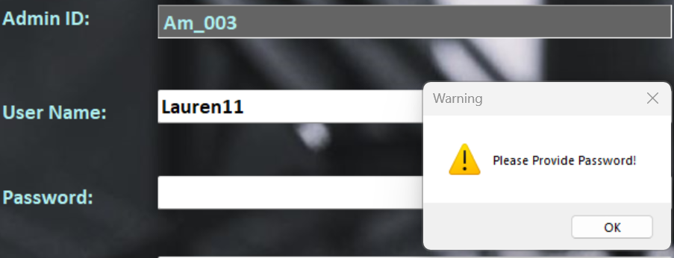 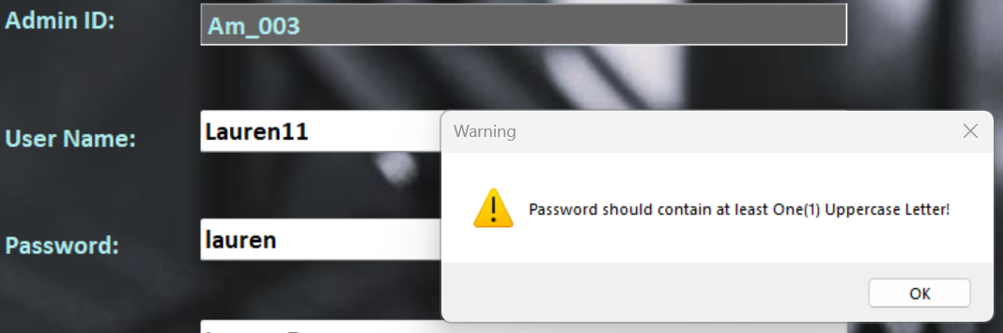

*Figure 2.2.1*

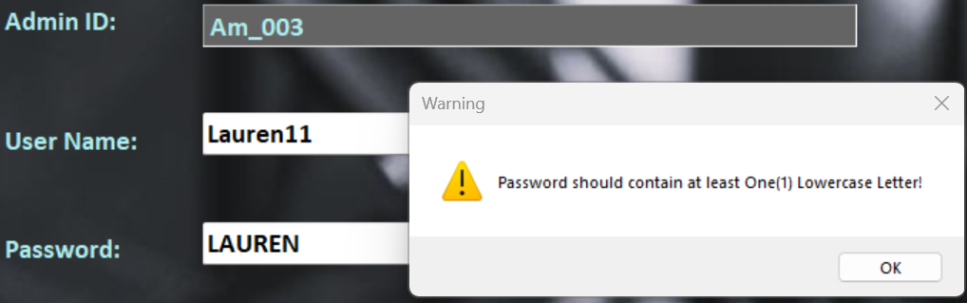 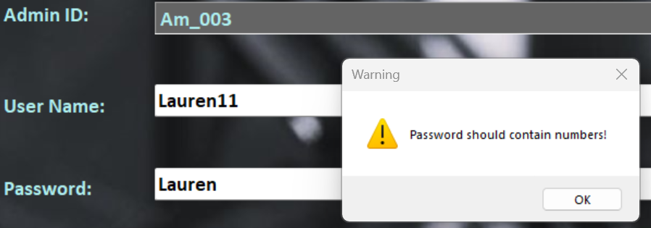

*Figure 2.2.2*

|  |  |
| --- | --- |
| Test Case ID | 2.3 |
| Test Description | Testing Full Name, Email and Contact Fields |
| Test Objective | To verify if an error message box appears when the Full Name, Email or Contact Field is empty. |
| Procedure | 1. Leave the Full Name, Email or Contact field empty and click “Register” button. |
| Expected Result | When the "Register" button is clicked, the form should show the corresponding error message box. |
| Actual Results | The error message boxes showed up as anticipated. (Figure 2.3.1, Figure 2.3.2) |
| Result Status | Pass |

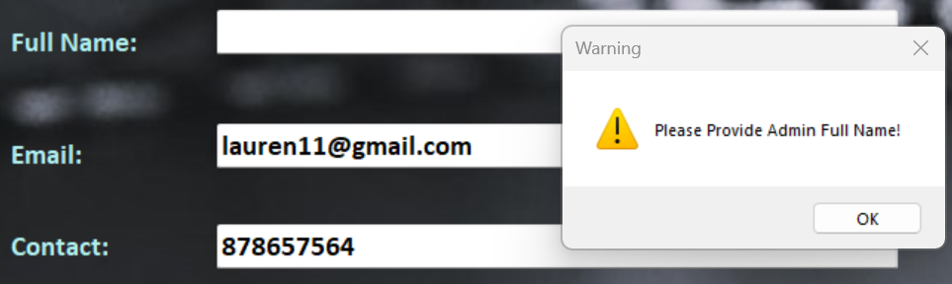 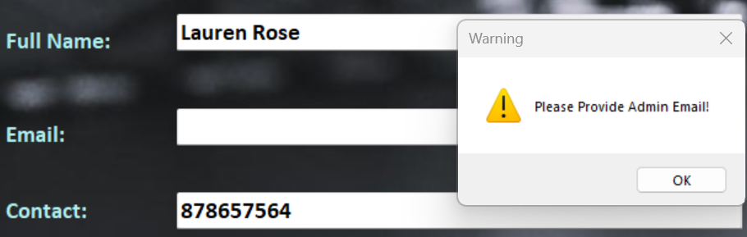

*Figure 2.3.1*

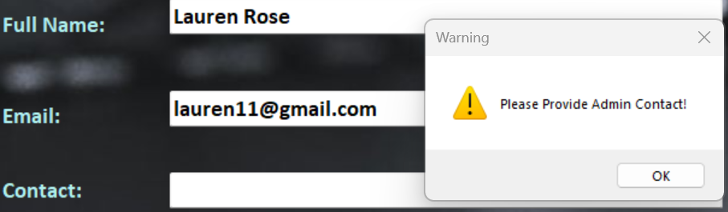

*Figure 2.3.2*

|  |  |
| --- | --- |
| Test Case ID | 2.4 |
| Test Description | Testing Empty Profile Photo |
| Test Objective | To verify if an error message box appears when admin didn’t upload photo. |
| Procedure | 1. Leave the profile photo empty and click “Register” button. |
| Expected Result | When the "Register" button is clicked, the form should show the error message box to input image. |
| Actual Results | The error message boxes appeared as predicted. (Figure 2.4.1) |
| Result Status | Pass |

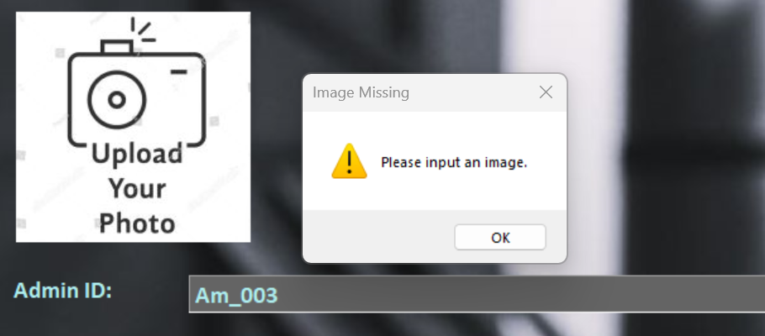

*Figure 2.4.1*

|  |  |
| --- | --- |
| Test Case ID | 2.5 |
| Test Description | Testing Admin Registration: |
| Test Objective | To test if the admin registration form loads successfully |
| Procedure | 1. Leave the profile photo empty and click “Register” button. |
| Expected Result | When the "Register" button is clicked, the form should show the error message box to input image. |
| Actual Results | The error message boxes appeared as predicted. (Figure 2.5.1) |
| Result Status | Pass |

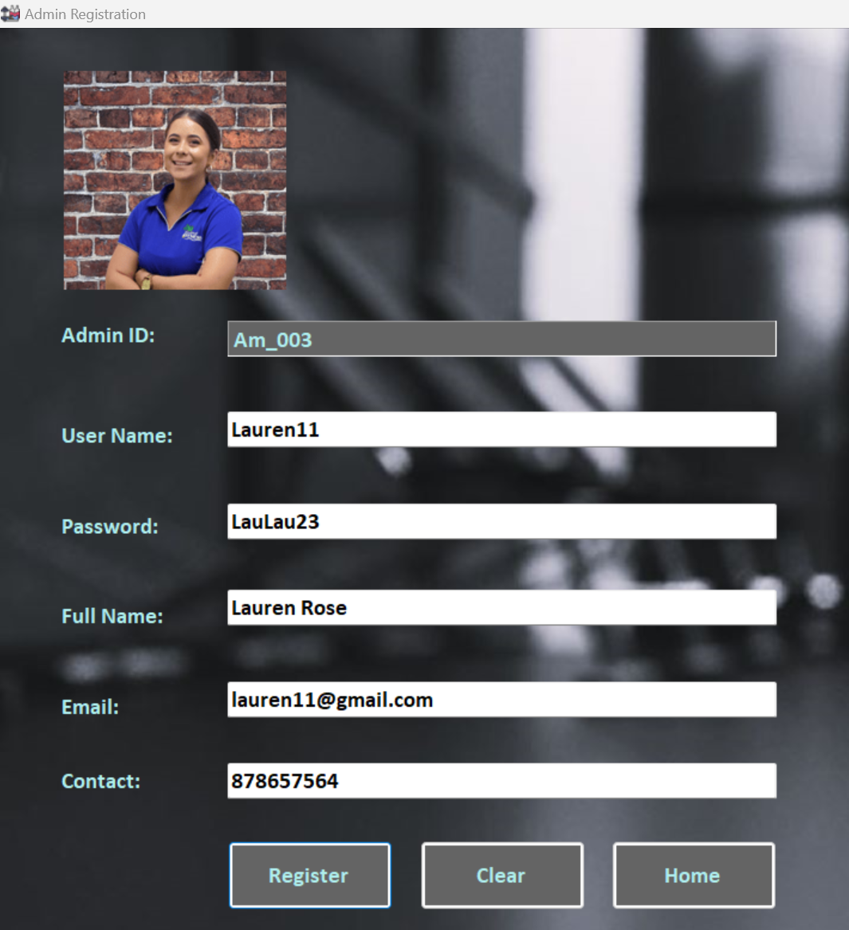 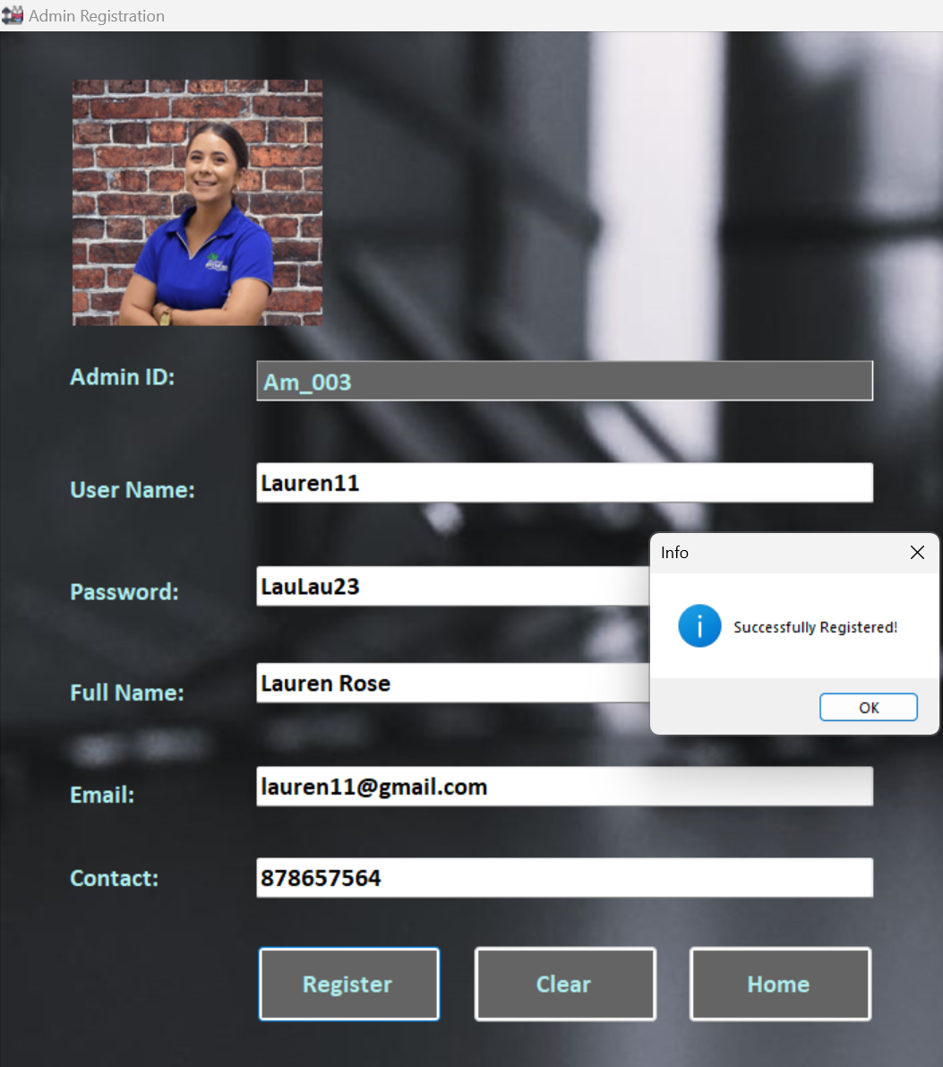

*Figure 2.5.1*

|  |  |
| --- | --- |
| Test Case ID | 2.6 |
| Test Description | Testing AdminID |
| Test Objective | To test if the Admin ID increments when the new registration is successful. |
| Procedure | 1. Reopen the admin registration form and see whether the Admin ID increases or not. |
| Expected Result | Upon reopening the admin registration form, the Admin ID should incrementally increase, reflecting the addition of a new admin registration. |
| Actual Results | The Admin ID incrementally increases. (Figure 2.6.1) |
| Result Status | Pass |

 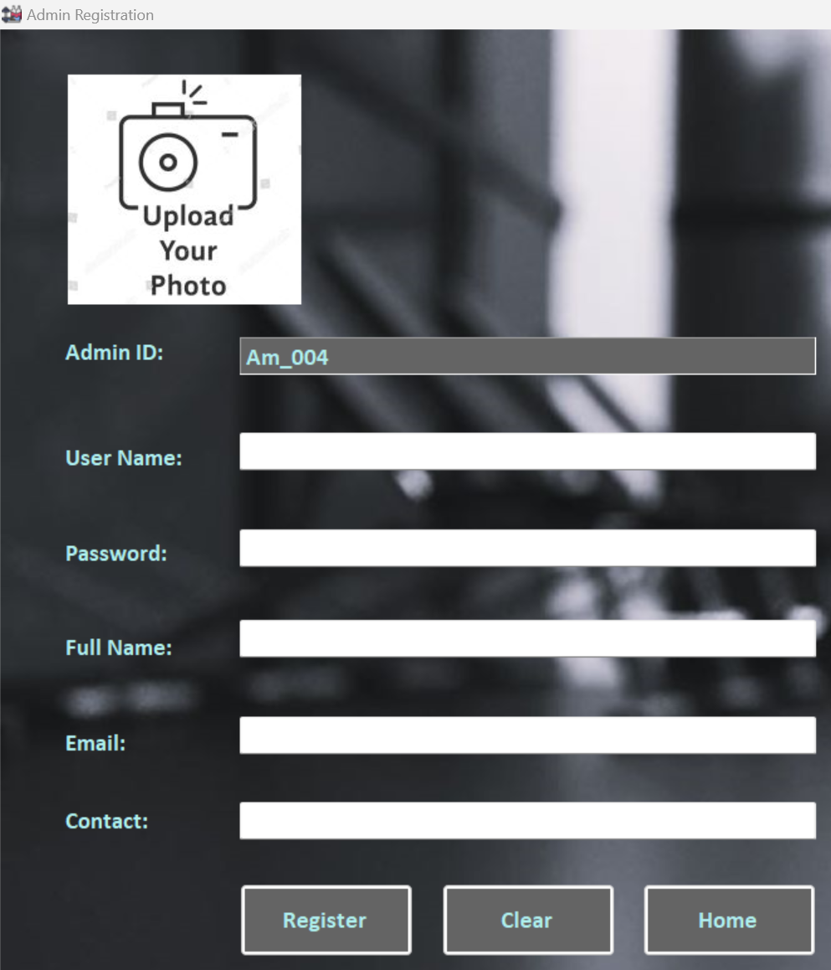

*Figure 2.6.1*

**Unit Testing 3**

**Member Login Form**

|  |  |
| --- | --- |
| Test Case ID | 3.1 |
| Test Description | Testing empty Username and Password Login: |
| Test Objective | To test if the Member Login form responds error message box |
| Procedure | 1. Open the member login form. 2. Leave username or password field empty. 3. Press login button to check whether the error message box appears. |
| Expected Result | An error message box should appear for empty username or password field. |
| Actual Results | The error message box shows (Figure 3.1.1, Figure 3.1.2) |
| Result Status | Pass |

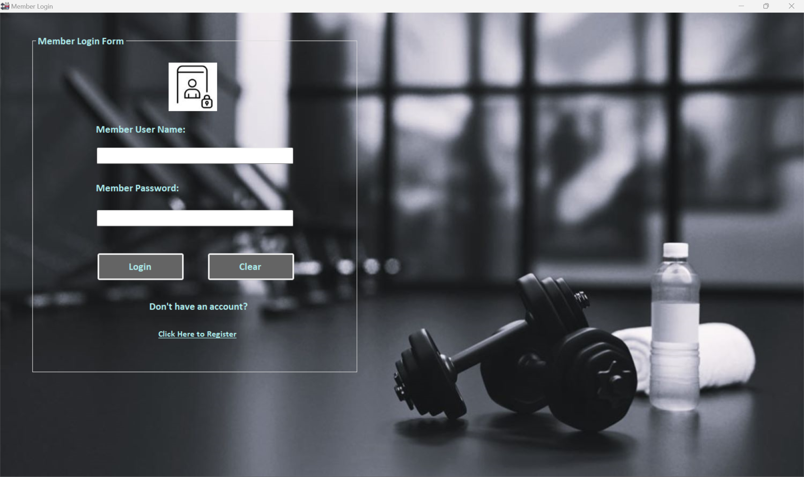

*Figure 3.1.1*

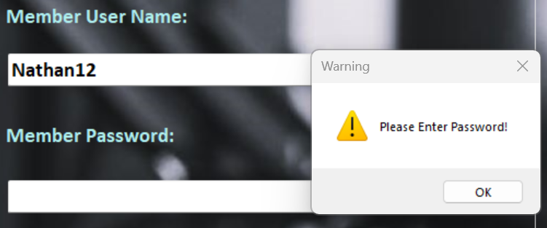 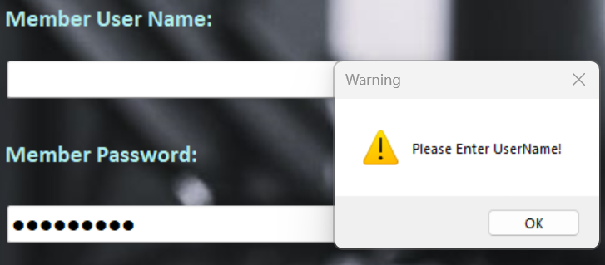

*Figure 3.1.2*

|  |  |
| --- | --- |
| Test Case ID | 3.2 |
| Test Description | Testing Invalid Log-in attempts: |
| Test Objective | To test if the Member Login form accepts invalid login |
| Procedure | 1. Fil in wrong username of password up to 3 times. 2. Press login button. |
| Expected Result | Error message should appear indicating that the credentials are incorrect. |
| Actual Results | Figure 3.2.1, Figure 3.2.2 |
| Result Status | Pass |

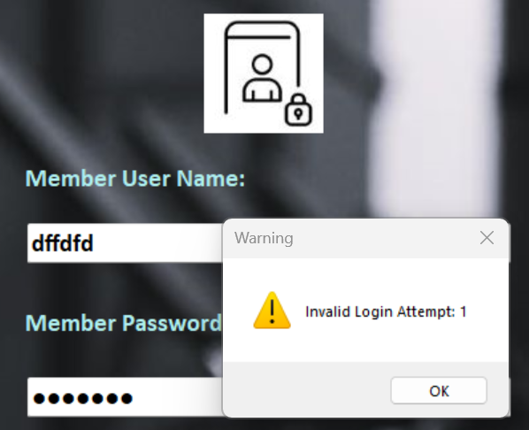 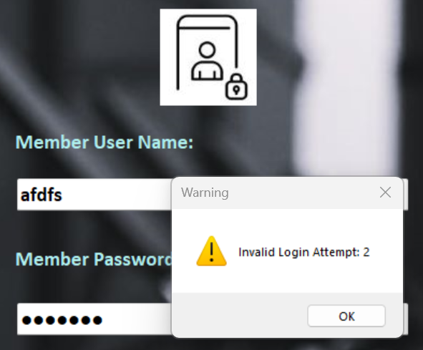

*Figure 3.2.1*

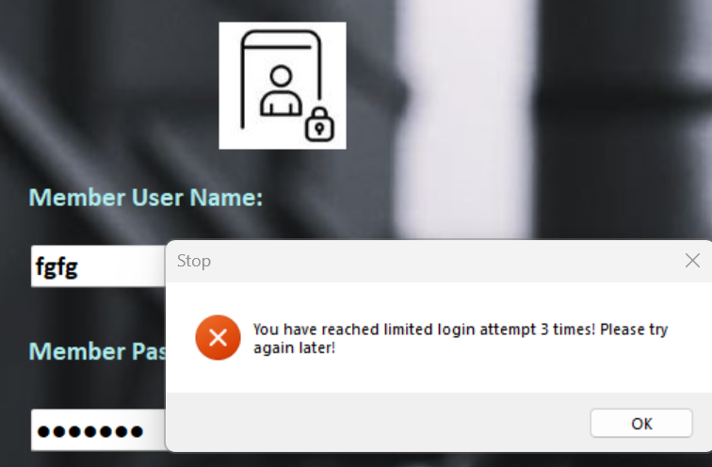

*Figure 3.2.2*

|  |  |
| --- | --- |
| Test Case ID | 3.3 |
| Test Description | Testing Clear Button |
| Test Objective | To test whether clear button works correctly |
| Procedure | 1. Fil in username of password. 2. Press clear button. |
| Expected Result | The input details should disappear. |
| Actual Results | The login details were removed. Figure 3.3.1 |
| Result Status | Pass |

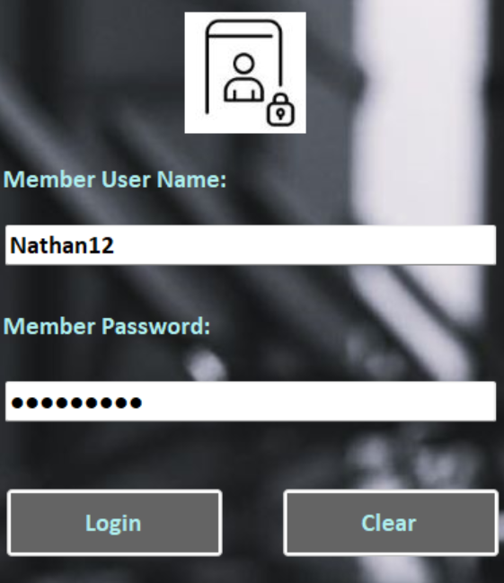 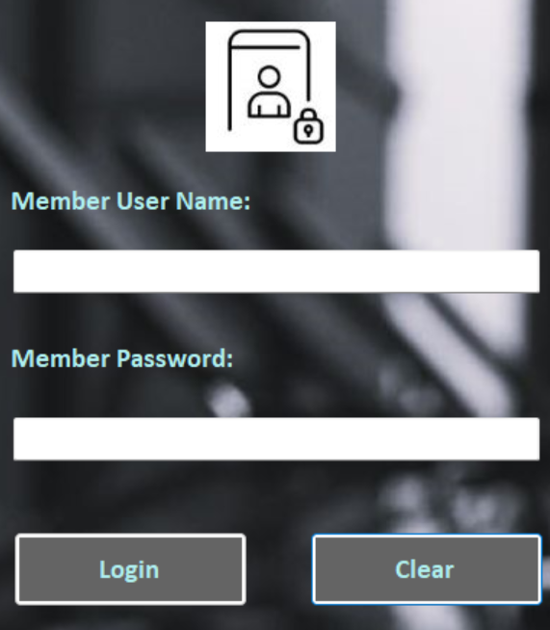

*Figure 3.3.1*

|  |  |
| --- | --- |
| Test Case ID | 3.4 |
| Test Description | Testing Linked Member Registration Form |
| Test Objective | To test whether the registration link works correctly |
| Procedure | 1. Open the member login form. 2. Click “Click Here to Register” link. |
| Expected Result | It should navigate to member registration form. |
| Actual Results | The member registration form loaded. Figure 3.4.1 |
| Result Status | Pass |

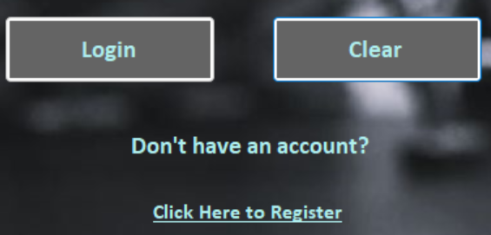

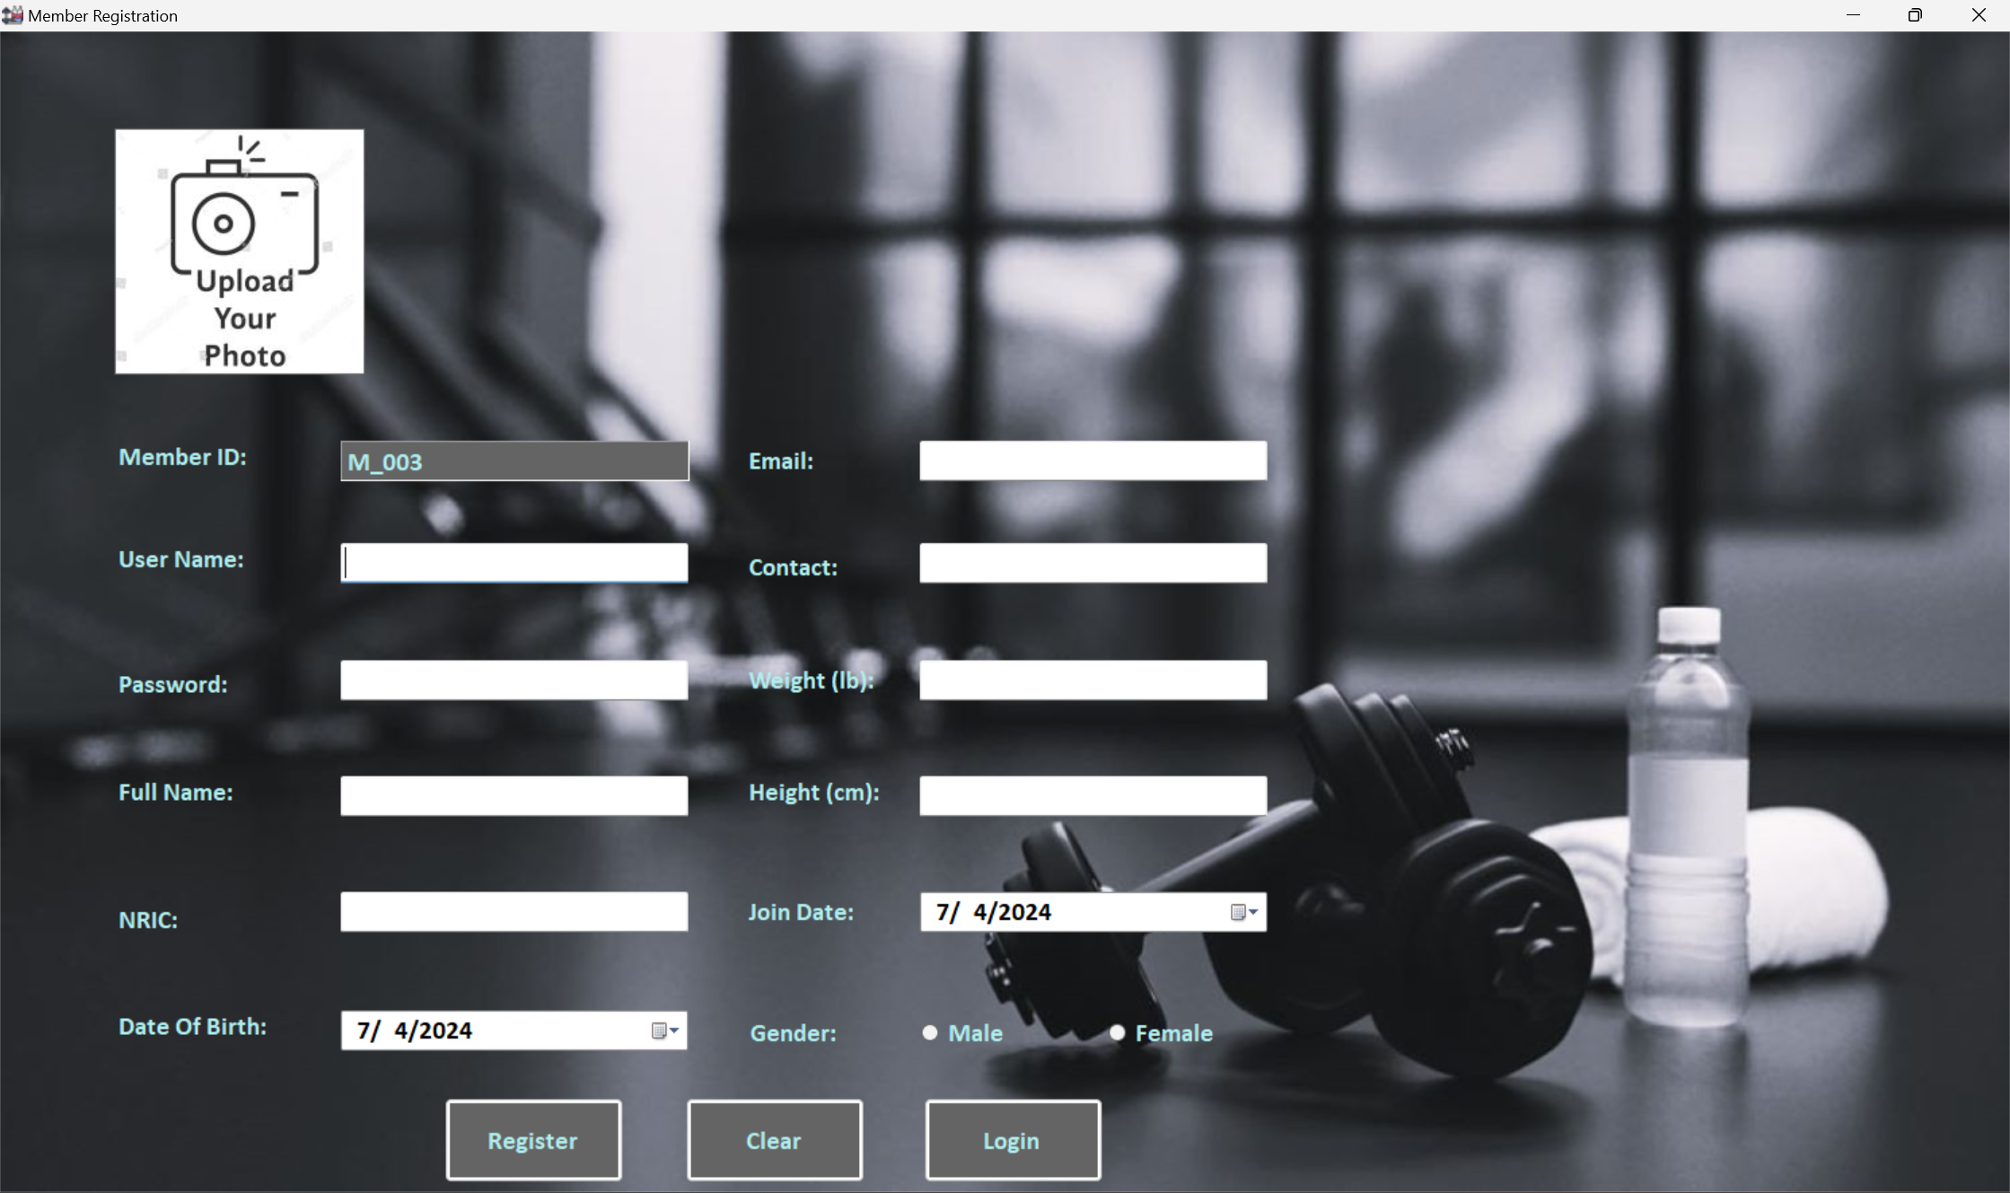

*Figure 3.4.1*

**Unit Testing 4**

**Member Registration Form**

|  |  |
| --- | --- |
| Test Case ID | 4.1 |
| Test Description | Testing Username Field |
| Test Objective | To check whether the registration form shows error message box |
| Procedure | 1. Leave username field empty or without letters or numbers. 2. Click “Register” button. |
| Expected Result | Error message boxes should appear accordingly. |
| Actual Results | See Figure 4.1.1, Figure 4.1.2 |
| Result Status | Pass |

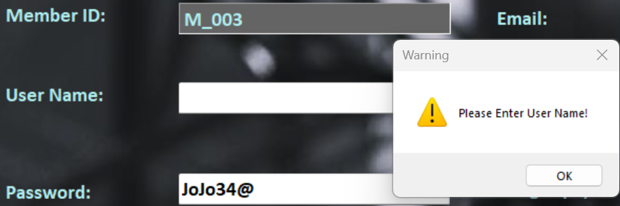 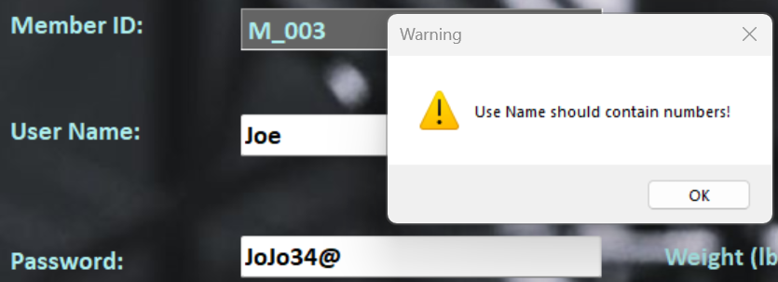

*Figure 4.1.1*

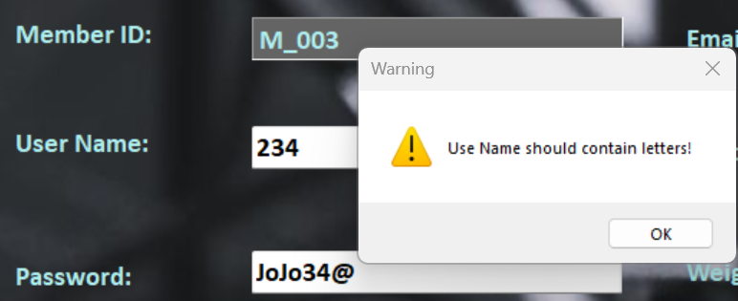

*Figure 4.1.2*

|  |  |
| --- | --- |
| Test Case ID | 4.2 |
| Test Description | Testing Password Field |
| Test Objective | To check password constraints for member registration. |
| Procedure | 1. Leave the password field empty or enter a password with less than 6 or more than 12 characters. And click “Register” button. |
| Expected Result | Error message boxes should appear accordingly. |
| Actual Results | See Figure 4.2.1, Figure 4.2.2, Figure 4.2.3 |
| Result Status | Pass |

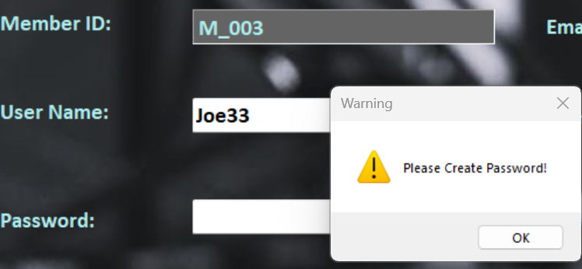 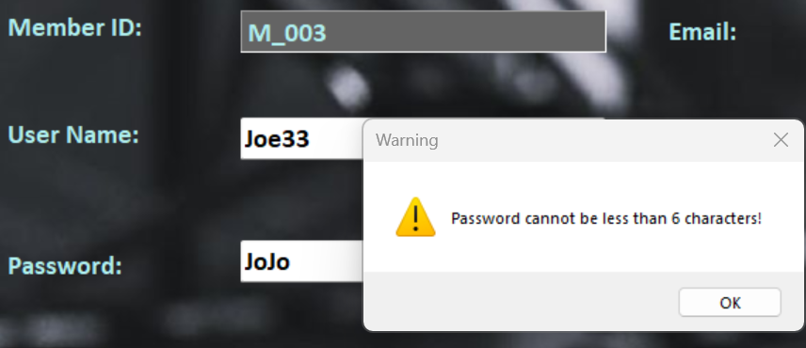

*Figure 4.2.1*

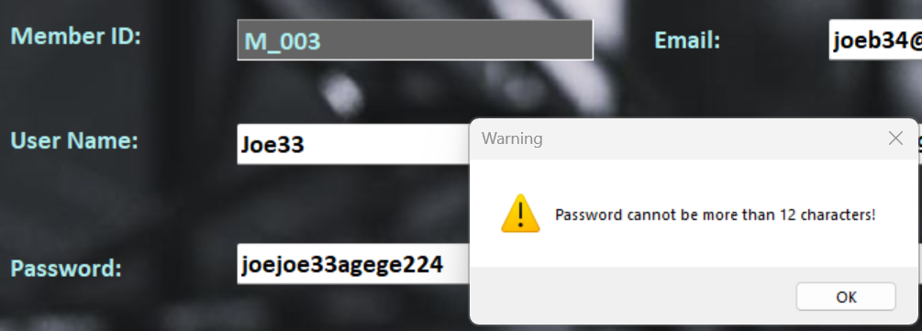 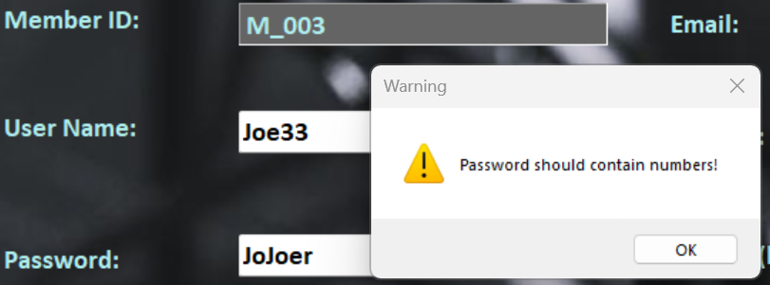

*Figure 4.2.2*

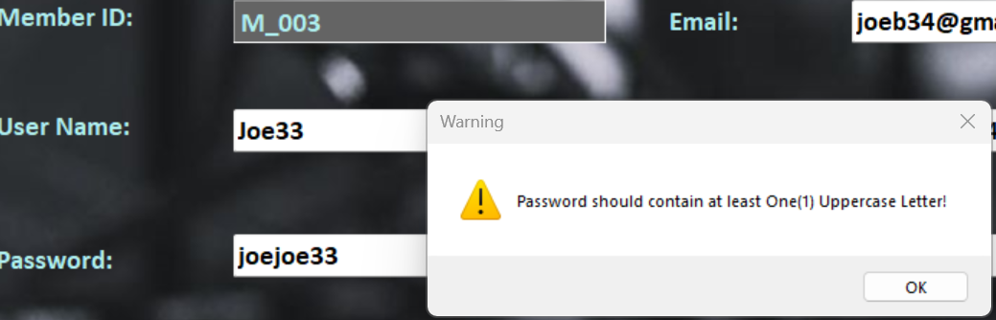 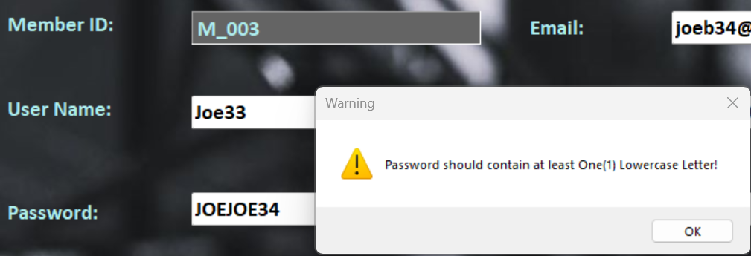

*Figure 4.2.3*

|  |  |
| --- | --- |
| Test Case ID | 4.3 |
| Test Description | Testing Full Name, Email and NRIC Fields |
| Test Objective | To verify error message box for the below empty fields. |
| Procedure | 1. Leave the Full Name, Email and NRIC fields empty and click “Register” button. |
| Expected Result | Error message boxes should appear accordingly for empty data. |
| Actual Results | See Figure 4.3.1, Figure 4.3.2 |
| Result Status | Pass |

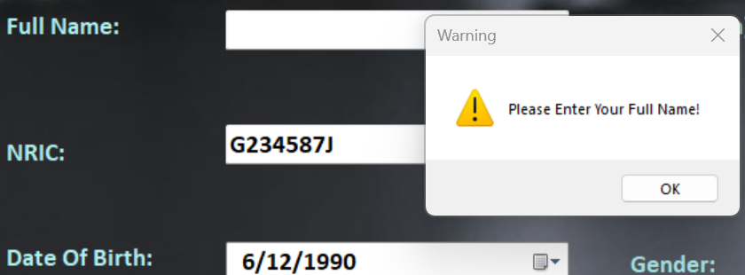 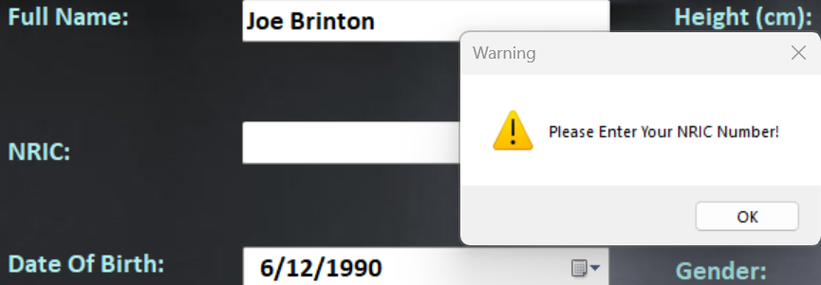

*Figure 4.3.1*

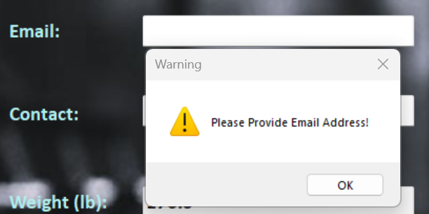

*Figure 4.3.2*

|  |  |
| --- | --- |
| Test Case ID | 4.4 |
| Test Description | Testing Age Constraints and Contact Field |
| Test Objective | To verify whether the error message box appears age constraint between 18 and 40 and empty contact field. |
| Procedure | 1. Fill in the date of birth out of age 18 to 40 or leave the contact field empty. |
| Expected Result | Error message boxes should appear accordingly. |
| Actual Results | The error message shows. See Figure 4.4.1, Figure 4.4.2, Figure 4.4.3 |
| Result Status | Pass |

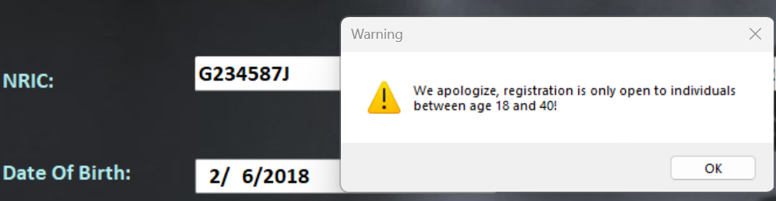

*Figure 4.4.1*

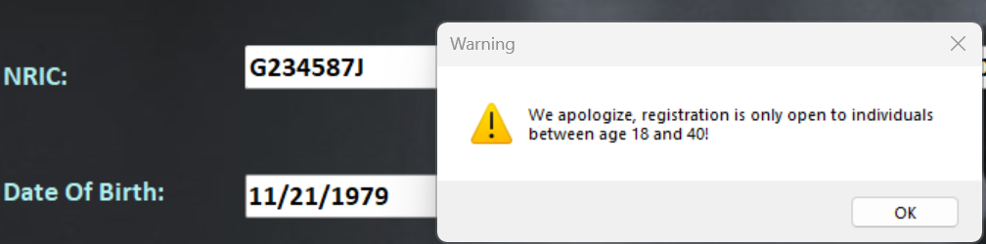

*Figure 4.4.2*

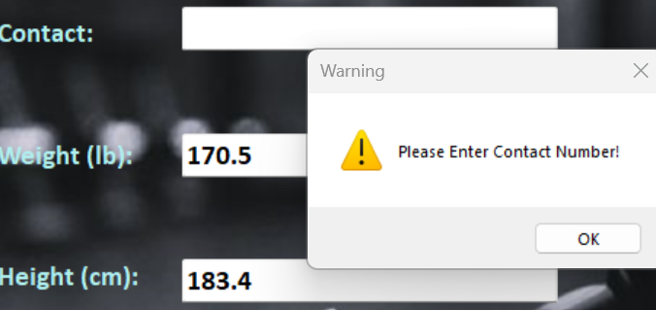

*Figure 4.4.3*

|  |  |
| --- | --- |
| Test Case ID | 4.5 |
| Test Description | Testing Weight Constraints |
| Test Objective | To check if the error message box shows accordingly. |
| Procedure | 1. Leave weight field empty or input letters or input weight out of range between 45lb and 600lb and click “Register” button. |
| Expected Result | Error message boxes should appear accordingly for each weight constraint. |
| Actual Results | See Figure 4.5.1, Figure 4.5.2 |
| Result Status | Pass |

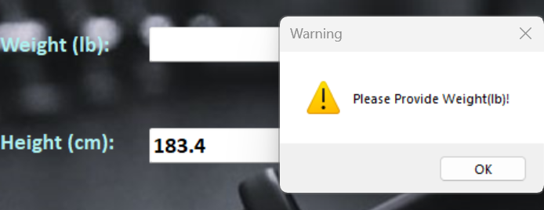 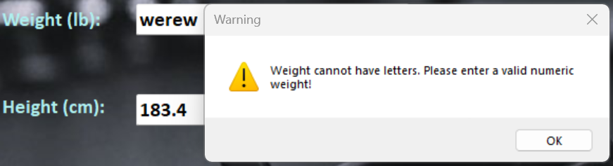

*Figure 4.6.1*

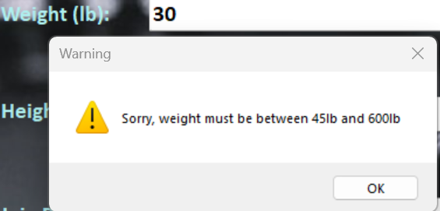 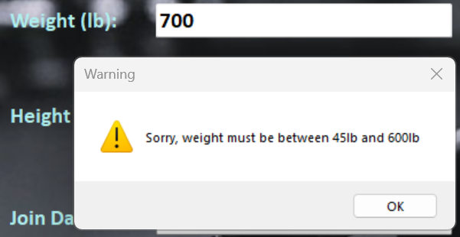

*Figure 4.6.2*

|  |  |
| --- | --- |
| Test Case ID | 4.6 |
| Test Description | Testing Height Constraints |
| Test Objective | To check if the error message box shows accordingly. |
| Procedure | 1. Leave height field empty or input letters or input height out of range between 120cm and 200cm and click “Register” button. |
| Expected Result | Error message boxes should show for each height constraint. |
| Actual Results | See Figure 4.6.1, Figure 4.6.2 |
| Result Status | Pass |

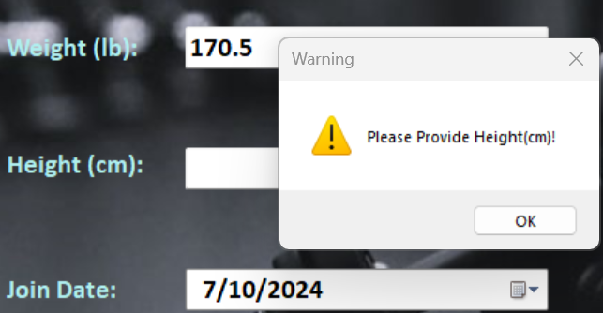 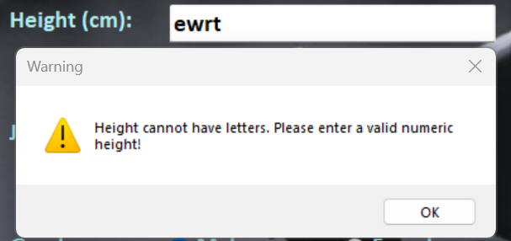

*Figure 4.6.1*

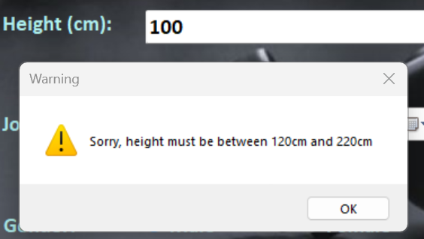 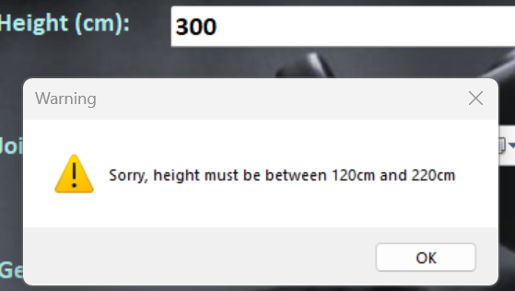

*Figure 4.6.2*

|  |  |
| --- | --- |
| Test Case ID | 4.7 |
| Test Description | Testing Image and Gender Fields: |
| Test Objective | Testing Image and Gender Fields: |
| Procedure | 1. Leave Gender radio button unchecked or leave input image empty and click “Register” button. |
| Expected Result | Error message boxes should show accordingly. |
| Actual Results | See Figure 4.7.1 |
| Result Status | Pass |

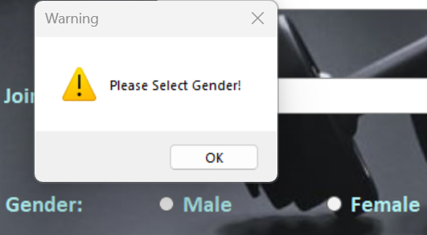 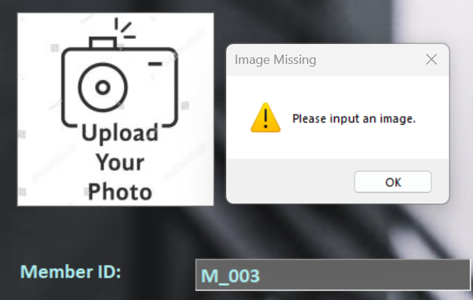

*Figure 4.7.1*

|  |  |
| --- | --- |
| Test Case ID | 4.8 |
| Test Description | Testing Member Registration: |
| Test Objective | To test if the registration process is successful or fail |
| Procedure | 1. Fill in all the required information and click “Register” button. |
| Expected Result | Registration should be successful, and a message box should appear. |
| Actual Results | Successfully added new member See Figure 4.8.1 |
| Result Status | Pass |

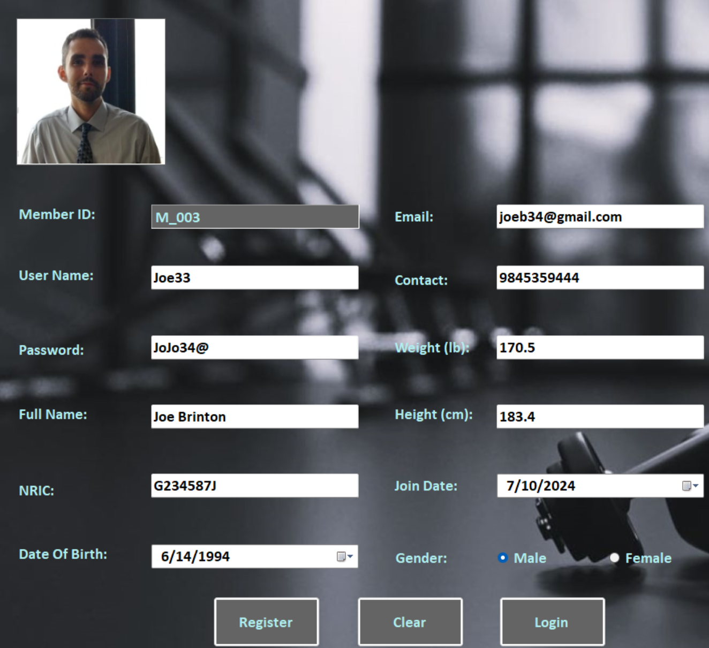 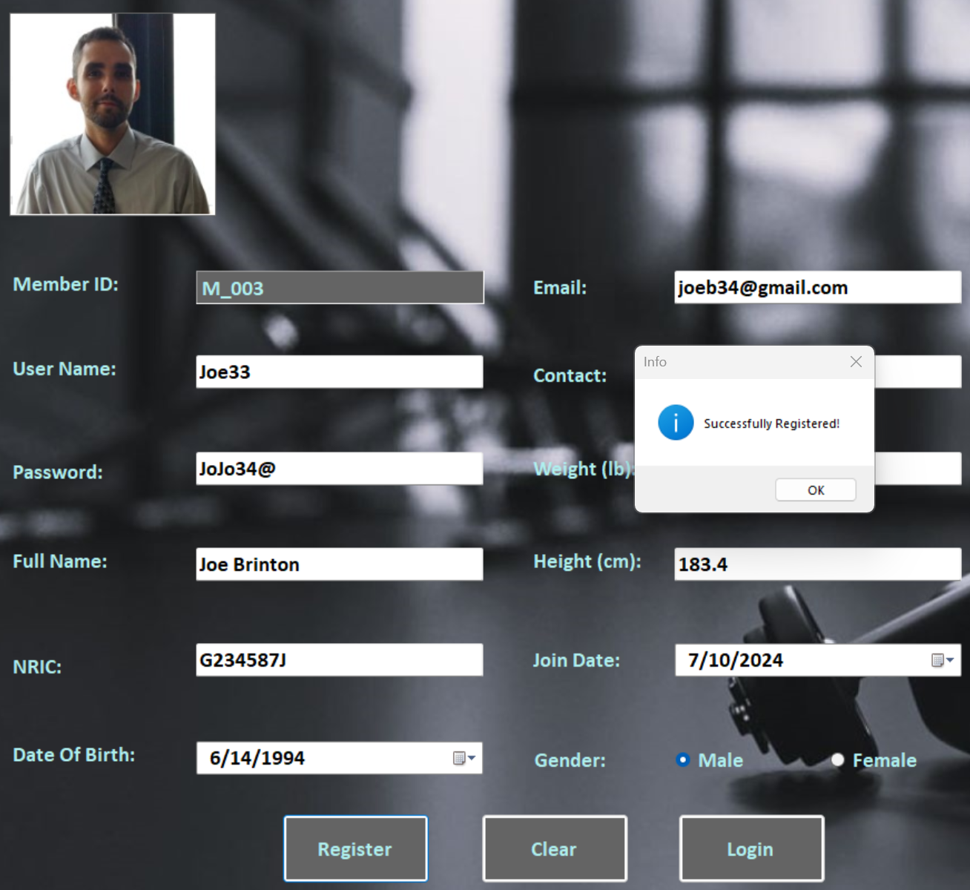

*Figure 4.8.1*

**Unit Testing 5**

**Member Homepage Form**

|  |  |
| --- | --- |
| Test Case ID | 5.1 |
| Test Description | Testing Member Homepage |
| Test Objective | To test if the member homepage loads after successful login |
| Procedure | 1. Fill in member login details and click “login” button. |
| Expected Result | Homepage loaded successfully displaying correct member information. |
| Actual Results | See Figure 5.1.1, Figure 5.1.2 |
| Result Status | Pass |

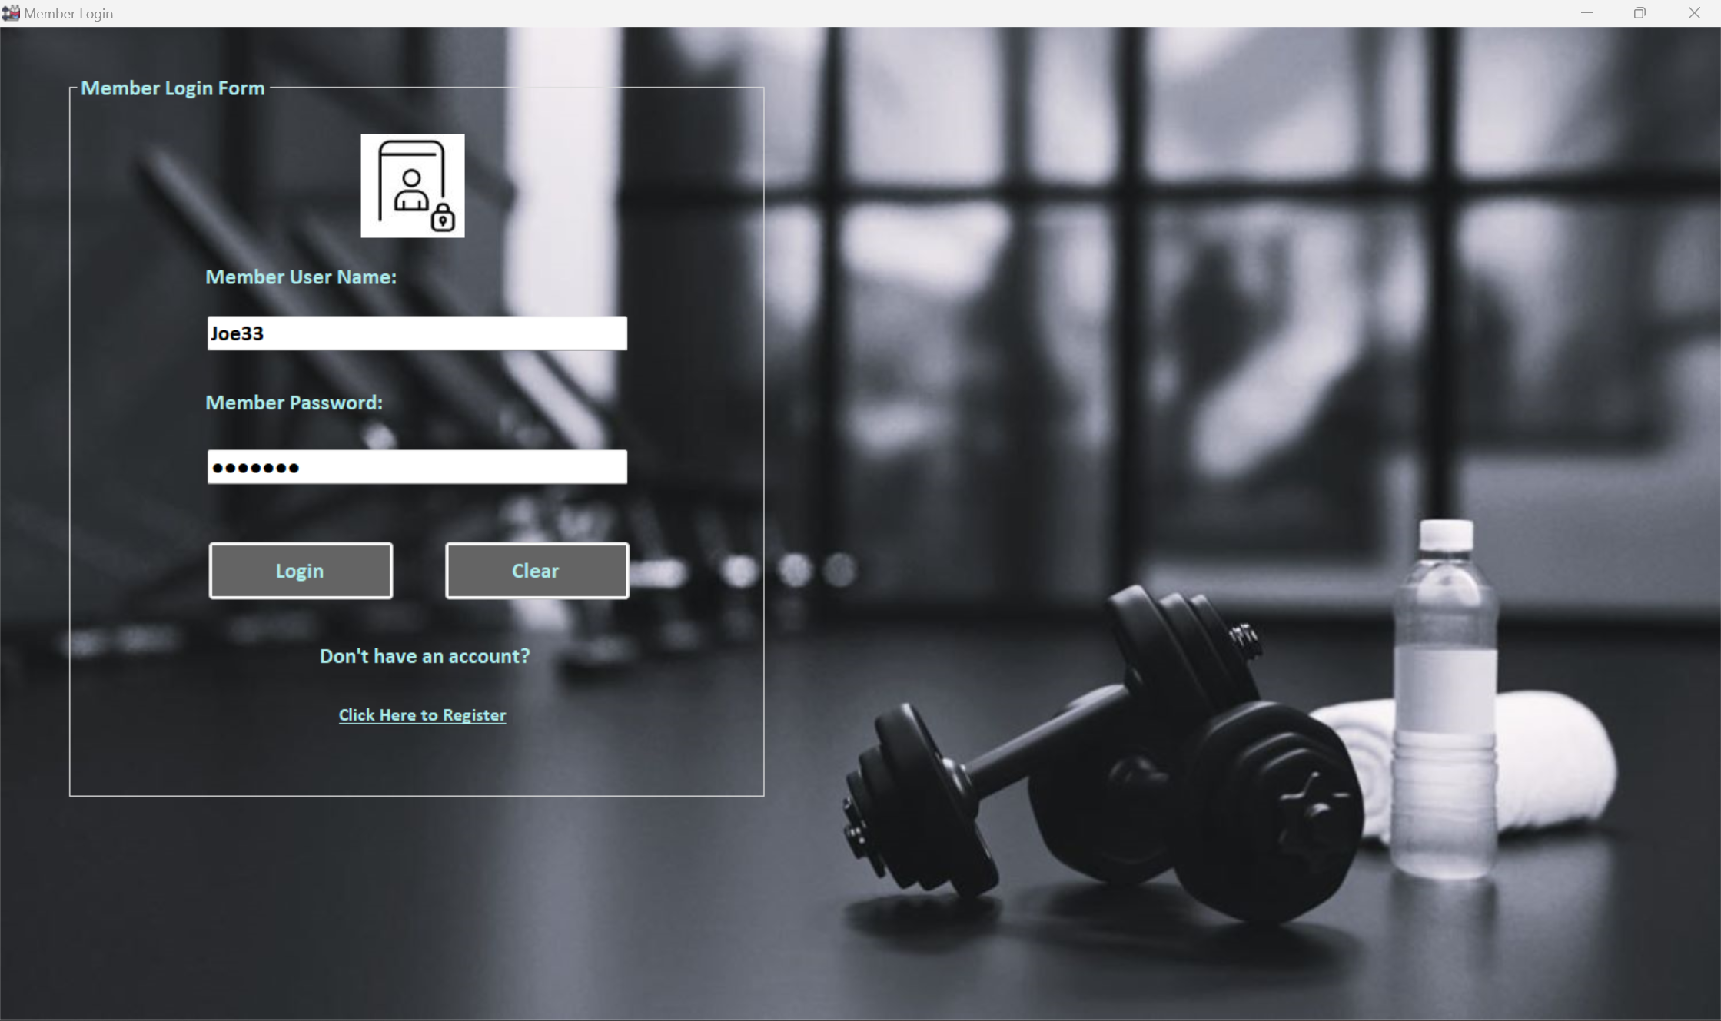

*Figure 5.1.1*

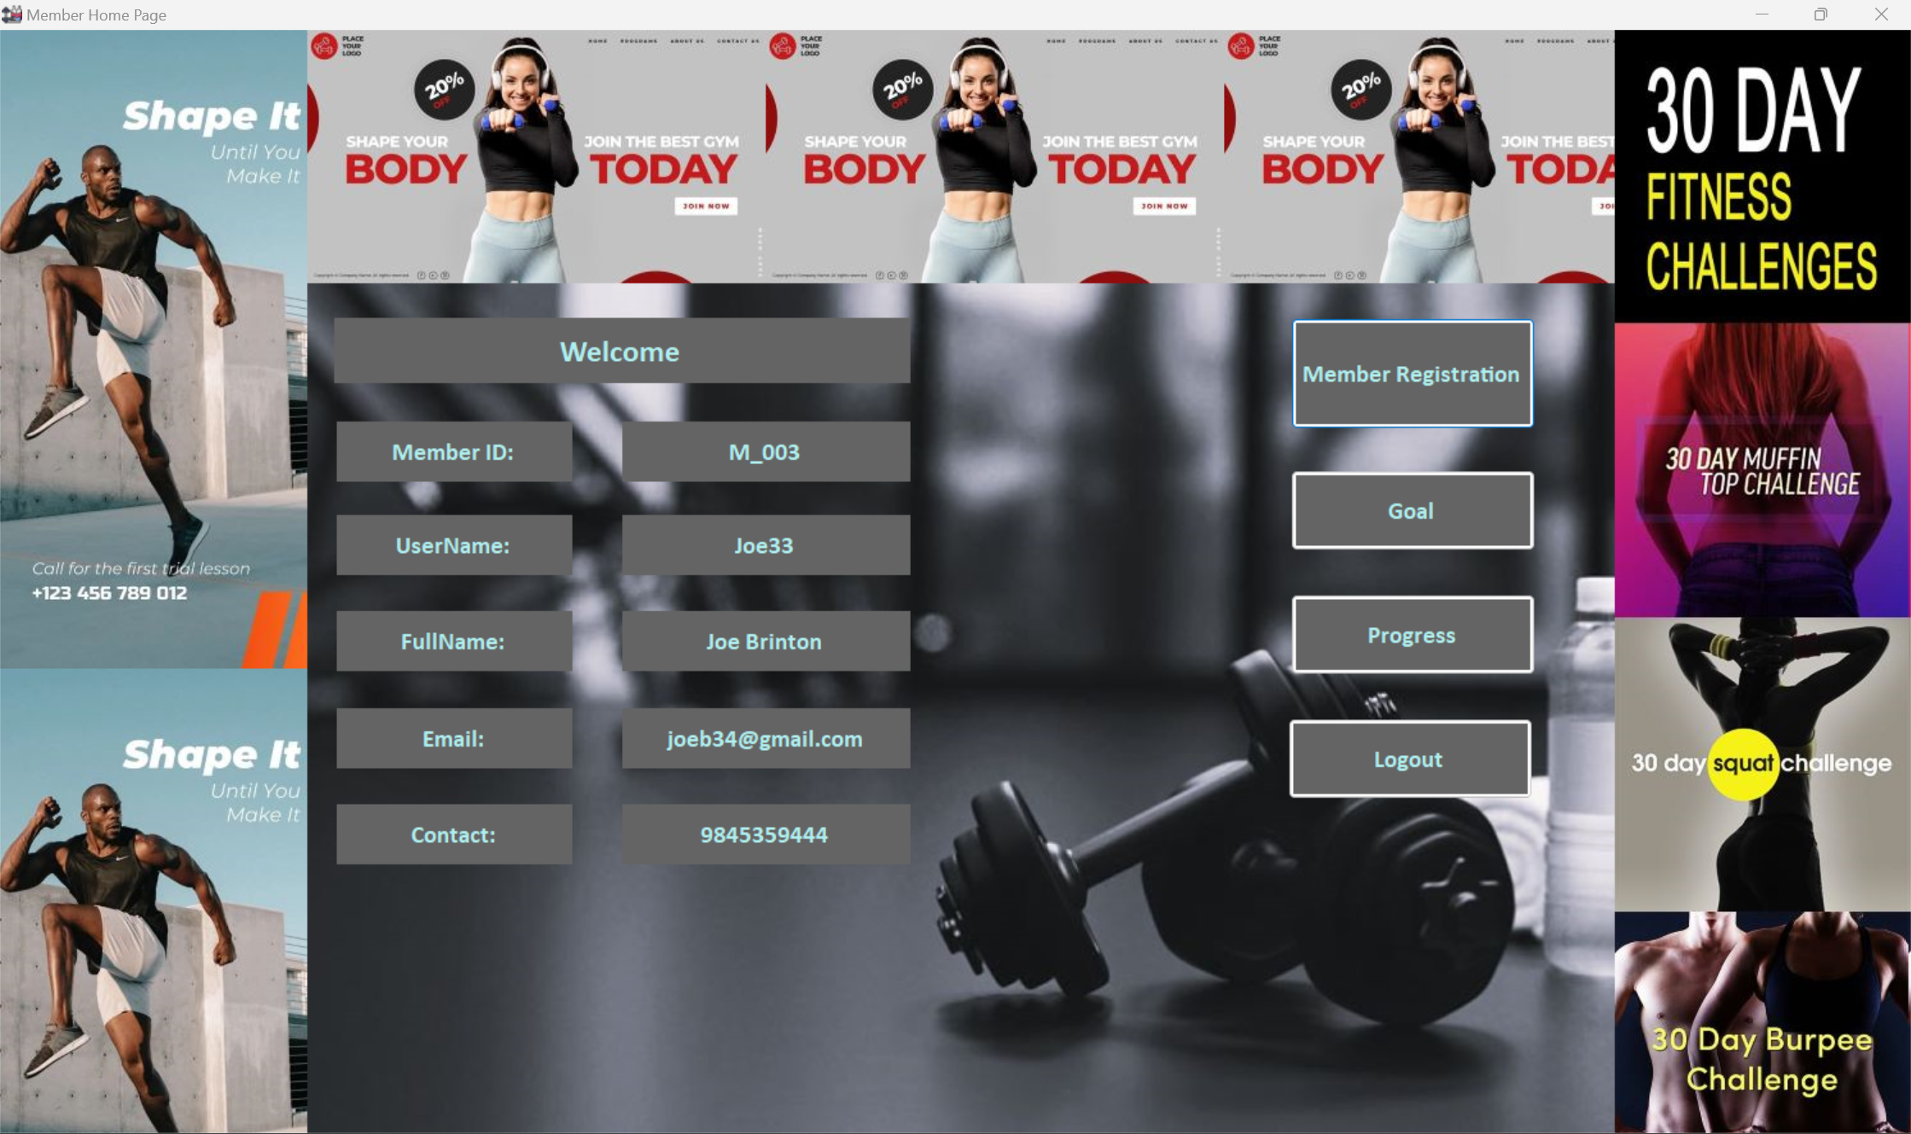

*Figure 5.1.2*

|  |  |
| --- | --- |
| Test Case ID | 5.2 |
| Test Description | Testing Member Registration button and ID increment |
| Test Objective | To check if the “Member Registration” button navigates to registration form and the Member ID increases. |
| Procedure | 1. Fill in member login details and click “login” button. |
| Expected Result | Member Homepage should appear. |
| Actual Results | The registration loaded with increased Member ID. See Figure 5.2.1 |
| Result Status | Pass |

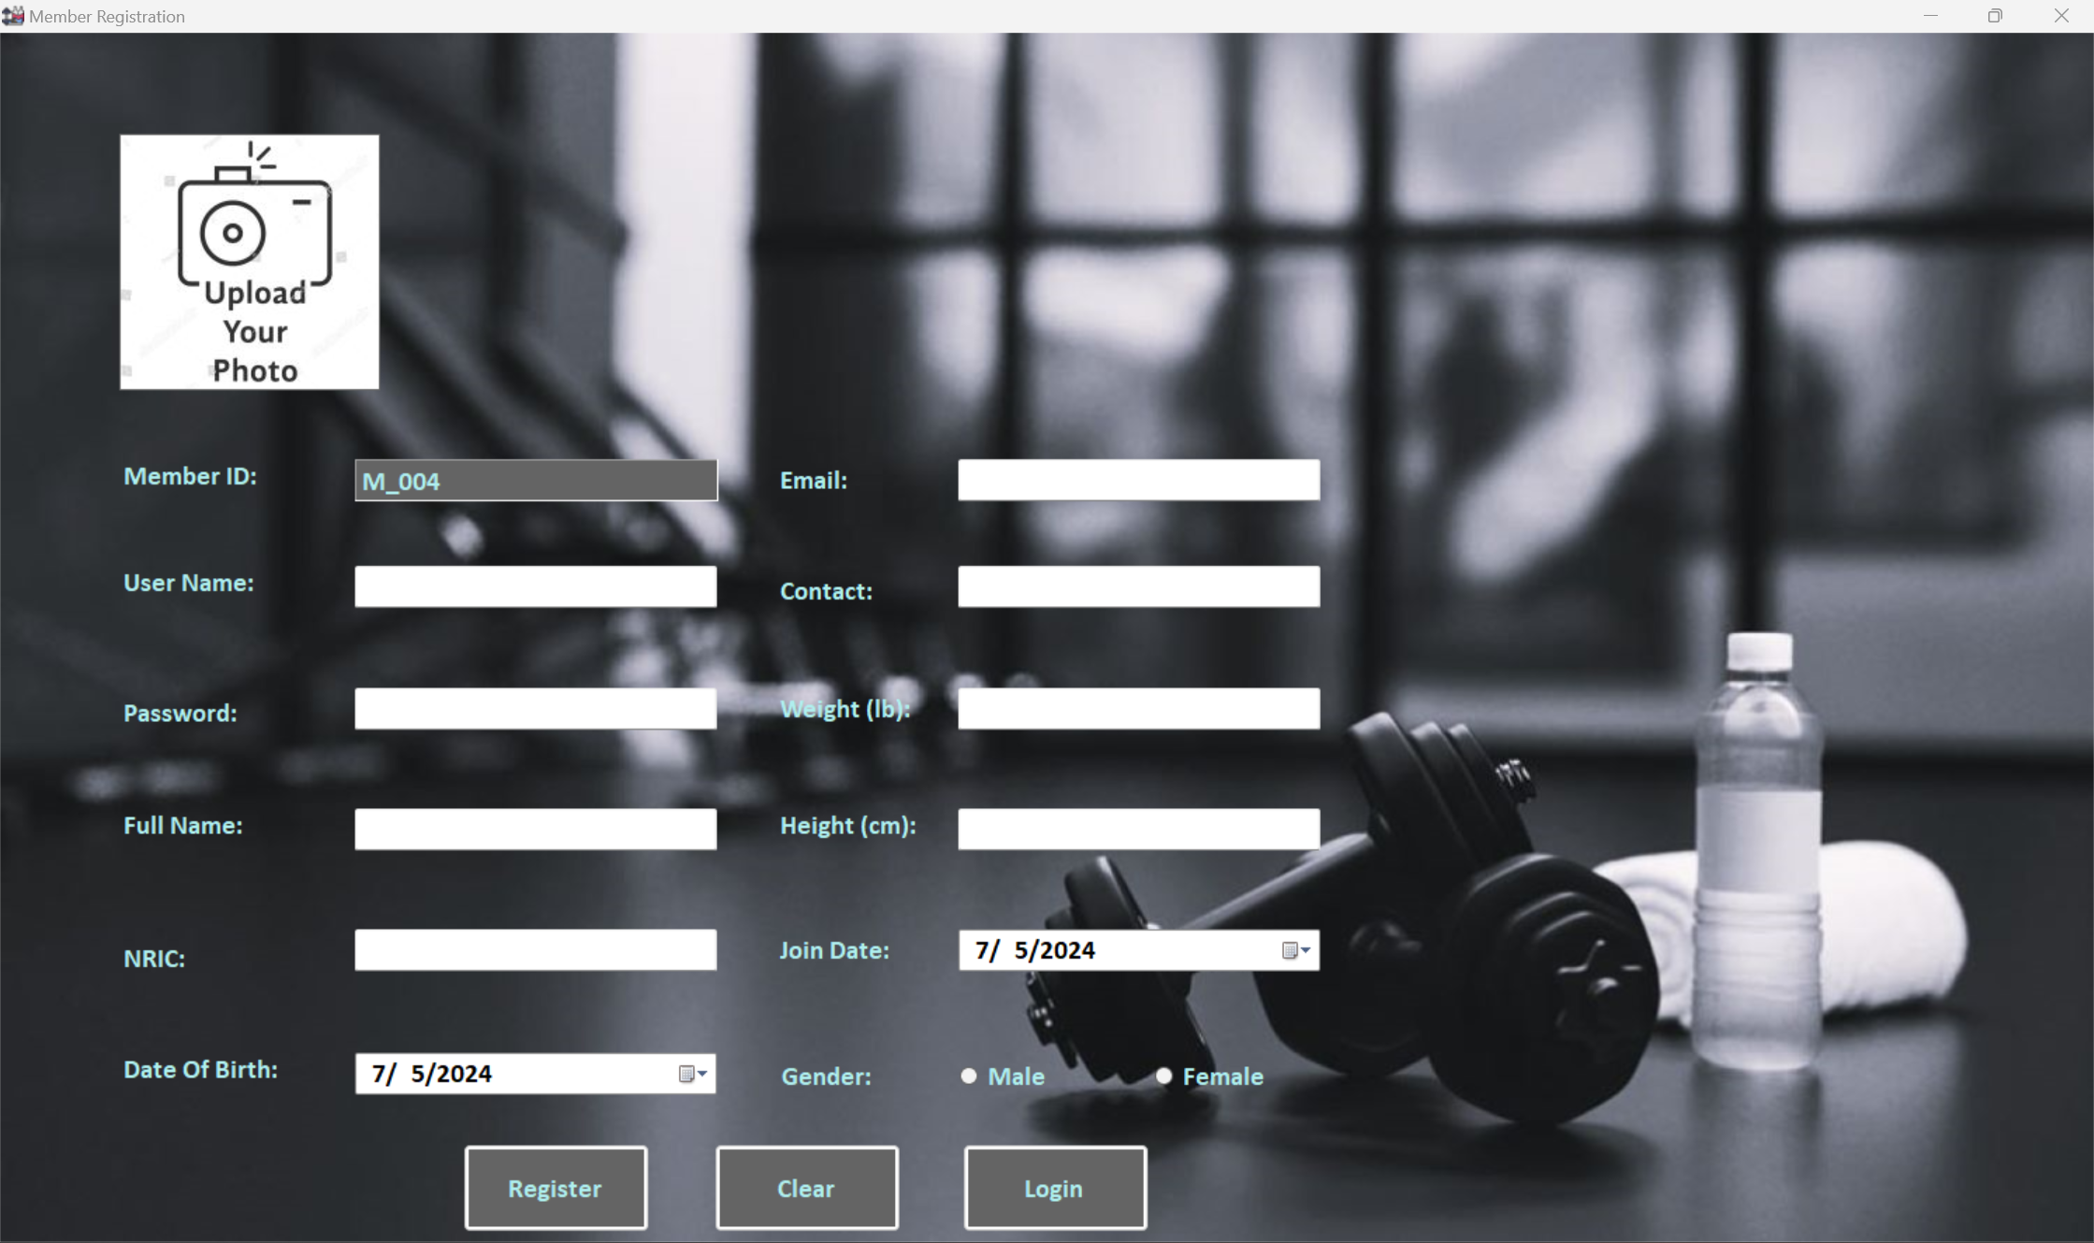

*Figure 5.1.2*

**Unit Testing 6**

**Goal Form**

|  |  |
| --- | --- |
| Test Case ID | 6.1 |
| Test Description | Testing Goal Form |
| Test Objective | To check if the “Goal” button in member homepage navigates to goal form and check target weight loss field. |
| Procedure | 1. Click “Goal” button in member homepage 2. Leave target weight loss empty and save the goal. |
| Expected Result | Goal form should load, and the error message box should appear. |
| Actual Results | The goal form loaded, the error message box appeared and upon inputting target weight loss, automatically converted to target calories. See Figure 6.1.1, 6.1.2, 6.1.3 |
| Result Status | Pass |

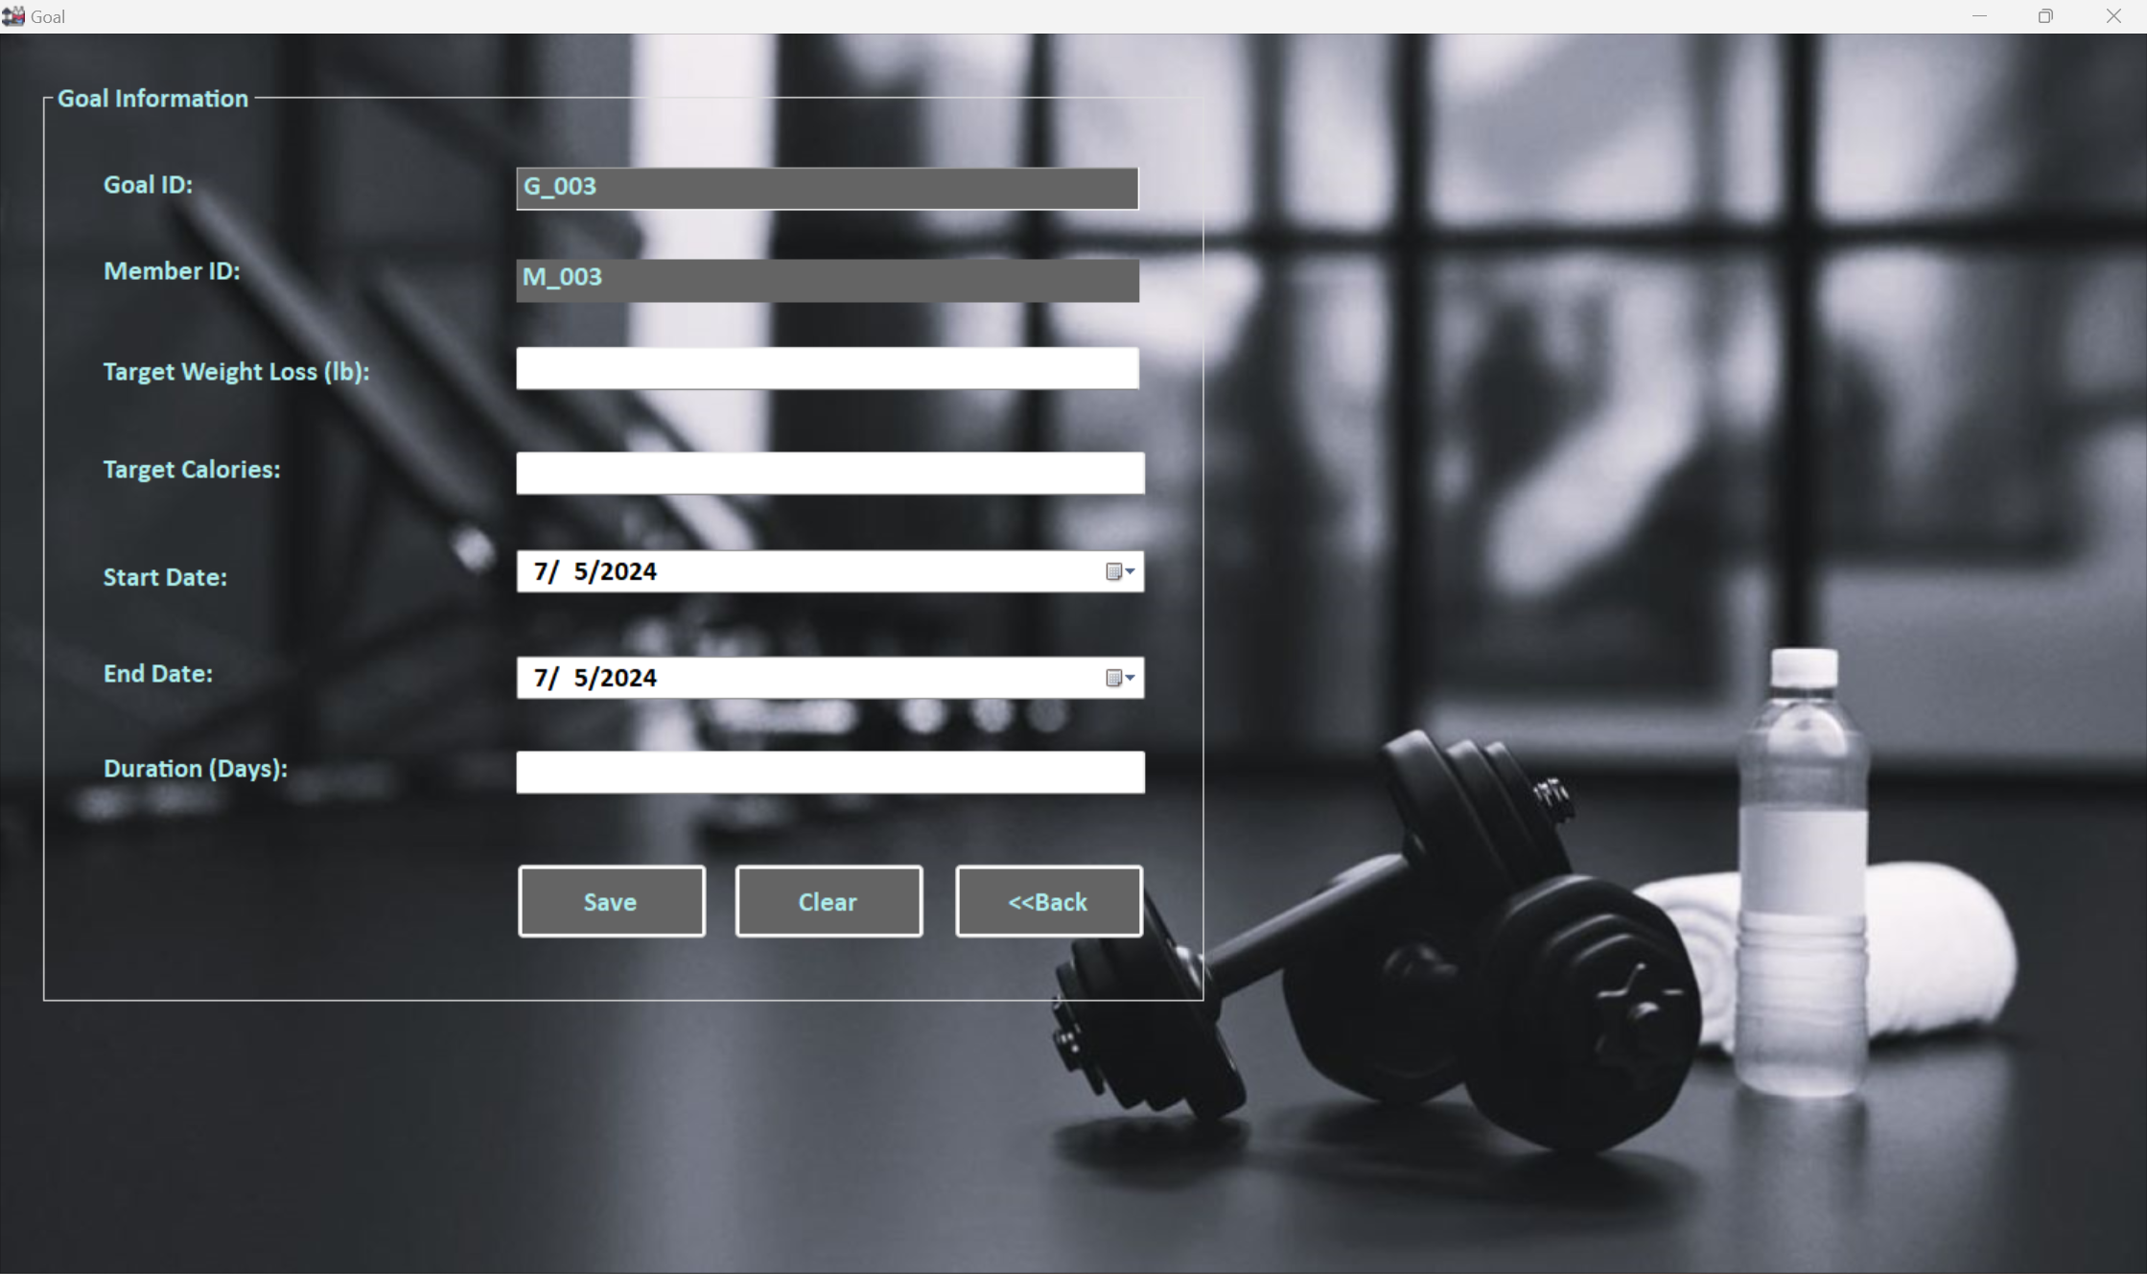

*Figure 6.1.1*

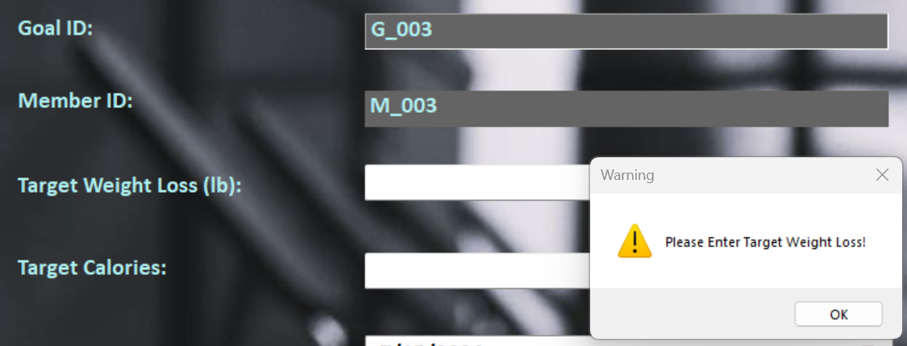

*Figure 6.1.2*

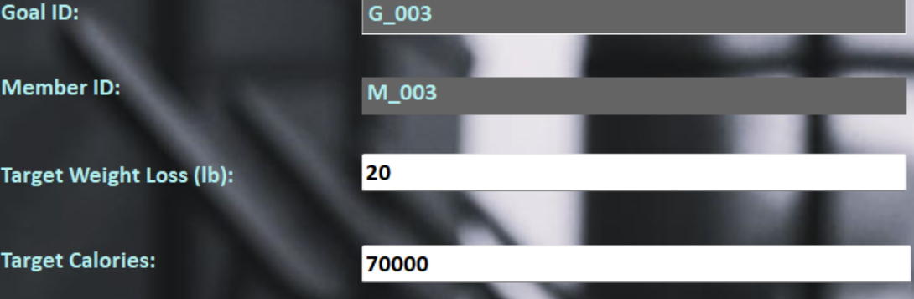

*Figure 6.1.3*

|  |  |
| --- | --- |
| Test Case ID | 6.2 |
| Test Description | Testing Goal Start Date and End Date |
| Test Objective | To test empty duration and invalid duration period. |
| Procedure | 1. Choose “End Date” as today date. 2. Click “Save” button. |
| Expected Result | Error message box should appear for invalid duration. |
| Actual Results | The error message box appeared and automatically converted total days in duration field. See Figure 6.2.1, 6.2.2 |
| Result Status | Pass |

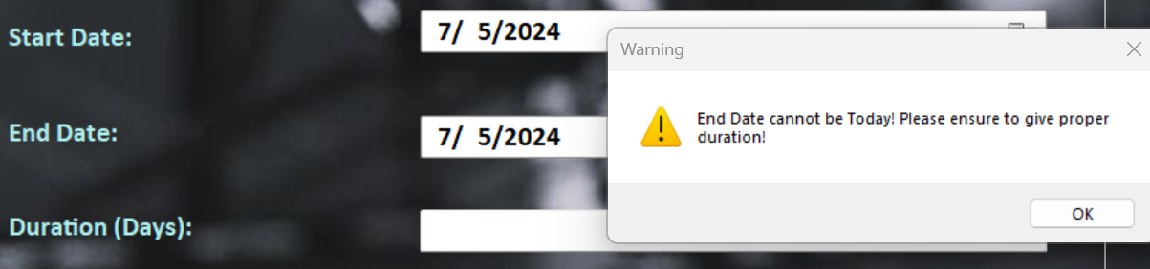

*Figure 6.2.1*

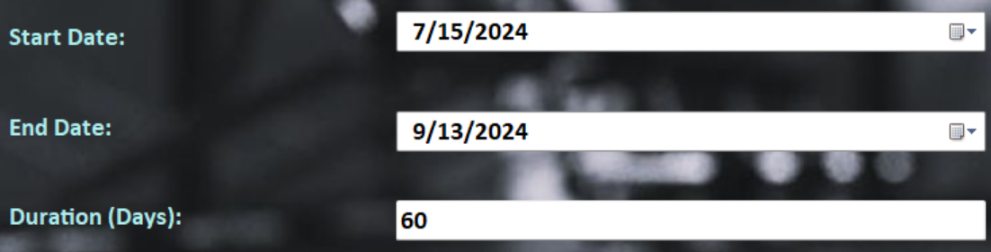

*Figure 6.2.2*

|  |  |
| --- | --- |
| Test Case ID | 6.3 |
| Test Description | Testing Goal |
| Test Objective | To check whether member can add a new goal. |
| Procedure | 1. Fill in all the required data. 2. Click “Save” button. |
| Expected Result | A new goal should be successfully saved. |
| Actual Results | Successfully saved. See Figure 6.3.1, 6.3.2 |
| Result Status | Pass |

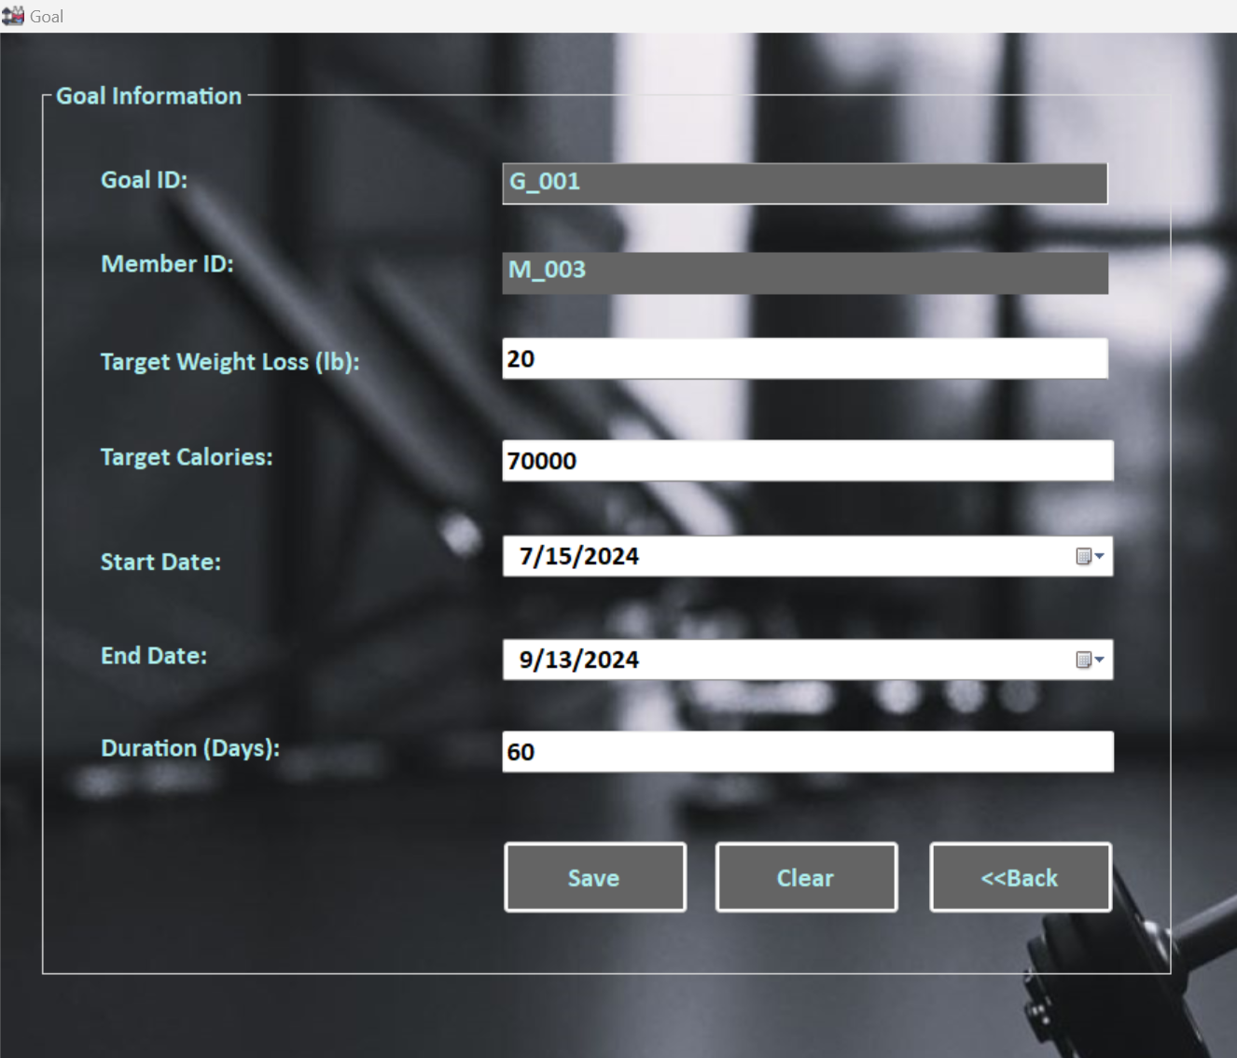

*Figure 6.3.1*

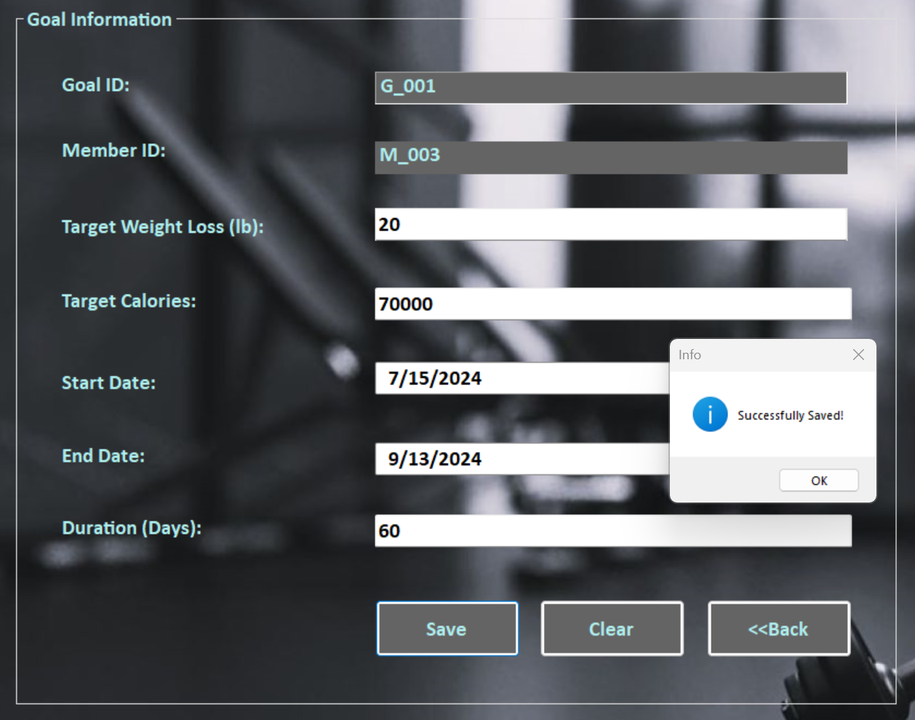

*Figure 6.3.2*

**Unit Testing 7**

**Admin Homepage Form**

|  |  |
| --- | --- |
| Test Case ID | 7.1 |
| Test Description | Testing Admin Homepage |
| Test Objective | To check the admin homepage functionality and displaying correct admin information. |
| Procedure | 1. Login Admin form and check the admin information. |
| Expected Result | Admin form should load with correct admin information. |
| Actual Results | See Figure 7.1.1, Figure 7.1.2 |
| Result Status | Pass |

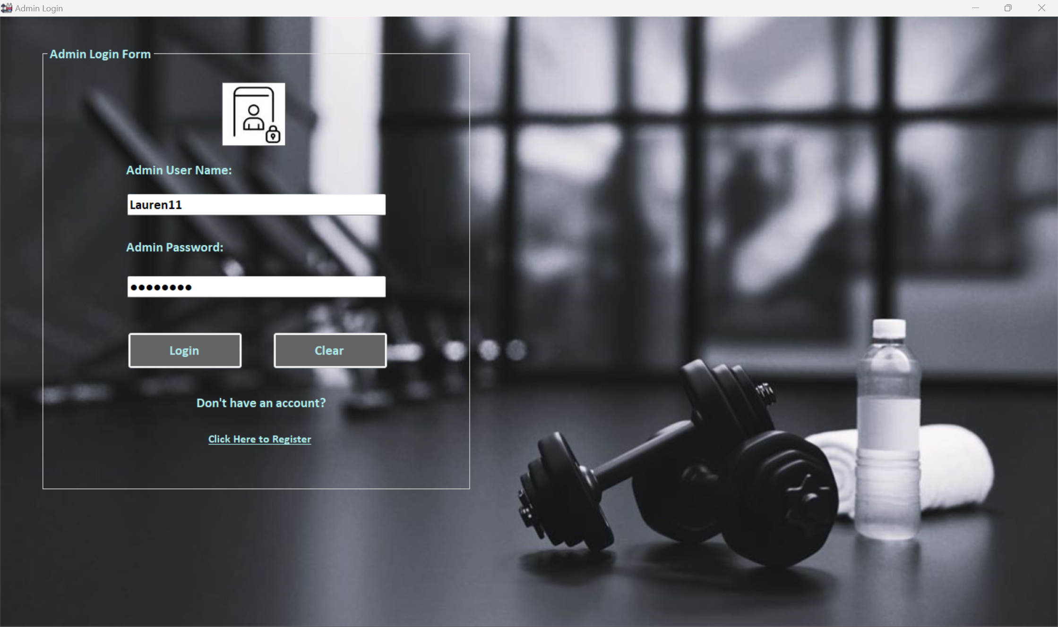

*Figure 7.1.1*

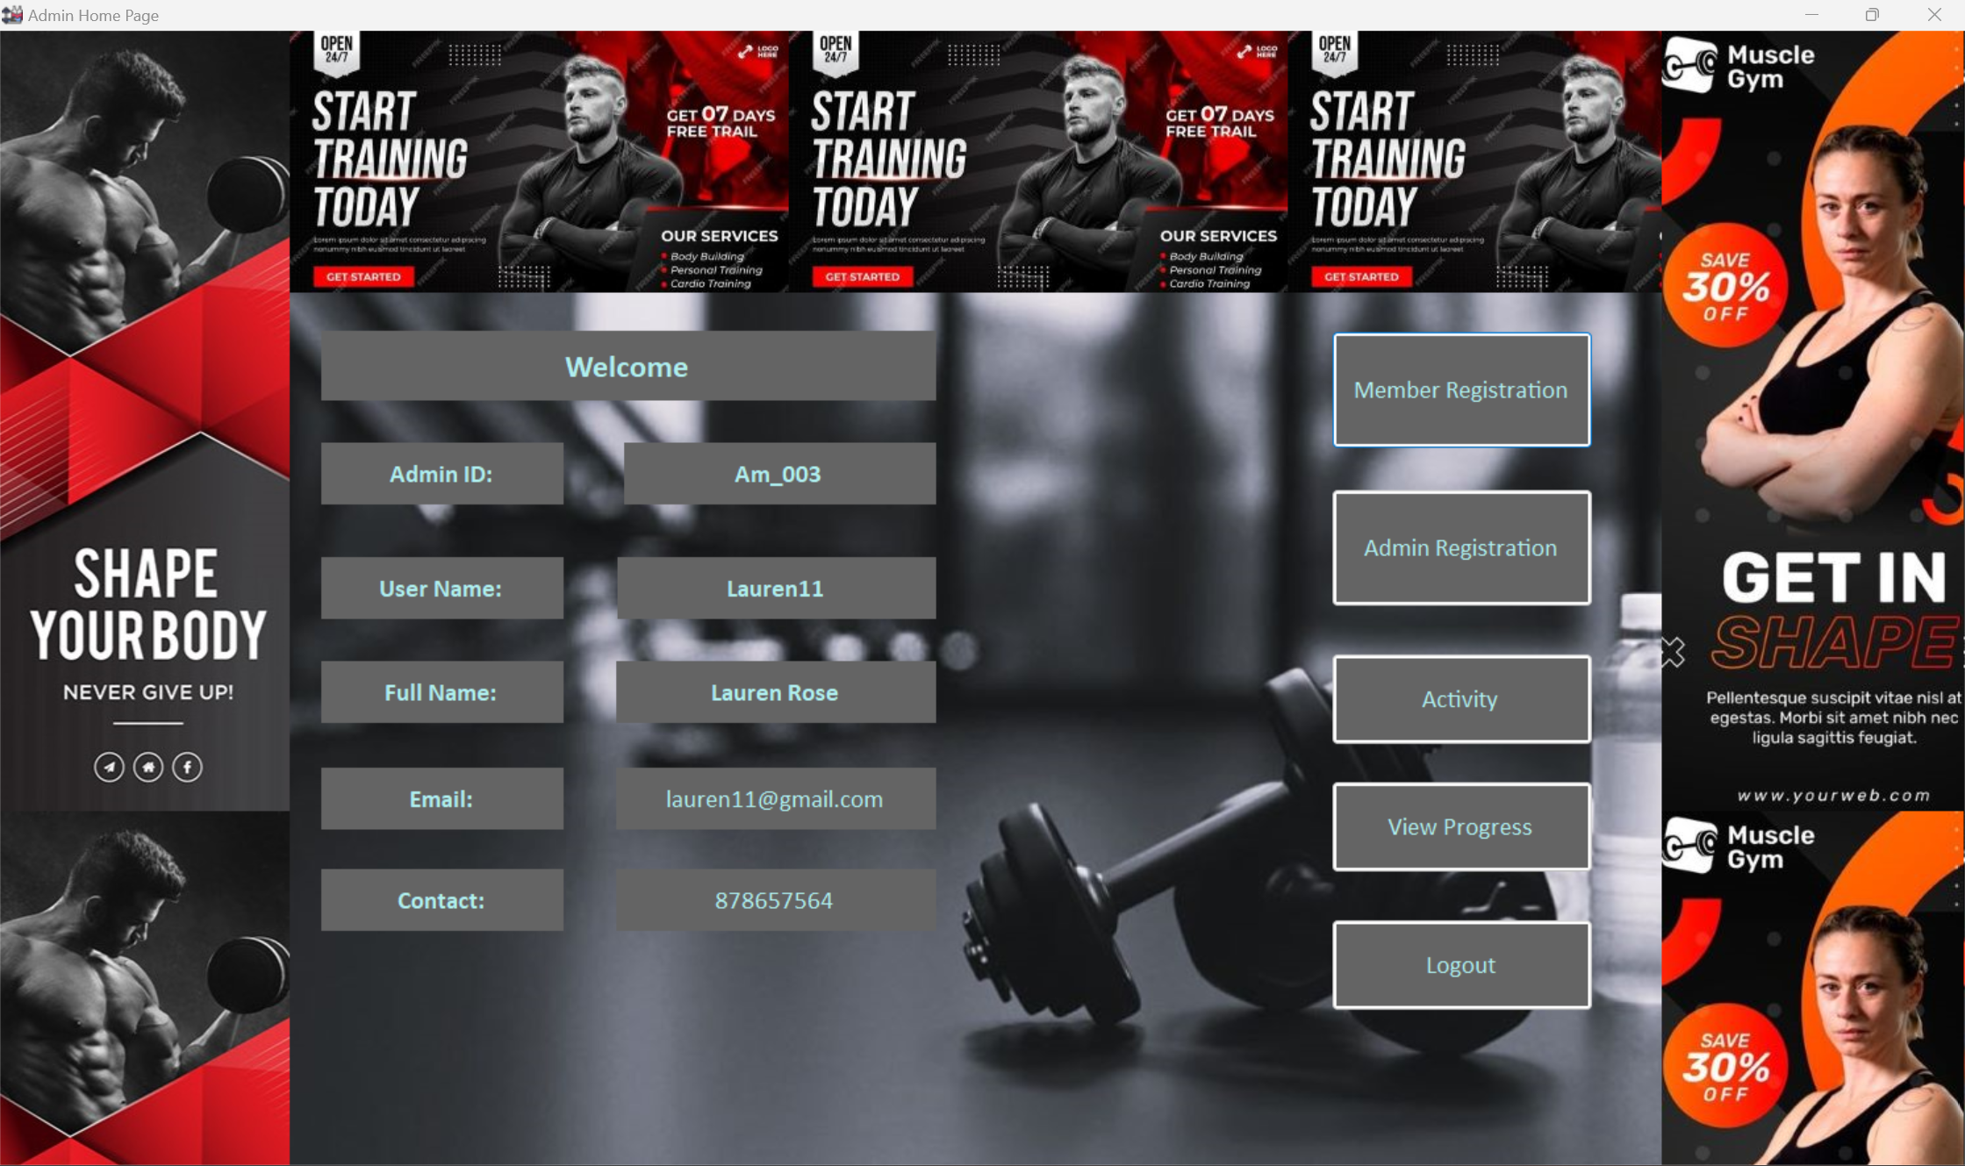

*Figure 7.1.2*

|  |  |
| --- | --- |
| Test Case ID | 7.2 |
| Test Description | Testing Admin Registration Button |
| Test Objective | To check whether the admin registration button function correctly and navigate to correct form. |
| Procedure | 1. Click “Admin Registration” button at admin homepage. |
| Expected Result | The button should lead to correct admin registration form. |
| Actual Results | See Figure 7.2.1, Figure 7.2.2 |
| Result Status | Pass |

**

*Figure 7.2.1*

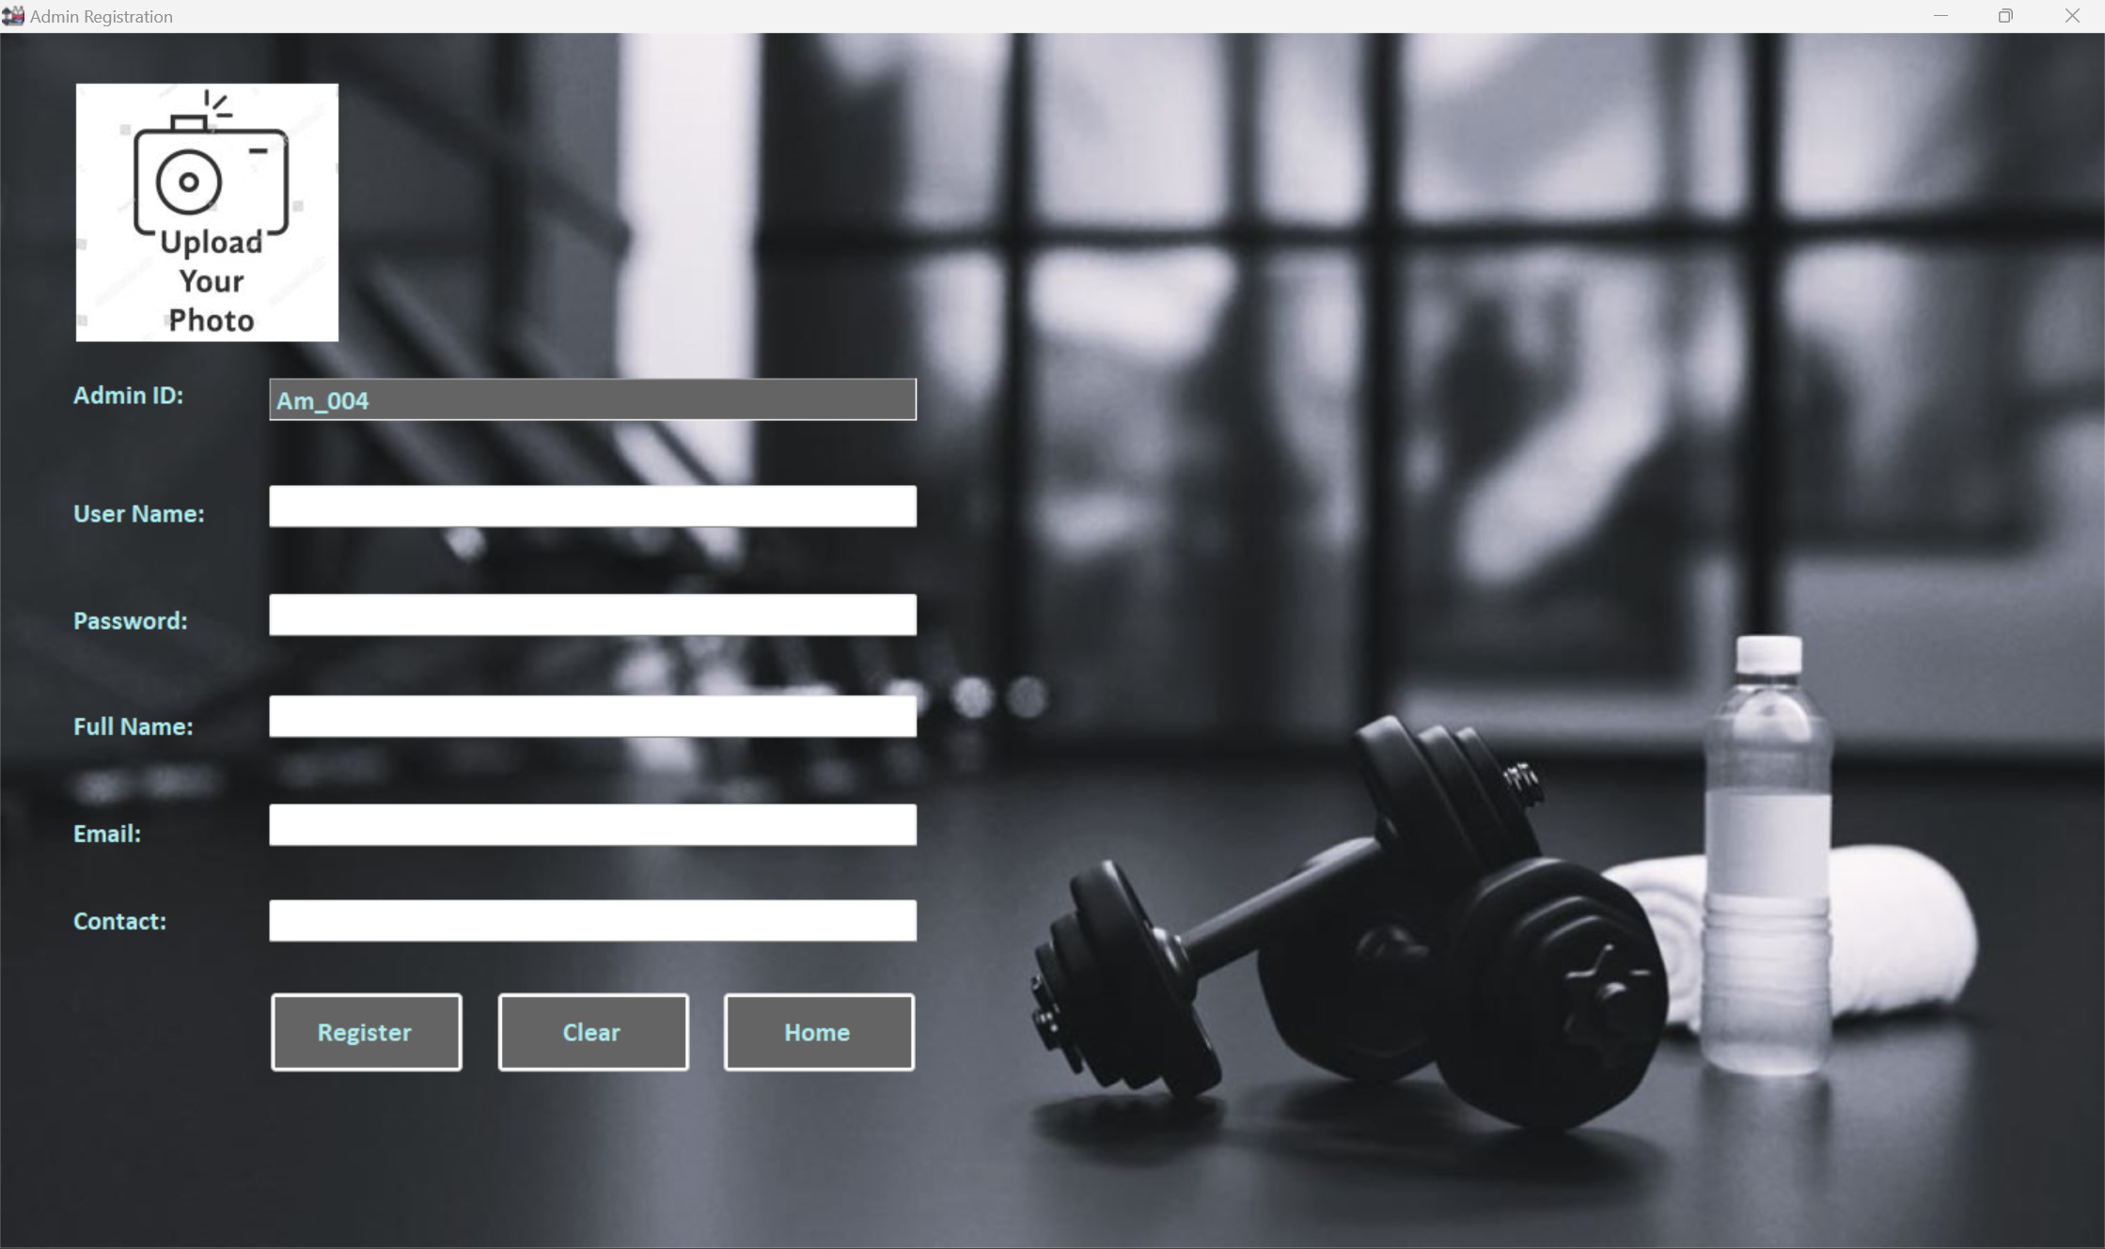

*Figure 7.2.2*

**Unit Testing 8**

**Activity Form**

|  |  |
| --- | --- |
| Test Case ID | 8.1 |
| Test Description | Adding the new activity |
| Test Objective | To check the activity button works correctly and whether the admin can add new activities. |
| Procedure | 1. Click “Activity” button, fill in the required data and click “Save” button. |
| Expected Result | The button should lead to activity form and admin should be able to add new activities. |
| Actual Results | Successful. See Figure 8.1.1, Figure 8.1.2 |
| Result Status | Pass |

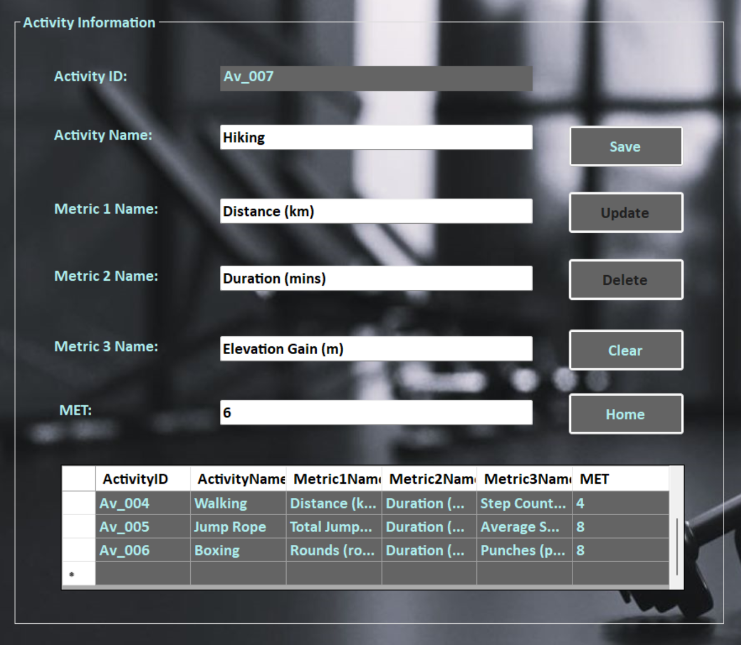

*Figure 8.1.1*

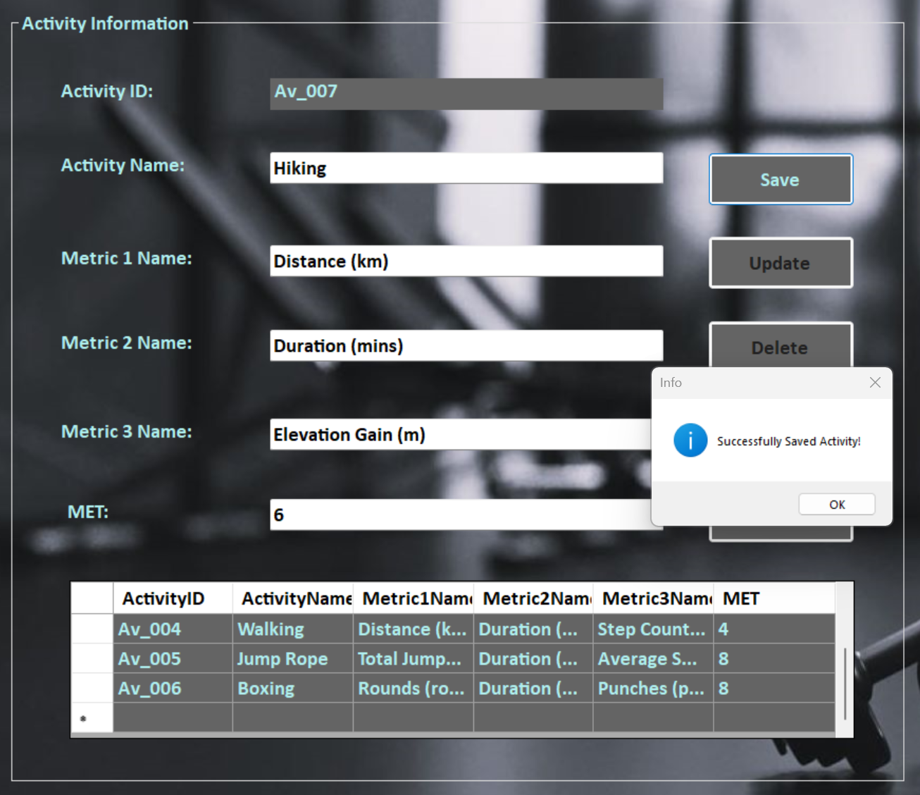

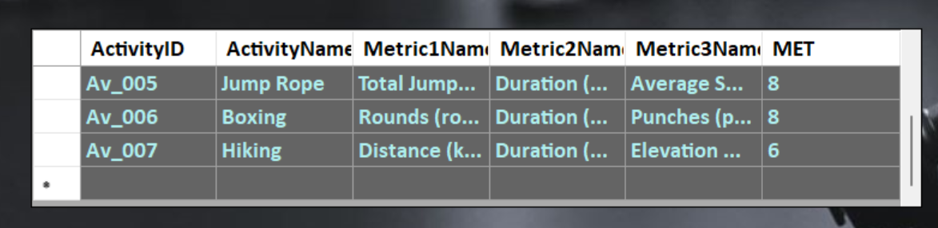

*Figure 8.1.2*

|  |  |
| --- | --- |
| Test Case ID | 8.2 |
| Test Description | Testing “update” button |
| Test Objective | To check “update” button works correctly and whether the admin can update existing activities. |
| Procedure | 1. Select the data or row from the data grid-view to update. 2. Change the value or activity name, metric names and click “update”. |
| Expected Result | The admin should be able to update the information and new data should be reflected in data grid-view. |
| Actual Results | See Figure 8.2.1, Figure 8.2.2 |
| Result Status | Pass |

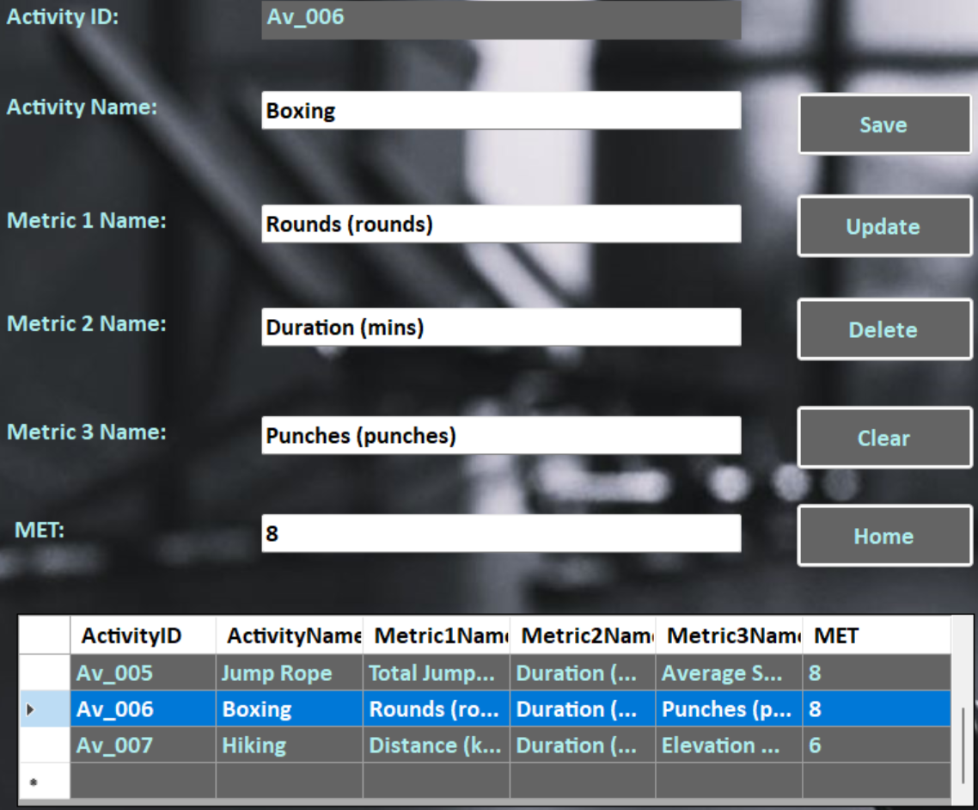

*Figure 8.2.1*

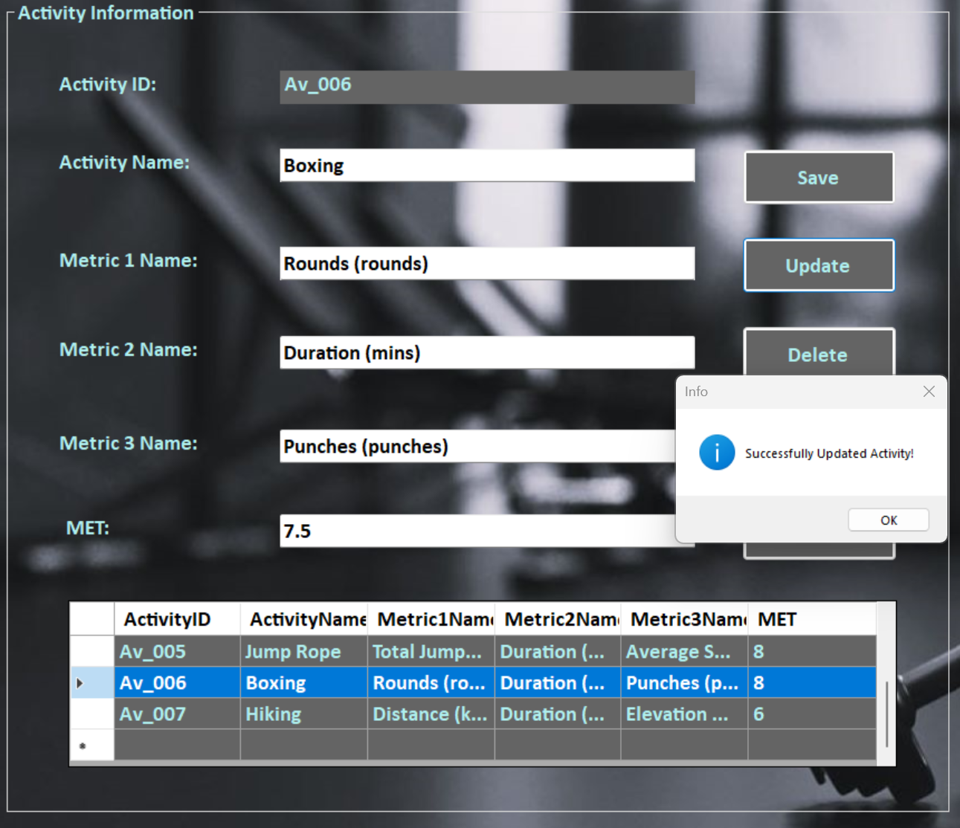

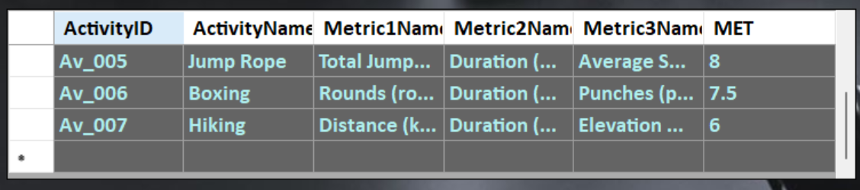

*Figure 8.2.2*

|  |  |
| --- | --- |
| Test Case ID | 8.3 |
| Test Description | Testing “delete” button |
| Test Objective | To verify “delete” button works correctly and if the admin can delete existing activities. |
| Procedure | 1. Select the activity row from the data grid-view to delete. 2. Click “delete” button. |
| Expected Result | The admin should be able to delete existing activities and the delete activity should be removed from data grid-view. |
| Actual Results | See Figure 8.3.1, Figure 8.3.2 |
| Result Status | Pass |

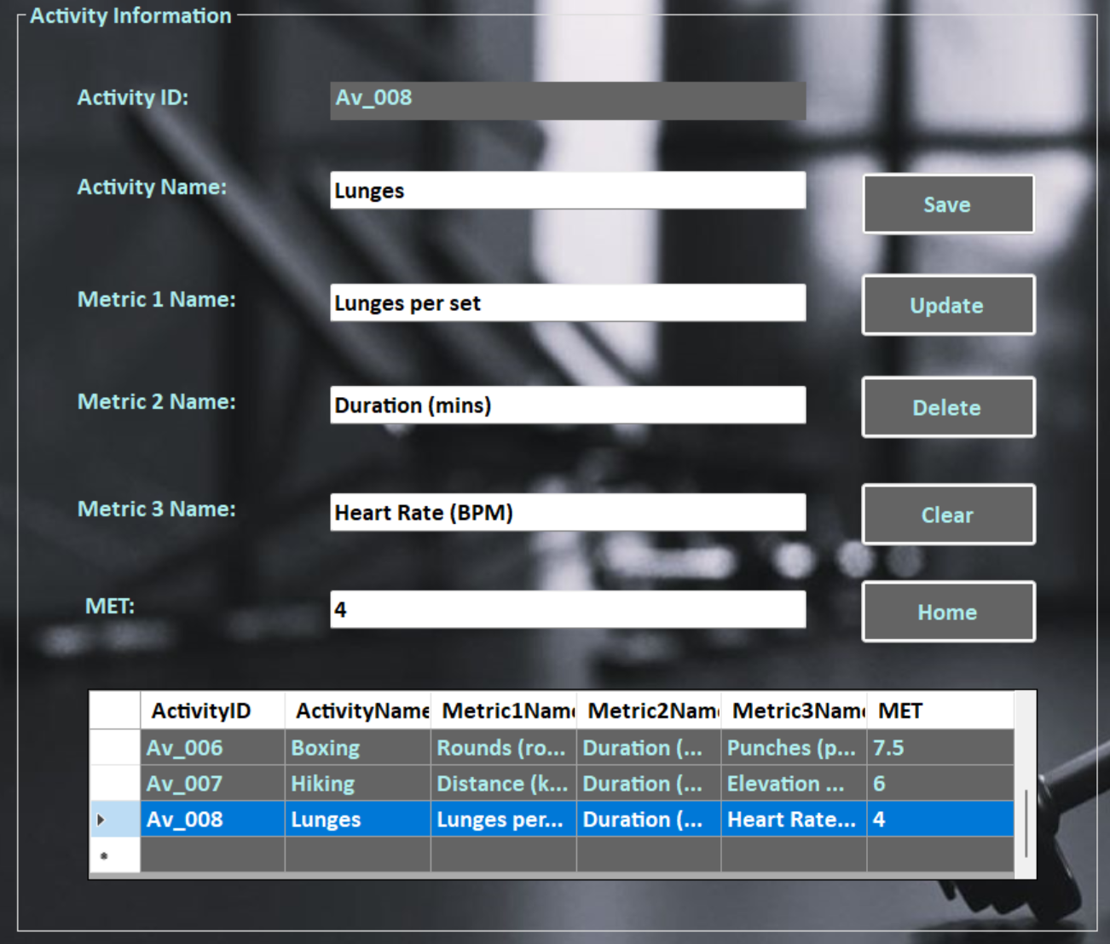

*Figure 8.3.1*

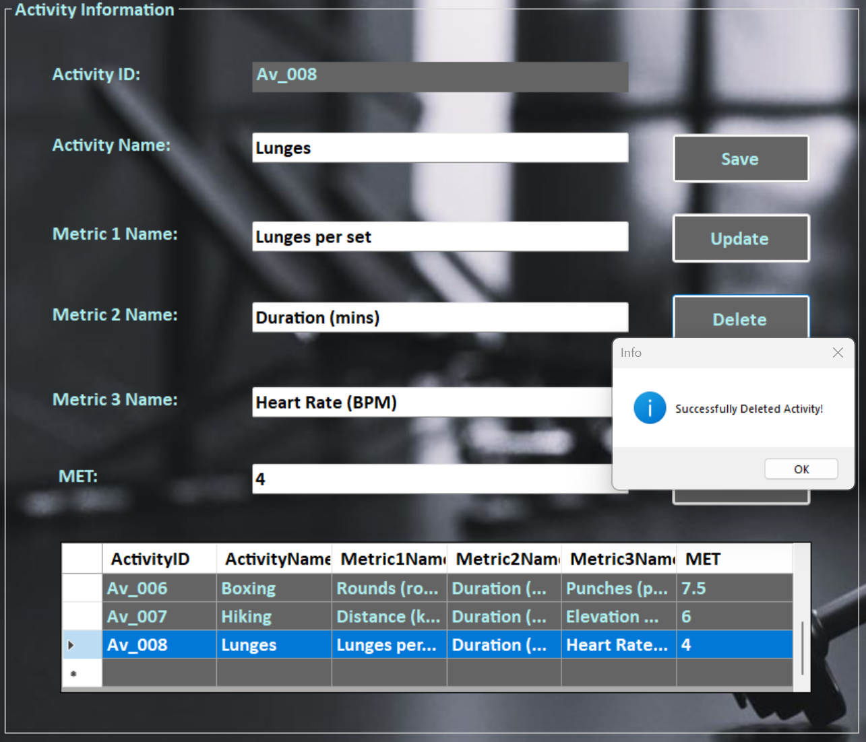

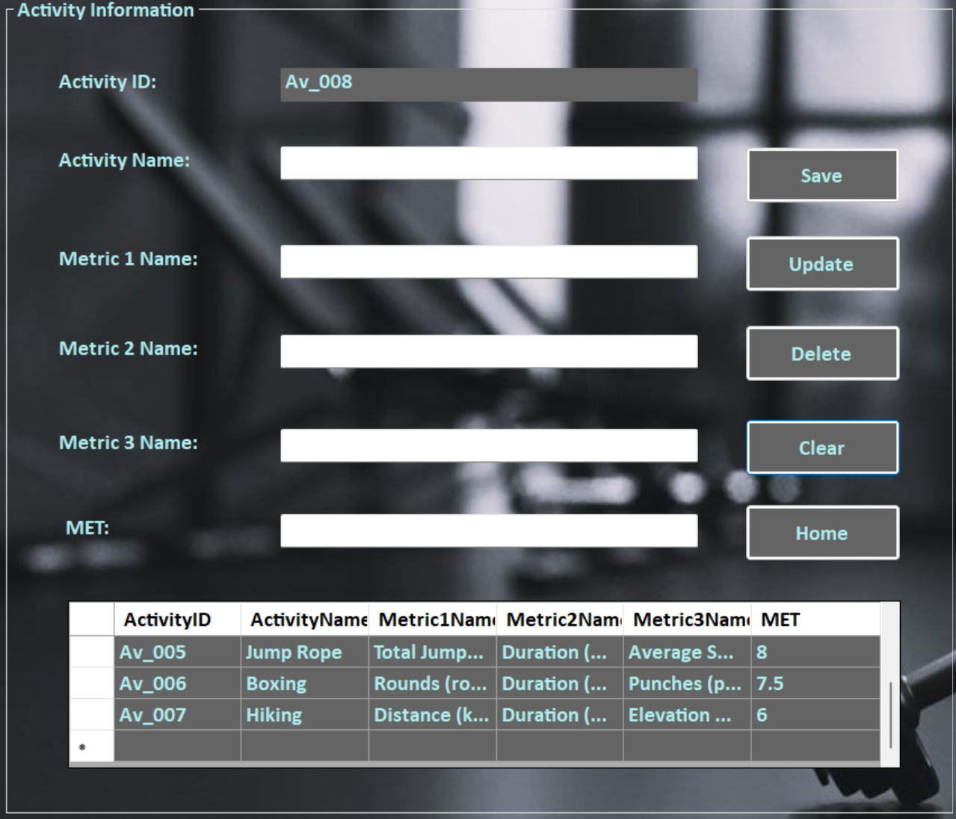

*Figure 8.3.2*

**Unit Testing 9**

**Progress Form**

|  |  |
| --- | --- |
| Test Case ID | 9.1 |
| Test Description | Testing Progress Form |
| Test Objective | To verify if progress form loads correctly upon clicking “progress” button at member homepage. |
| Procedure | 1. Click the “progress” button at member homepage. |
| Expected Result | The button should navigate to progress form. |
| Actual Results | See Figure 9.1.1 |
| Result Status | Pass |

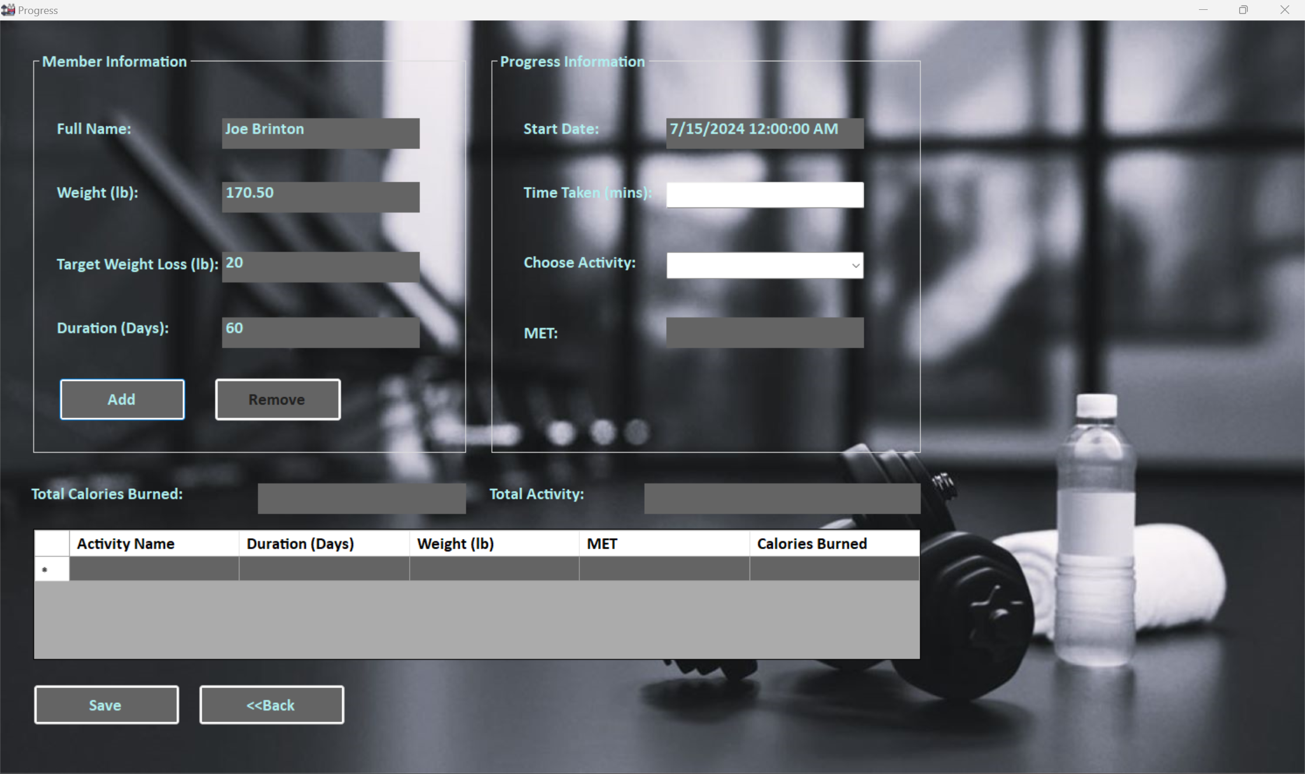

*Figure 9.1.1*

|  |  |
| --- | --- |
| Test Case ID | 9.1 |
| Test Description | Testing activity combo and add button |
| Test Objective | To check if the combo box shows available activities and whether member can add the completed to progress data grid-view. |
| Procedure | 1. Select activities from activity combo box and click “Add” button. |
| Expected Result | MET should display based on chosen activity. Member should be able to add activities to progress data grid-view. |
| Actual Results | See Figure 9.1.1 and Figure 9.1.2 |
| Result Status | Pass |

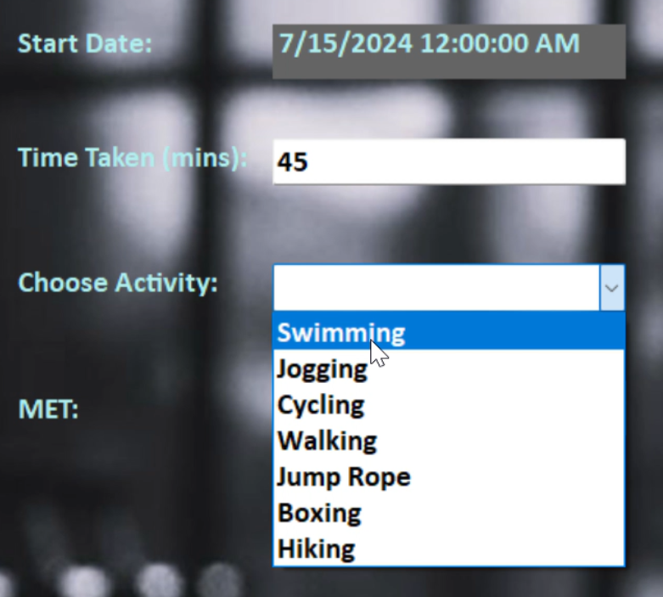 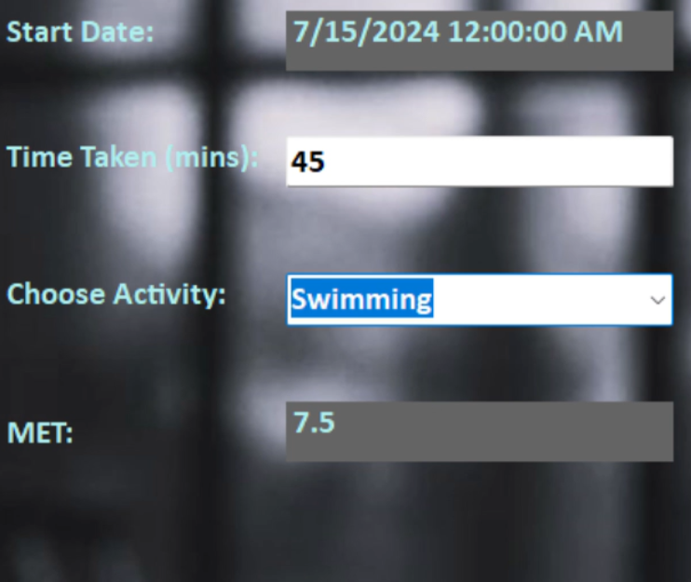

*Figure 9.1.1*

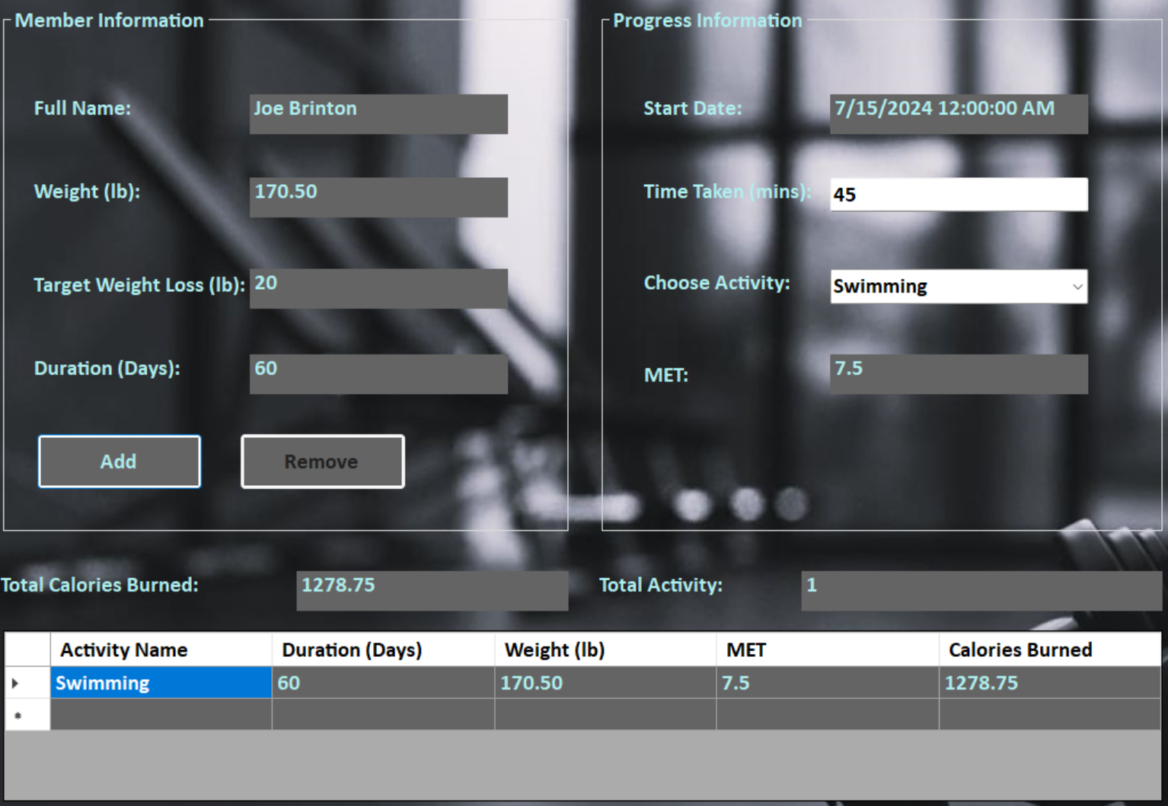

*Figure 9.1.2*

|  |  |
| --- | --- |
| Test Case ID | 9.2 |
| Test Description | Testing remove button |
| Test Objective | To check if the “Remove” works correctly to remove the progress from data grid-view. |
| Procedure | 1. Select the activity row to remove from progress data grid-view |
| Expected Result | Member should be able to remove activities from progress data grid-view. |
| Actual Results | See Figure 9.2.1 and Figure 9.2.2 |
| Result Status | Pass |

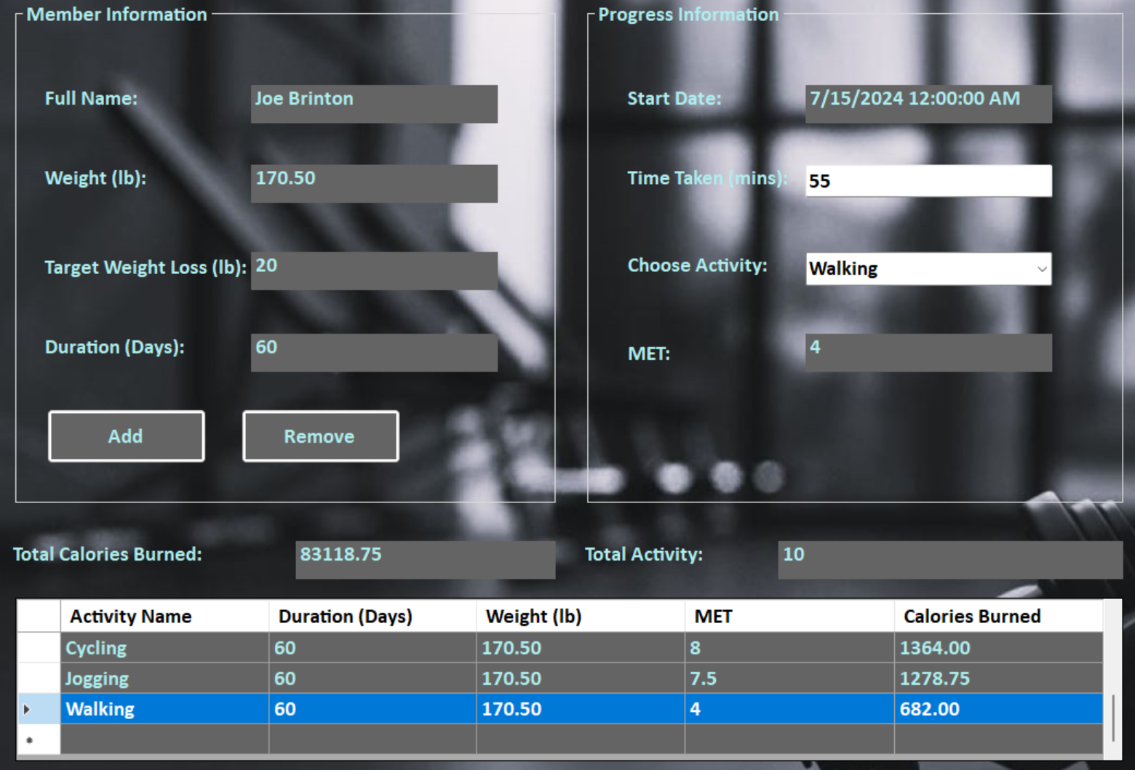

*Figure 9.2.1*

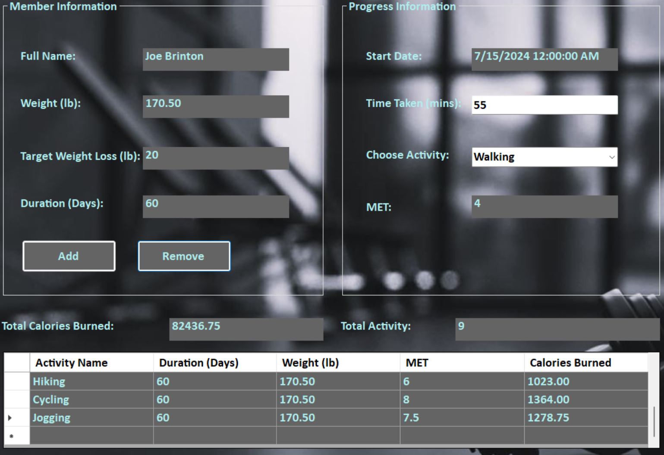

*Figure 9.2.2*

|  |  |
| --- | --- |
| Test Case ID | 9.3 |
| Test Description | Testing save button |
| Test Objective | To check if the “Remove” works correctly to remove the progress from data grid-view. |
| Procedure | 1. Click “Save” button. |
| Expected Result | Member should be able to save the activities from progress data grid-view to progress table and the message box should display whether the progress is successful or fail. |
| Actual Results | See Figure 9.3.1, Figure 9.3.2, Figure 9.3.3, Figure 9.3.4 |
| Result Status | Pass |

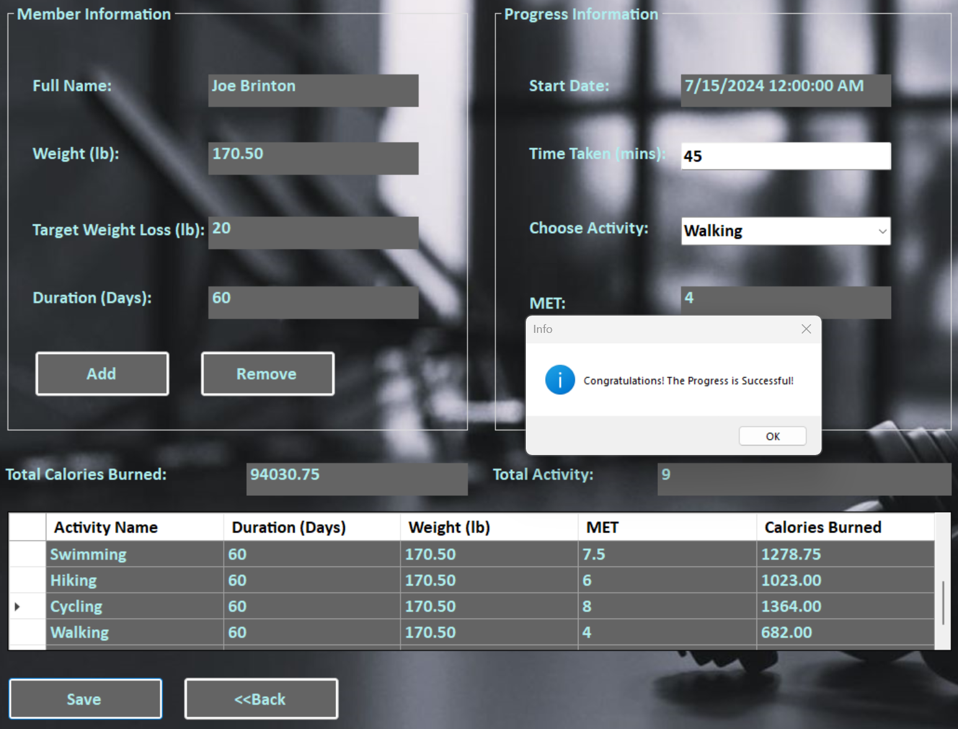

*Figure 9.3.1*

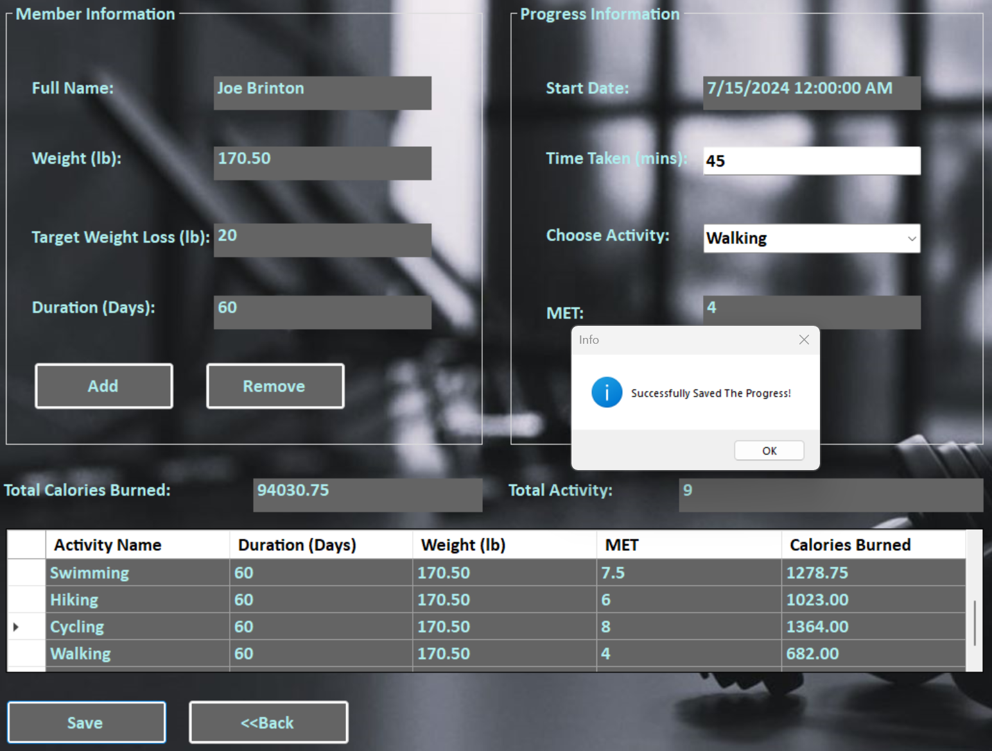

*Figure 9.3.2*

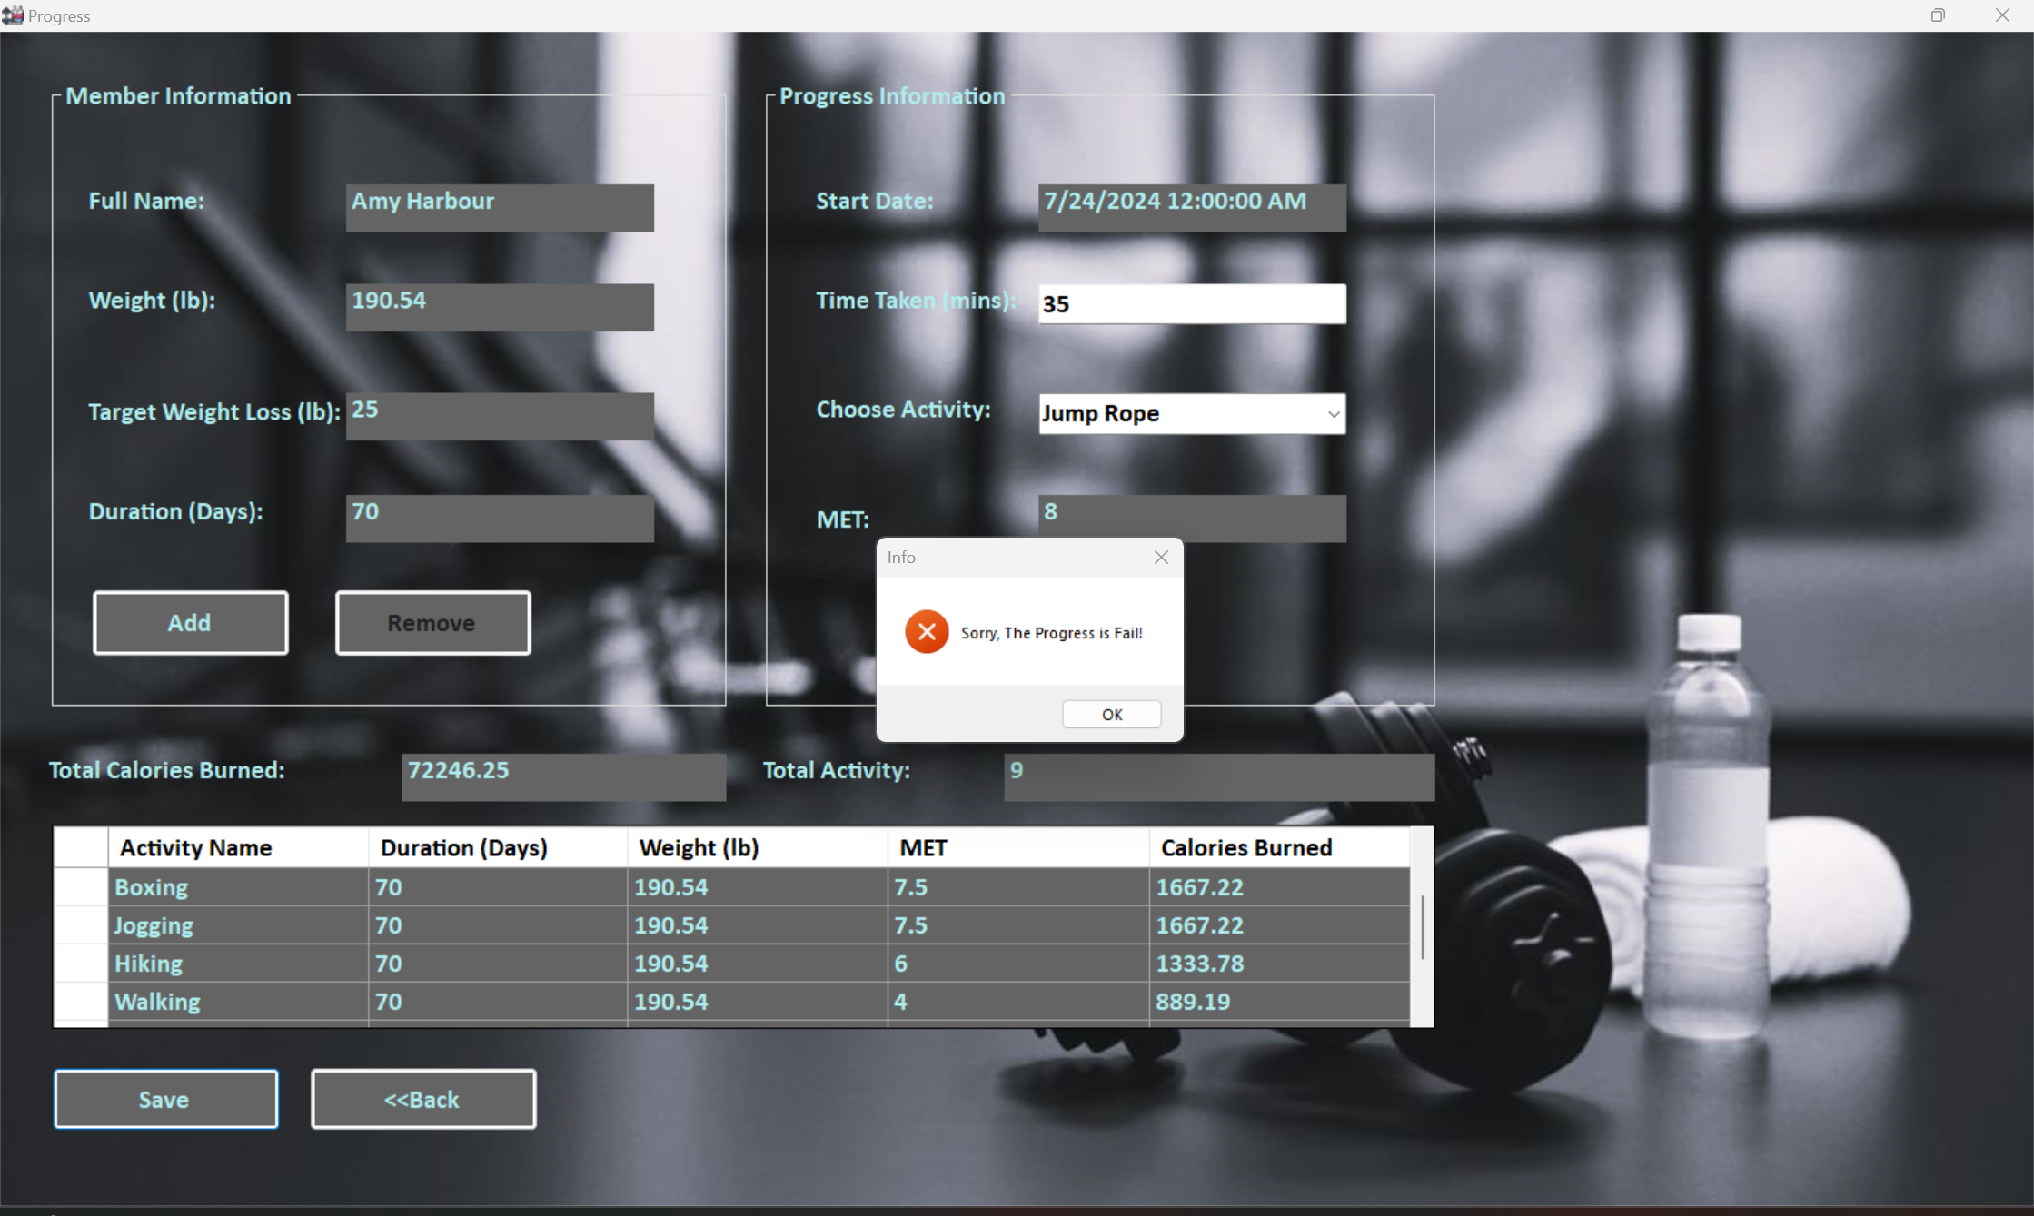

*Figure 9.3.3*

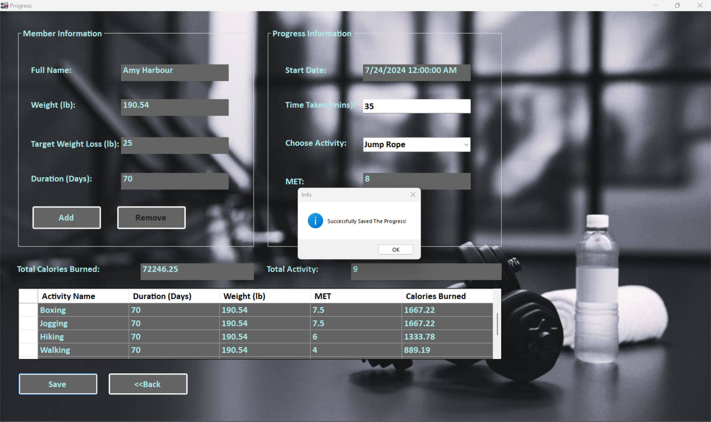

*Figure 9.3.4*

**Unit Testing 10**

**Progress View Form**

|  |  |
| --- | --- |
| Test Case ID | 10.1 |
| Test Description | Testing “View Progress” button in admin homepage |
| Test Objective | To check if the button navigates to correct form. |
| Procedure | 1. Login admin form and click “View Progress” button. |
| Expected Result | The progress view form should load successfully and display members progress. |
| Actual Results | See Figure 10.1.1, Figure 10.1.2, Figure 10.1.3 |
| Result Status | Pass |

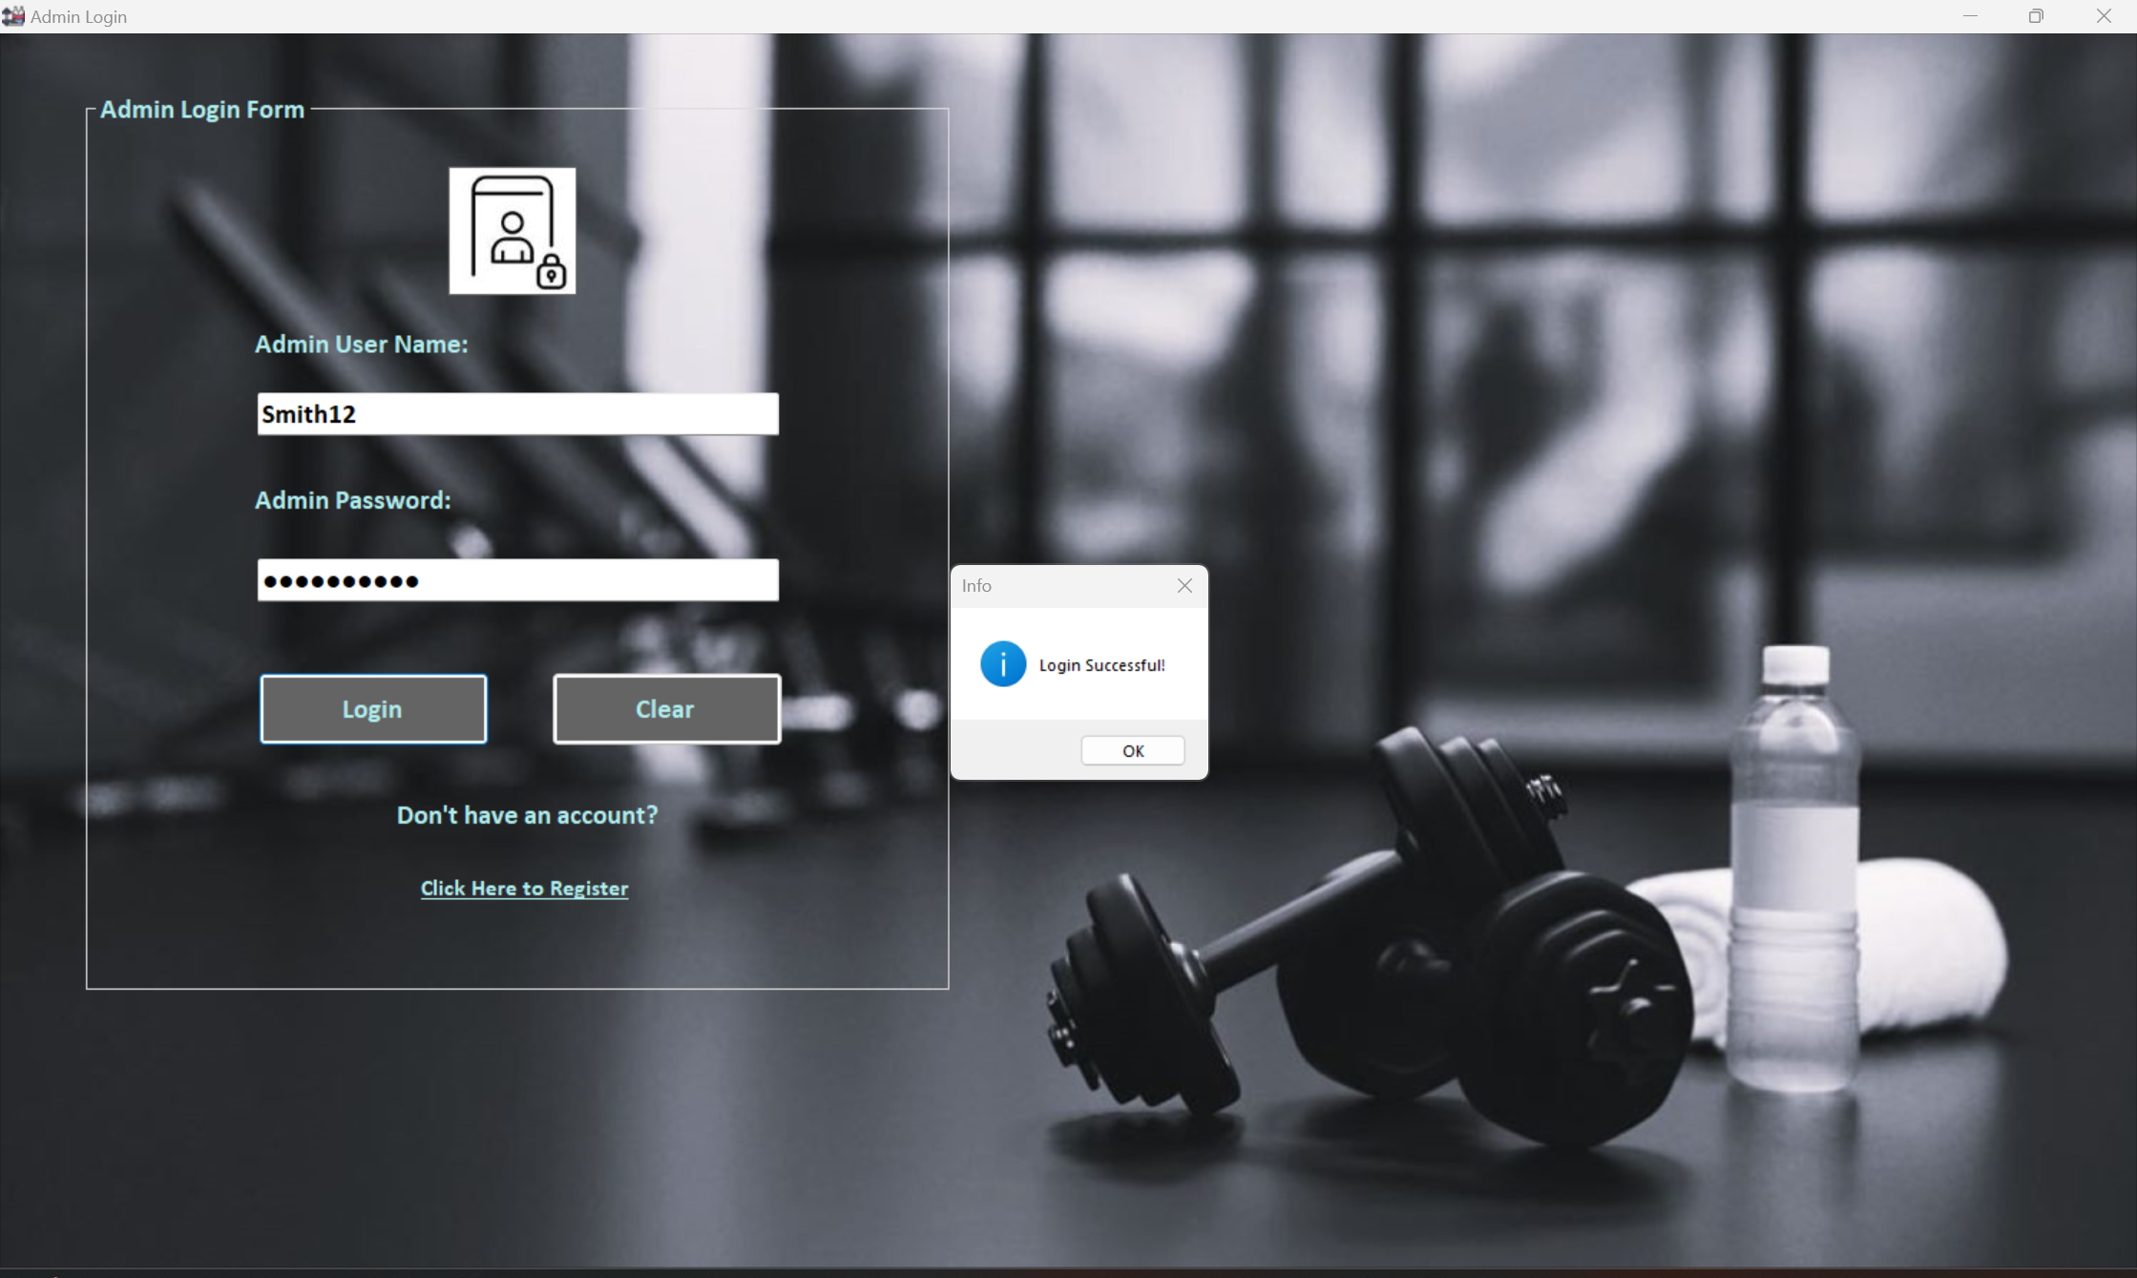

*Figure 10.1.1*

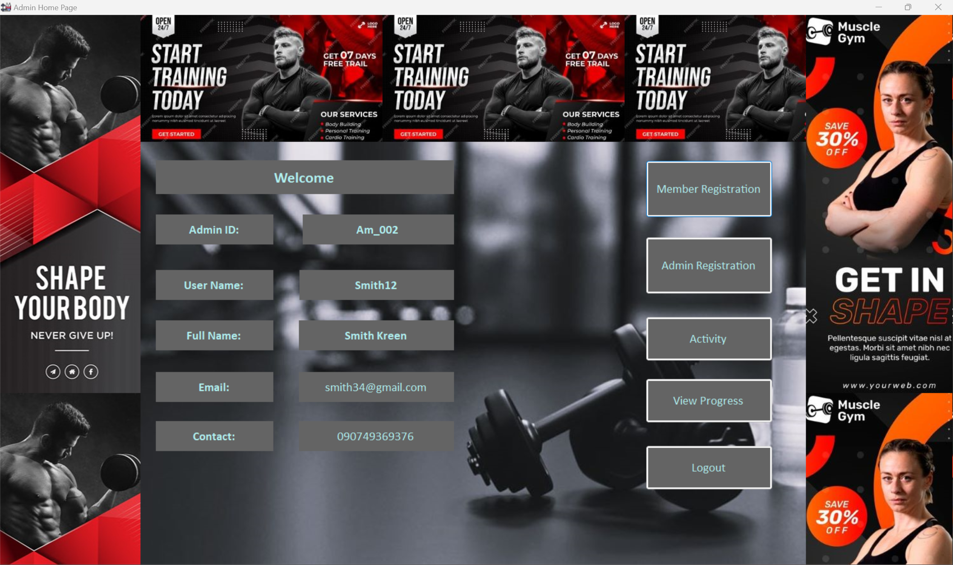

*Figure 10.1.2*

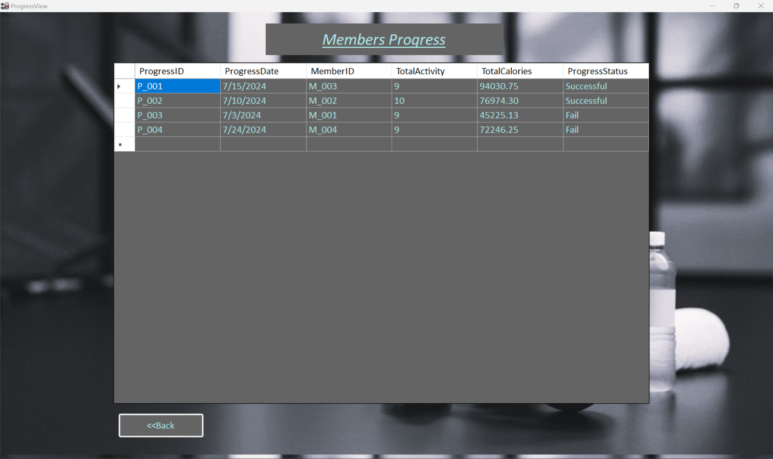

*Figure 10.1.3*

**Task3**

# **Task3_Detailed Class Diagram**

## **Class Diagram**

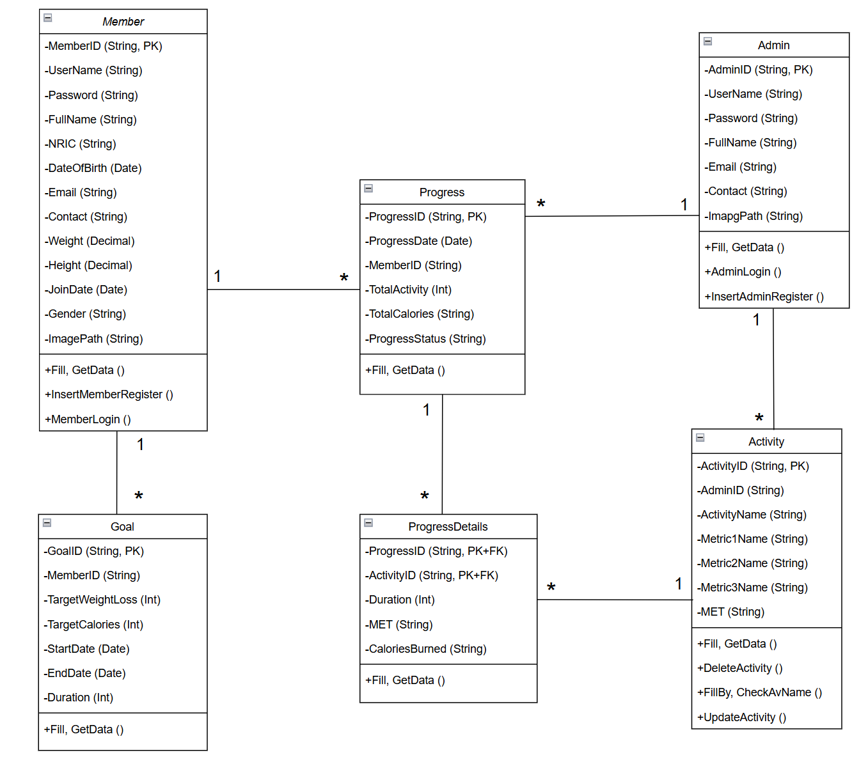

***Fitness Tracker Class Diagram***

## **Explanation**

The above class diagram illustrates the fitness tracking system composed of (6) entities/tables such as Admin, Member, Goal, Activity, Progress, ProgressDetails, displaying the relationships and interactions between different entities/tables. In this Fitness Tracking system, each table are connected in a way that one-to-many relationship, facilitating members to have multiple progress records while each admin can oversee members progress records and manage various activities. Each member can set multiple goals and track different fitness goals. An admin can create, update and delete different types of activities available to members. Each progress record contains multiple different activities, enabling specific tracking and activities can be reused across different records. These entities relationships ensure effective management and comprehensive tracking of member progress for admins and members to set fitness goals and keep track of their progress.

## **Description**

|  |  |
| --- | --- |
| **Class Name** | Member |
| **Attributes** | MemberID, UserName, Password, FullName, NRIC, DateOfBirth, Email, Contact, Weight, Height, JoinDate, Gender, ImagePath |
| **Operation** | +Fill, GetData ()  +InsertMemberRegister ()  +MemberLogin () |
| **Description** | The member table captures information from the member registration form and helps retrieve data when members want to log in the system. It also allows admins to record members information. |

|  |  |
| --- | --- |
| **Class Name** | Admin |
| **Attributes** | AdminID, UserName, Password, FullName, Email, Contact, ImagePath |
| **Operation** | +Fill, GetData ()  +InsertAdminRegister ()  +MemberLogin () |
| **Description** | The admin data table stores information from the admin registration form and assists in data retrieval for subsequent logins. This table contains details about the admins who manage the system and monitor member activities and progress. |

|  |  |
| --- | --- |
| **Class Name** | Goal |
| **Attributes** | GoalID, MemberID, TargetWeightLoss, TargetCalories, StartDate, EndDate, Duration |
| **Operation** | +Fill, GetData () |
| **Description** | The Goal table enables members to set personalized fitness objectives, such as specific targets for weight loss and calorie intake. It stores this information for future reference, allowing both members and admins to monitor and manage progress effectively. |

|  |  |
| --- | --- |
| **Class Name** | Activity |
| **Attributes** | ActivityID, AdminID, ActivityName, Metric1Name, Metric2Name, Metric3Name, MET |
| **Operation** | +Fill, GetData ()  +DeleteActivity ()  +FillBy, CheckAvName ()  +UpdateActivity () |
| **Description** | The Activity table enables admins to create and manage a variety of fitness activities, which can subsequently be assigned to progress records. It stores this information, allowing members to browse, select, and engage in different activities that align with their desired calorie burn goals. |

|  |  |
| --- | --- |
| **Class Name** | ProgressDetails |
| **Attributes** | ProgressID, ActivityID, Duration, MET, CaloriesBurned |
| **Operation** | +Fill, GetData () |
| **Description** | ProgressDetails table stores data that enables admins and members to monitor specific activities within each progress report, including details like time spent, calories burned, and MET scores, ensuring detailed oversight of fitness progress. |

|  |  |
| --- | --- |
| **Class Name** | Progress |
| **Attributes** | ProgressID, ProgressDate, MemberID, TotalActivity, TotalCalories, ProgressStatus |
| **Operation** | +Fill, GetData () |
| **Description** | The progress table records and summarizes members' overall progress by recording their activities, calories burned, weight loss, and generates a final assessment of success or failure. This information is accessible to both members and admins, providing insight of their fitness accomplishments. |

These tables' interconnections empower members with detailed tracking and goal setting, provides admins with detailed tracking and comprehensive management tools, enhancing fitness tracking system effectiveness.

# References

Dua, A., 20 Feb 2024. *Black Box Testing vs White Box Testing: Understanding Key Differences.* [Online]   
Available at: https://www.turing.com/blog/black-box-testing-vs-white-box-testing-understanding-key-differences  
[Accessed July 2024].

Ganesh, G. A., Jan 28, 2023. *Encapsulation In C#.* [Online]   
Available at: https://www.c-sharpcorner.com/article/encapsulation-in-C-Sharp/  
[Accessed July 2024].

Hamilton, T., April 8, 2024. *Difference Between Black Box and White Box Testing.* [Online]   
Available at: https://www.guru99.com/back-box-vs-white-box-testing.html  
[Accessed July 2024].

LambdaTest., 2024. *What Is Test Plan? Its Components, Types, and Example.* [Online]   
Available at: https://www.lambdatest.com/learning-hub/test-plan  
[Accessed July 2024].

Sadangi, M., Oct. 11 2017. *10 Tips for Improving the Readability of Your Code.* [Online]   
Available at: https://dzone.com/articles/10-tips-how-to-improve-the-readability-of-your-sof  
[Accessed July 2024].

Science, T. C., 2024. *Selection In Programming.* [Online]   
Available at: https://teachcomputerscience.com/selection-in-programming/  
[Accessed July 2024].

StudySmarter, 2024. *Loop in programming.* [Online]   
Available at: https://www.studysmarter.co.uk/explanations/computer-science/computer-programming/loop-in-programming/  
[Accessed July 2024].

**Candidate Checklist**

Please use the following checklist to ensure that your work is ready for submission.

Have you read the NCC Education documents 'What is Academic Misconduct? Guidance for Candidates' and 'Avoiding Plagiarism and Collusion: Guidance for Candidates' and ensured that you have acknowledge all the sources that you have used in your work?





Have you completed the 'Statement and Confirmation of Own Work' form and attached it to your assignment? **You must do this**.



Have you ensured that your work has not gone over or under the recommended word count by more than 10%?



Have you ensured that your work does not contain viruses and can be run directly?